**REVISTA CEPAL**

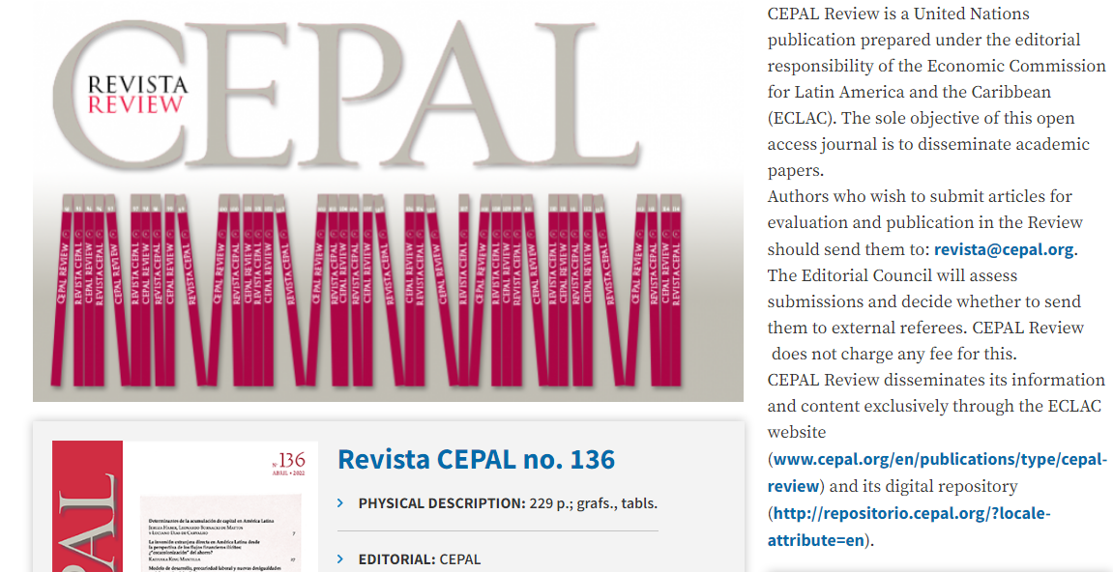

https://www.cepal.org/en/publications/type/cepal-review