Spectrum details
Project New project Spectrum name Spectrum 1

Electron Image
Image Width: 109.3 µm
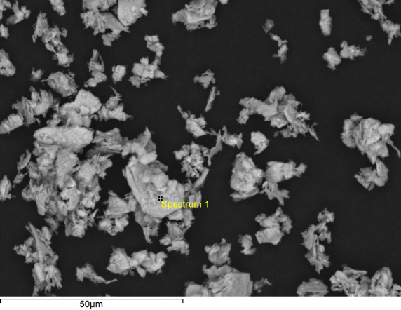

Acquisition conditions
Acquisition time (s) 30.0 Process time 5
Accelerating voltage (kV) 15.0
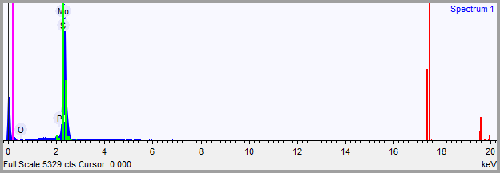

Quantification Settings
Quantification method All elements (normalised)
Coating element None

Summary results
Element | Weight % | Weight % σ | Atomic %
Oxygen | 6.017 | 0.645 | 17.553
Phosphorus | 0.233 | 0.137 | 0.352
Sulfur | 37.650 | 1.116 | 54.804
Molybdenum | 56.099 | 1.252 | 27.291

Spectrum details
Project New project Spectrum name Spectrum 2

Electron Image
Image Width: 109.3 µm
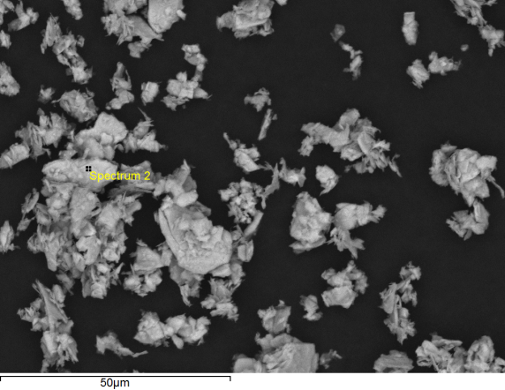

Acquisition conditions
Acquisition time (s) 30.0 Process time 5
Accelerating voltage (kV) 15.0
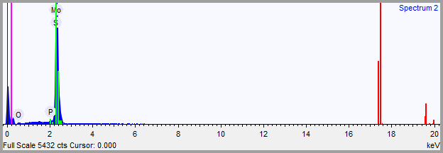

Quantification Settings
Quantification method All elements (normalised)
Coating element None

Summary results
Element | Weight % | Weight % σ | Atomic %
Oxygen | 4.361 | 0.709 | 13.121
Phosphorus | 0.136 | 0.136 | 0.212
Sulfur | 38.759 | 1.145 | 58.194
Molybdenum | 56.743 | 1.258 | 28.473

Spectrum details
Project New project Spectrum name Spectrum 3

Electron Image
Image Width: 109.3 µm
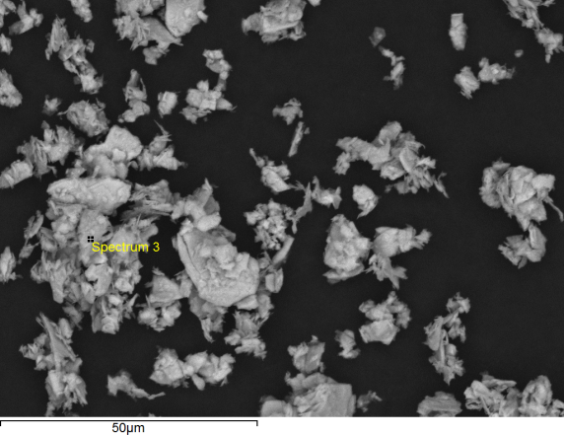

Acquisition conditions
Acquisition time (s) 30.0 Process time 5
Accelerating voltage (kV) 15.0
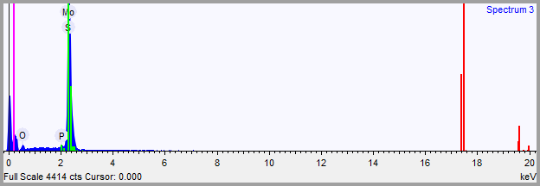

Quantification Settings
Quantification method All elements (normalised)
Coating element None

Summary results
Element | Weight % | Weight % σ | Atomic %
Oxygen | 15.256 | 0.979 | 37.181
Phosphorus | 0.326 | 0.143 | 0.411
Sulfur | 34.706 | 1.127 | 42.204
Molybdenum | 49.712 | 1.444 | 20.204

Spectrum details
Project New project Spectrum name Spectrum 4

Electron Image
Image Width: 109.3 µm
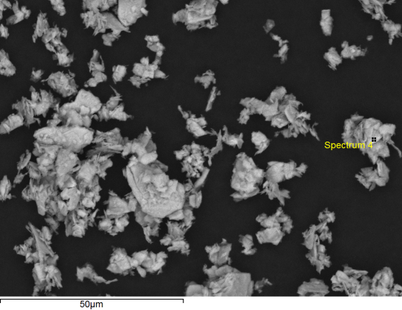

Acquisition conditions
Acquisition time (s) 30.0 Process time 5
Accelerating voltage (kV) 15.0
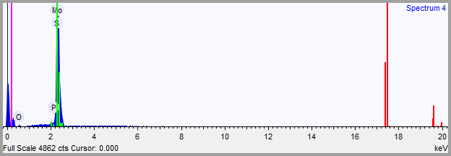

Quantification Settings
Quantification method All elements (normalised)
Coating element None

Summary results
Element | Weight % | Weight % σ | Atomic %
Oxygen | 7.166 | 0.626 | 20.554
Phosphorus | 0.113 | 0.138 | 0.168
Sulfur | 36.660 | 1.119 | 52.464
Molybdenum | 56.060 | 1.272 | 26.813

Spectrum details
Project New project Spectrum name Spectrum 5

Electron Image
Image Width: 109.3 µm
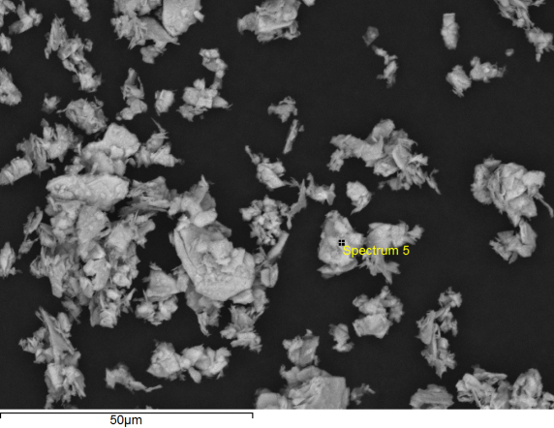

Acquisition conditions
Acquisition time (s) 30.0 Process time 5
Accelerating voltage (kV) 15.0
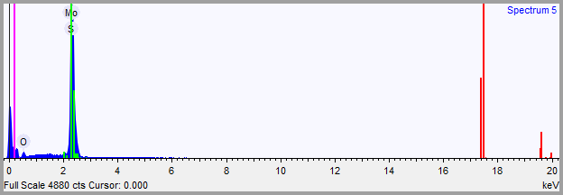

Quantification Settings
Quantification method All elements (normalised)
Coating element None

Summary results
Element | Weight % | Weight % σ | Atomic %
Oxygen | 15.214 | 0.922 | 37.039
Sulfur | 35.290 | 1.047 | 42.867
Molybdenum | 49.496 | 1.330 | 20.094

Spectrum details
Project New project Spectrum name Spectrum 6

Electron Image
Image Width: 109.3 µm
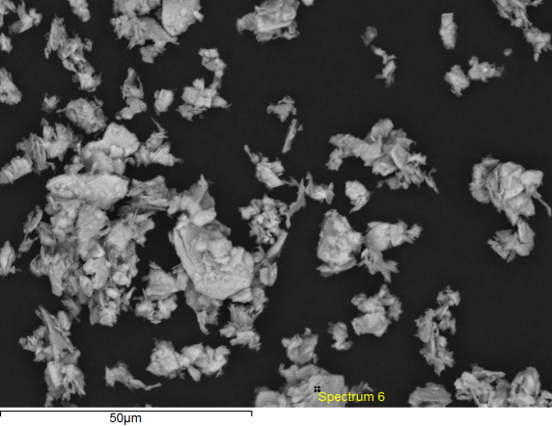

Acquisition conditions
Acquisition time (s) 30.0 Process time 5
Accelerating voltage (kV) 15.0
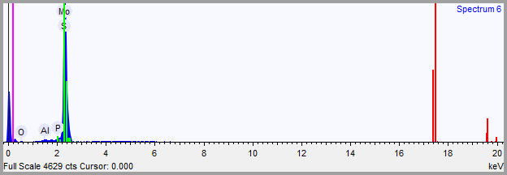

Quantification Settings
Quantification method All elements (normalised)
Coating element None

Summary results
Element | Weight % | Weight % σ | Atomic %
Oxygen | 4.965 | 0.544 | 14.795
Aluminum | 0.319 | 0.085 | 0.563
Phosphorus | 0.059 | 0.144 | 0.090
Sulfur | 37.888 | 1.179 | 56.339
Molybdenum | 56.770 | 1.295 | 28.213

