Spectrum details
Project New project Spectrum name Spectrum 2

Electron Image
Image Width: 196.8 µm
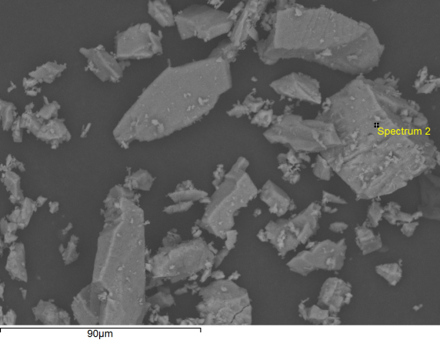

Acquisition conditions
Acquisition time (s) 30.0 Process time 5
Accelerating voltage (kV) 15.0
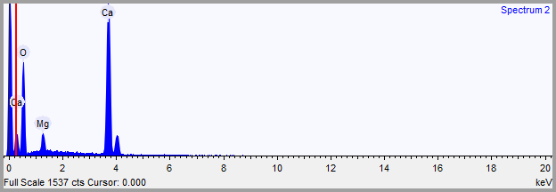

Quantification Settings
Quantification method All elements (normalised)
Coating element None

Summary results
Element | Weight % | Weight % σ | Atomic %
Oxygen | 64.416 | 0.529 | 81.234
Magnesium | 2.614 | 0.146 | 2.169
Calcium | 32.970 | 0.498 | 16.597

Spectrum details
Project New project Spectrum name Spectrum 3

Electron Image
Image Width: 196.8 µm
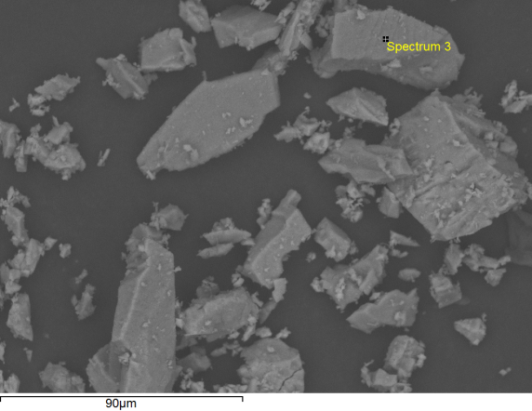

Acquisition conditions
Acquisition time (s) 30.0 Process time 5
Accelerating voltage (kV) 15.0
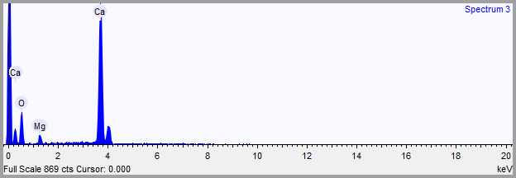

Quantification Settings
Quantification method All elements (normalised)
Coating element None

Summary results
Element | Weight % | Weight % σ | Atomic %
Oxygen | 50.387 | 1.178 | 71.326
Magnesium | 1.745 | 0.174 | 1.626
Calcium | 47.868 | 1.145 | 27.048

Spectrum details
Project New project Spectrum name Spectrum 4

Electron Image
Image Width: 196.8 µm
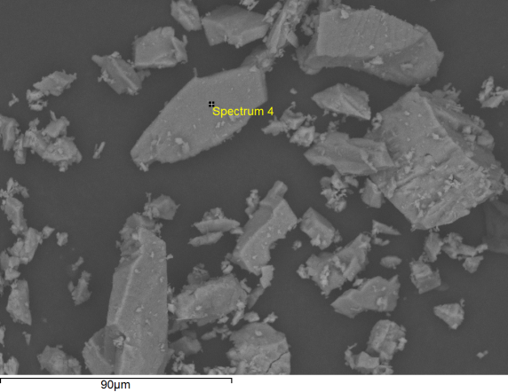

Acquisition conditions
Acquisition time (s) 30.0 Process time 5
Accelerating voltage (kV) 15.0
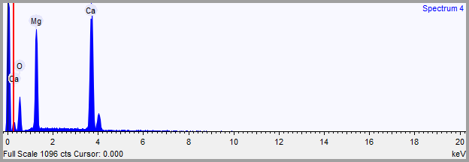

Quantification Settings
Quantification method All elements (normalised)
Coating element None

Summary results
Element | Weight % | Weight % σ | Atomic %
Oxygen | 42.173 | 0.910 | 60.212
Magnesium | 18.480 | 0.409 | 17.363
Calcium | 39.347 | 0.687 | 22.425

Spectrum details
Project New project Spectrum name Spectrum 5

Electron Image
Image Width: 196.8 µm
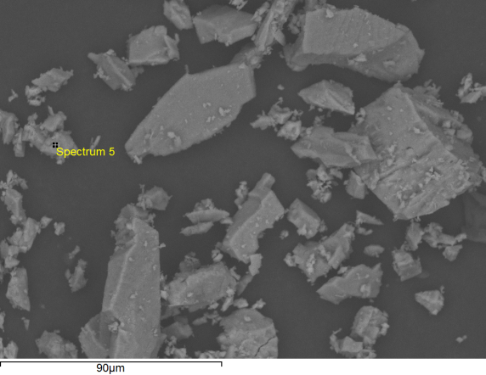

Acquisition conditions
Acquisition time (s) 30.0 Process time 5
Accelerating voltage (kV) 15.0
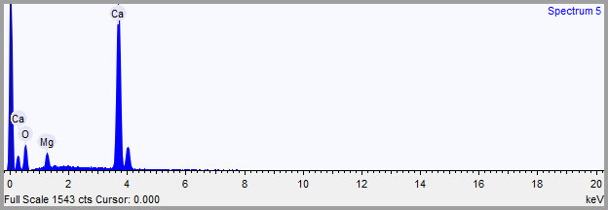

Quantification Settings
Quantification method All elements (normalised)
Coating element None

Summary results
Element | Weight % | Weight % σ | Atomic %
Oxygen | 44.492 | 1.002 | 65.993
Magnesium | 2.974 | 0.191 | 2.902
Calcium | 52.535 | 0.959 | 31.105

Spectrum details
Project New project Spectrum name Spectrum 6

Electron Image
Image Width: 196.8 µm
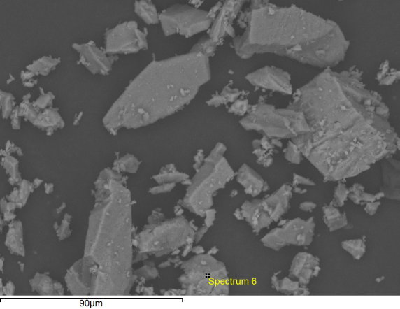

Acquisition conditions
Acquisition time (s) 30.0 Process time 5
Accelerating voltage (kV) 15.0
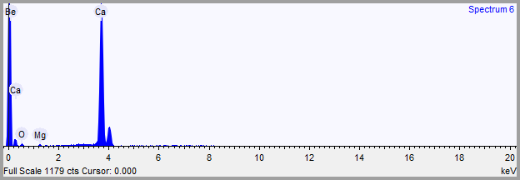

Quantification Settings
Quantification method All elements (normalised)
Coating element None

Summary results
Element | Weight % | Weight % σ | Atomic %
Oxygen | 14.950 | 1.769 | 30.461
Magnesium | 0.691 | 0.131 | 0.926
Calcium | 84.359 | 1.759 | 68.613

Spectrum details
Project New project Spectrum name Spectrum 7

Electron Image
Image Width: 196.8 µm
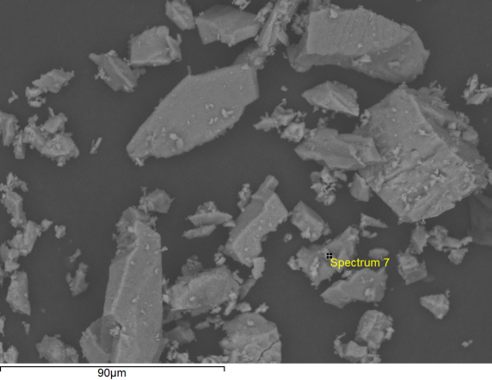

Acquisition conditions
Acquisition time (s) 30.0 Process time 5
Accelerating voltage (kV) 15.0
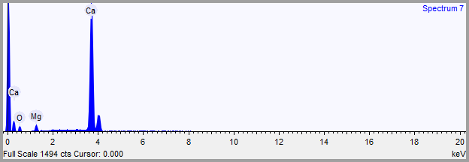

Quantification Settings
Quantification method All elements (normalised)
Coating element None

Summary results
Element | Weight % | Weight % σ | Atomic %
Oxygen | 23.136 | 1.476 | 42.498
Magnesium | 2.401 | 0.177 | 2.902
Calcium | 74.463 | 1.439 | 54.600

