Exemplos de figuras e tabela –comentar e tentar melhorar.
Comparison in sales for Facebook in billions of dollars.
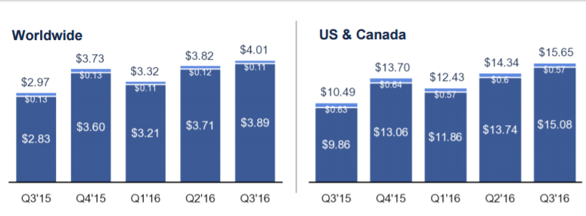
Ambev Sales
