https://www.horiba.com/en_en/en-en/technology/measurement-and-control-techniques/material-characterization/dynamic-light-scattering/

Dynamic Light Scattering (DLS) Particle Size Distribution Analysis
Dynamic Light Scattering Technology
Particle size can be determined by measuring the random changes in the intensity of light scattered from a suspension or solution. This technique is commonly known as dynamic light scattering (DLS), but is also called photon correlation spectroscopy (PCS) and quasi-elastic light scattering (QELS). The latter terms are more common in older literature.
After a few comments on the applications of dynamic light scattering, this page explains the technique beginning the actual phenomena under study (particle motion, not particle size). The nature of the measurement and data interpretation is then discussed. Finally, there are some concluding comments.
Applications for Dynamic Light Scattering
DLS is most commonly used to analyze nanoparticles. Examples include determining nanogold size, protein size, latex size, and colloid size. In general, the technique is best used for submicron particles and can be used to measure particle with sizes less than a nanometer. In this size regime (microns to nanometers) and for the purposes of size measurement (but not thermodynamics!) the distinction between a molecule (such as a protein or macromolecule) and a particle (such as nanogold) and even a second liquid phase (such as in an emulsion) becomes blurred. Dynamic light scattering can also be used as a probe of complex fluids such as concentrated solutions. However, this application is much less common than particle sizing.
Stokes Einstein: Relating Particle Size to Particle Motion
Small particles in suspension undergo random thermal motion known as Brownian motion. This random motion is modeled by the Stokes-Einstein equation. Below the equation is given in the form most often used for particle size analysis.
where
- Dh is the hydrodynamic diameter (this is the goal: particle size!)
- Dt is the translational diffusion coefficient (we find this by dynamic light scattering)
- kB is Boltzmann’s constant (we know this)
- T is thermodynamic temperature (we control this)
- η is dynamic viscosity (we know this)
The calculations are handled by instrument software. However, the equation does serve as important reminder about a few points. The first is that sample temperature is important, at it appears directly in the equation. Temperature is even more important due to the viscosity term since viscosity is a stiff function of temperature. Finally, and most importantly, it reminds the analyst that the particle size determined by dynamic light scattering is the hydrodynamic size. That is, the determined particle size is the size of a sphere that diffuses the way as your particle.
For those who work with protein sizing and other areas where hydrodynamic radius is more commonly used, note that the development here is around diameter. Radius calculations are the same except for a factor of two.
Also, a note to those interested in polymer size. The hydrodynamic radius is not the same as the radius of gyration. Hydrodynamic sizes are more easily measured than radii of gyration and can be measured over a wider range of sizes. The conversion from hydrodynamic radius to radius of gyration is a function of chain architecture (including questions of random coil vs. hard sphere, globular, dendrimer, chain stiffness, and degree of branching).
How to Measure Particle Motion I: Dynamic Light Scattering Optical Setup
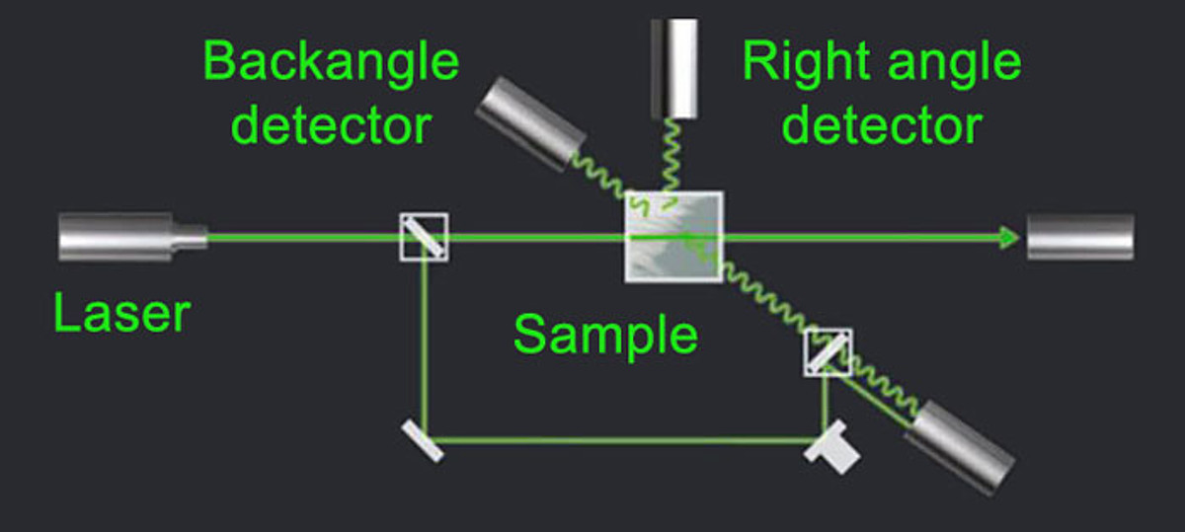
A top view of the optical setup for DLS is shown above.
Light from the laser light source illuminates the sample in the cell. The scattered light signal is collected with one of two detectors, either at a 90 degree (right angle) or 173 degree (back angle) scattering angle. The provision of both detectors allows more flexibility in choosing measurement conditions. Particles can be dispersed in a variety of liquids. Only liquid refractive index and viscosity needs to be known for interpreting the measurement results.
The obtained optical signal shows random changes due to the randomly changing relative position of the particles. This is shown schematically in the graph below.
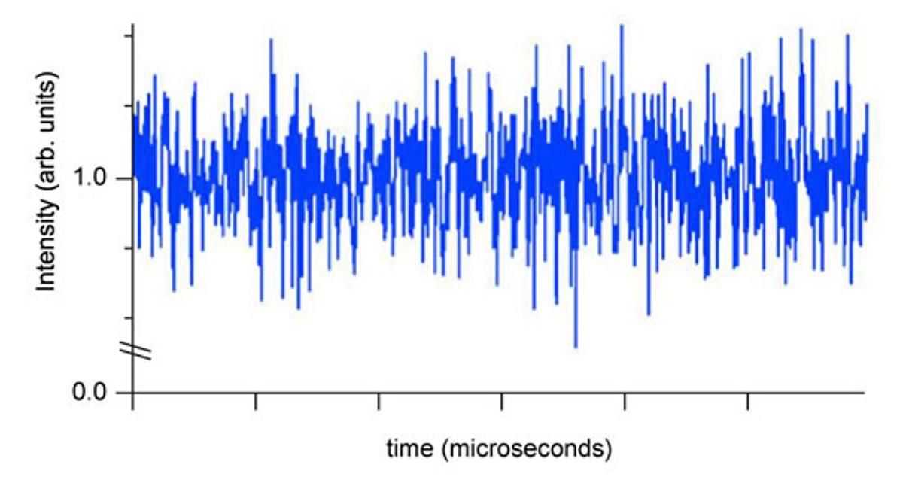
The “noise” is actually due to particle motion and will be used to extract the particle size. In contrast to laser diffraction, DLS measurements are typically made at a single angle, although data obtained at several angles can be useful. In addition, the technique is completely noninvasive; the particle motion continues whether or not it is being probed by DLS.
The variations in the signal arise due to the random Brownian motion of the particles. Treating this random signal is discussed in the next section on extracting particle motion.
How to Extract Particle Diffusion Coefficient: Dynamic Light Scattering Data Interpretation
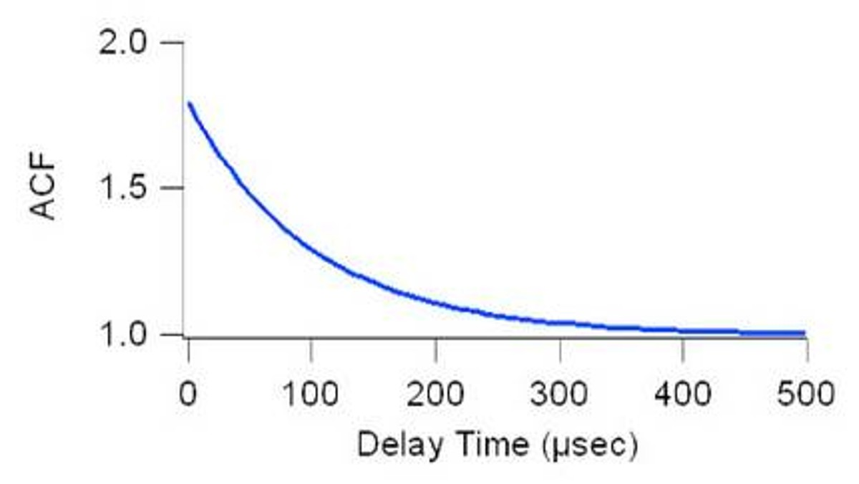
The signal can be interpreted in terms of an autocorrelation function. Incoming data is processed in real time with a digital signal processing device known as a correlator and the autocorrelation function as a function of delay time, τ, is extracted.
For a sample where all of the particles are the same size, the baseline subtracted autocorrelation function, C, is simply an exponential decay of the following form:
Γ is readily derived from experimental data by a curve fit. The diffusion coefficient is obtained from the relation Γ=Dtq2 where q is the scattering vector, given by q=(4πn/λ)sin(θ/2). The refractive index of the liquid is n. The wavelength of the laser light is λ, and scattering angle, θ. Inserting Dt into the Stokes-Einstein equation above and solving for particle size is the final step.
Analyzing Real Particle Size Distributions I: The Method of Cumulants and Z-average
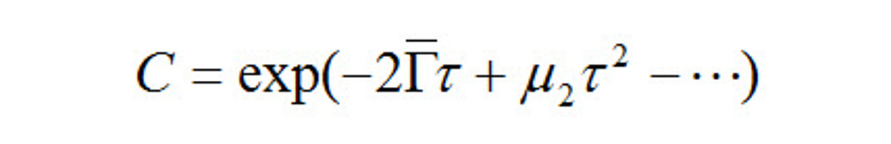
The discussion above can be extended to real nanoparticle samples that contain a distribution of particle sizes. The exponential decay is rewritten as a power series:
Once again, a decay constant is extracted and interpreted to obtain particle size. However, in this case, the obtained particle size, known as the z-average size, is a weighted mean size. Unfortunately, the weighting is somewhat convoluted. Recall that the decay constant is proportional to the diffusion coefficient. So, by dynamic light scattering one has determined the intensity weighted diffusion coefficient. The diffusion coefficient is inversely proportional to size. So, in truth, the “z-average size” is the intensity weighted harmonic mean size. This definition differs substantially from that of the z-average radius of gyration encountered in the light scattering study of polymers.
Despite the convoluted meaning, the z-average size increases as the particle size increases. And, it is extremely easy to measure reliably. For these reasons, the z-average size has become the accepted norm for particle sizing by dynamic light scattering.
Analyzing Real Particle Size Distributions II: Size Distribution Data
While a detailed discussion is beyond the scope of this work, it is possible to extract size distribution data from DLS data. One can convert the measured autocorrelation function into what is known as an electric field autocorrelation function, g1(τ). Then use the following relationship between g1(τ) and the scattered intensity, S, for each possible decay constant, Γ. The overall electric field autocorrelation function is the intensity weighted sum of the decays due to every particle in the system.
Inversion of this equation, that is using experimentally determined values of g1(τ) to find values of S(Γ), will lead to information about the size distribution. Unlike the cumulants analysis discussed above, this is an ill-posed mathematical problem. Even so, the technique remains useful for interpreting DLS data.
Concluding Comments and Additional Thoughts
The underlying theory of measurement by dynamic light scattering was discussed. Many of the points on this web page are starting points for further investigation depending on the reader’s analytic needs and interests. All of these equations and the analysis are handled automatically in the HORIBA software. As such, dynamic light scattering has found application for determining protein size, nanoparticle size, and colloid size.

