Meta-informações das revisões bibliográficas (2018)

Várias dessas informações não podem ser extraídas do artigo e devem ser obtidas via internet.
O artigo de revisão que você irá analisar nem sempre contém informações para todas as meta-informações, além das que você pode encontrar na web. Se ele não contiver, digite NADA no tópico correspondente.
As informações podem ser inseridas em inglês, como cópia do original (citar a página)
Salvar este artigo antes de inserir o conteúdo, com o título: SEP5843 2018 - análise revisão <nome do aluno> <ano, autor principal>
- Referência completa do artigo:
MARTÍN-PEÑA, M. L.; PINILLOS, M. J.; REYES, L. E. The intellectual basis of servitization: A bibliometric analysis. Journal of Engineering and Technology Management, v. 43, p. 83–97, 2017.
- Autores (um registro por autor)
María Luz Martín-Penã
Tipo: Profesora Titular en el Departamento de Economía de la Empresa
Idade: -
Anos pesquisando no assunto: primeiro artigo com o tema servitização no scopus em 2014 (3 anos)
Instituição: Universidad Rey Juan Carlos, Mostoles, Spain
Índice-h: (scopus) 7
Colegas da mesma instituição: co-autores
Quantidade de artigos já publicados: Scopus: 15;
Outros artigos significativos (mais citados) sobre outros temas
MARTÍN-PEÑA, M. L.; DÍAZ-GARRIDO, E.; SÁNCHEZ-LÓPEZ, J. M. Analysis of benefits and difficulties associated with firms’ Environmental Management Systems: The case of the Spanish automotive industry. Journal of Cleaner Production, v. 70, p. 220–230, 2014. (32 citações)
GARRIDO, E. D.; MARTIN-PEÑA, M. L.; GARCIA-MUIÑA, F. Structural and infrastructural practices as elements of content operations strategy. the effect on a firm’s competitiveness. International Journal of Production Research, v. 45, n. 9, p. 2119–2140, 2007. (29 citações)
LUZ MARTÍN‐PEÑA, M.; DÍAZ‐GARRIDO, E. Typologies and taxonomies of operations strategy: a literature review. Management Research News, v. 31, n. 3, p. 200–218, 2008. (27 citações)
Outros artigos significativos (mais citados) neste tema
MARTÍN PEÑA, M. L. et al. Teaching in service systems: New challenges through services science management and engineering. Intangible Capital, v. 10, n. 2, 2014. (1 citação)
Co-autores recorrentes
Co autores | Número de documentos
Díaz-Garrido, Eloísa | 9
Sánchez-López, José María | 5
Garrido, Eloísa Díaz | 3
De Castro, Valeria Valeria | 1

María José Pinillos
Tipo: Professora
Idade: -
Anos pesquisando no assunto: ± 10 anos
Instituição: Universidad Rey Juan Carlos, Mostoles, Spain
Índice-h: 1 (scopus)
Colegas da mesma instituição: co-autores
Quantidade de artigos já publicados: Scopus: 2; Scholar: -
Outros artigos significativos (mais citados) sobre outros temas
PINILLOS, María-José; REYES Luisa. Relationship between individualist-collectivist culture and entrepreneurial activity: Evidence from Global Entrepreneurship Monitor data. Small Business Economics, v. 37, p. 23-37, 2011
Outros artigos significativos (mais citados) neste tema
NADA
Co-autores recorrentes
Co-authors | Co-authored documents
Pinillos, María José | 2
Martín-Peña, María | 1

Luisa Eugenia Reyes
Tipo: Professora
Idade: -
Anos pesquisando no assunto: ± 10 anos
Instituição: Universidad Rey Juan Carlos, Mostoles, Spain
Índice-h: 1 (scopus)
Colegas da mesma instituição: co-autores
Quantidade de artigos já publicados: Scopus: 2; Scholar: -
Outros artigos significativos (mais citados) sobre outros temas
PINILLOS, María-José; REYES Luisa. Relationship between individualist-collectivist culture and entrepreneurial activity: Evidence from Global Entrepreneurship Monitor data. Small Business Economics, v. 37, p. 23-37, 2011
Outros artigos significativos (mais citados) neste tema
NADA
Co-autores recorrentes
Co-authors | Co-authored documents
Reyes, Luisa Eugenia | 2
Martín-Peña, María | 1

- Estrutura do abstract (contextualização, gap/lacuna, objetivo, metodologia, resultados e conclusão)
Contextualização: -
Gap/lacuna: -
Objetivo: “This research pretends to identify the studies and disciplines that have had the greatest impact on servitization among manufacturing firms, with a view to illustrating the intellectual structure of this discipline”.
Metodologia: “The methodology is based on bibliometric techniques of citations and co-citations that appear in documents, in journals included in the Web of Science. Network theory was used to identify the documents that constitute the core of the co-cited documents.”And a multivariate analysis.
Resultados e conclusão: “A multivariate analysis has allowed establishing the underlying intellectual structure of servitization, comprising three factors: (a) service strategy in industrial firms, (b) service innovation, and (c) service dominant logic.”
- Palavras-chaves e se foram citadas no abstract.
Servitization - sim
Service innovation - não
Bibliometric analysis – no abstract, apresenta-se como “bibliometric techniques”
Co-citation analysis – não
- Introdução e/ou revisão bibliográfica introdutória, afirmações / constatações (tipo) versus citações (essa lista pode ser longa, por isso coloquei em forma de tabela)
Afirmação / Constatação | Tipo (*1) | Referência (*2)
Servitization can be defined as the process of increasing value by adding services to products; it is driven by customer demand and is perceived by corporations as sharpening their competitive edge. | C | -
Firms are increasingly offering ‘‘bundles’’ of customer-focussed combinations of goods, services, support, self-service, and knowledge’’ | C | Vandermerwe and Rada, 1988
It is a means of creating added value capabilities that are distinctive and sustainable versus competitors | C | (Baines et al., 2009a).
Authors such as Neely (2008) believe that the servitization process can be seen as the development of an organisation’s innovation capabilities, in the sense that it not only provides products but product-service systems | C | Visnjic Kastalli et al., 2013; Neely (2008)
Servitization can provide a competitive advantage from a strategic perspective | C | (Bustinza et al., 2015)
The manufacturing industry is undergoing a deep transformation, with services contributing to its income (more than 50% in some industries) and a large proportion of employees (65–75%) performing service functions. | C | (Doultsinou et al., 2009).
Furthermore, the value of chain of asset manufacturers is becoming less attractive as the demand for products remains stagnant. | C | -
In this scenario, firms are aware that value can be found in the provision of the services required to enhance the functionality and sustainability of the products that they manufacture | C | (Wise and Baumgartner, 1999).
Davies et al. (2007) say that services provide continuous income, plus high profit margins, and require less assets than manufacture. In sum, servitization has become an objective for many firms. | C | Davies et al. (2007)
Firms can operate in a ‘‘product-service continuum’’ during the servitization process | C | (Oliva and Kallenberg, 2003; Neu and Brown, 2005; Gebauer, 2008; Baines et al., 2009b).
On one end is the traditional manufacturer, who only supplies products, and services are added to these products; income and profits are largely generated through the products sold, and the contribution of services to the creation of value is quite low. | C | -
On the other end are service providers, in which services represent the foundation of the value creation process, with tangible assets added to satisfy clients’ needs; these assets represent but a small part of the total value | C | (Gebauer and Friedli, 2005)
Firms have to define their positions on said  continuum, providing product-service combinations. | G | -
In this context, interest in servitization has grown in the literature. | C | -
In other disciplines there have been bibliometric analyses, that help to  review the literature with a view to tracing the study’s origins, locating the more significant papers and the scientific community’s more recent contributions. | C | Casillas and Acedo, 2007; McKerlich et al., 2013; Pilkington and Meredith, 2009; Pinto et al., 2014; Pinillos, 2011; Ramos-Rodrı´guez and Ruı´z-Navarro, 2004; Ronda-Pupo and Guerras-Martı´n, 2010; Sa´ nchez-Riofrı´o et al., 2015)
Studies based on bibliometric analysis are classified in two categories, according to the indicators used: (1) activity indicators and (2) relation indicators. | C | -
The former provides information about the volume and impact of research activities, while the latter track the relationships and interactions between investigators and fields,  hence describing the content of research activities and their evolution. | C | (Callon et al., 1993; Ramos Rodrı´guez and Ruiz Navarro, 2006)
In the study of servitization, there are only 8 papers with literature reviews. | C | -
Five are largely qualitative and three are quantitative | C | (Pawar et al., 2009; Berkovich et al., 2011; Cavalieri and Pezzotta, 2012; Park et al., 2012; Beuren et al., 2013) (Lightfoot et al., 2013; Boehm and Thomas, 2013; Park and Yoon, 2015).
There is no general consensus on the theoretical and empirical development of the research. | L | -
Furthermore, bibliometric techniques have not been used to include the greatest amount of available information in the literature review. | L | -
Thus, there appears to be both a clear need and an opportune time to conduct this review of the literature on servitization. | J | -
(*1) Tipos de afirmação / constatação: G (geral), C (contexto), J (justifica o artigo / pesquisa), L (explicita a lacuna). A constatação da lacuna é muito importante. Mas é difícil diferenciar J de L.; (*2) Inserir somente autor(es) e ano. A referência completa encontra-se no próprio artigo

- Casos citados e principais características dos casos
NADA
- Questão da pesquisa, Foco (escopo) e Objetivos (geral primário e secundários)
Foco (escopo): Estudo quantitativo da estrutura intelectual no campo da Servitização
Objetivo: “The purpose of this study is to identify the papers that have had the greatest impact on research on servitization in the manufacturing industry in order to illustrate the intellectual structure of this discipline.”
- Qual o diferencial deste artigo (análise da revisão) com relação a outras revisões e/ou surveys? (segundo o autor, caso ele tenha citado). Avaliar uma por uma, caso o autor tenha feito isso. Pode montar uma tabela se for o caso.
- Não há uma clara comparação entre as análises, mas o autor apresenta na introdução algumas revisões e afirma que apesar do interesse no tema vir crescendo nos últimos anos, existe uma falha de definição que promove a aparição de novos termos, um grande problema delas é a falta de definição de um conceito (Baines, Lightfoot, Benedettini, & Kay, 2009; Lightfoot, Baines, & Smart, 2013; Neely et al., 2011; Gustafsson, Brax, &Witell, 2010; Kowalkowski, Witell, & Gustafsson, 2013; Matthyssens & Vandenbempt, 2010; Fang, Palmatier, & Steenkamp, 2008; Oliva & Kallenberg, 2003; Ulaga & Loveland, 2014). Com isso, a literatura sobre servitização se apresenta fragmentada. A revisão dos autores considera esses diferentes termos com o objetivo de fornecer um framework para facilitar a análise dos processos de servitização nesse meio em que a literatura apresenta estas características.
- “This study is the first time that bibliometric techniques have been applied to this discipline, identifying the most studied topics in servitization literature in the last thirty-five years. This supplements and enhances the results of other studies that have approached the topic from a qualitative perspective, obtaining the intellectual structure of the discipline and enabling is to define its theoretical foundations.”

- Metodologia
  - Descrição Geral: Nome do(s) método(s); se é qualitativo, quantitativo ou combinação de ambos
Método quantitativo
- Análise bibliométrica: Bibexcel
- Network theory: Ucinet software package and NetDraw
- Análise multivariada: SPSS statistical software

  - Período de análise das referências (publicações desde que ano)
from January 1980 to March 2015
  - Tamanho da amostra analisada
“The search resulted in a total of 343 documents related to servitization published on the WoS from 1992 to March 2015.”
“The 343 study papers cited 12,123 different documents, 1001 of which were cited more than once (henceforth referred to as the cited sample).”
Quantidade de referências citadas
120 referências
  - Foram realizadas observações complementares?
NADA
  - Fontes da revisão (casos, periódicos específicos, e quais bases de dados). Quais as justificativas para escolher essas fontes.
Índices de citação:
Science Citation Index Expanded (SCIE)
- Social Sciences Citation Index (SSCI) of the web of science
- Conference Proceeding Citation index (CPCI-S)
- Conference Proceedings Citation Index (CPI-SSH)
Justificativa: “considered ‘‘certified knowledge’’”
  - Estratégia para construção da string de busca
Primeira busca no WoS com as palavras servitização, resultando em 114 documentos. Os documentos foram analisadas utilizando o Bibexcel, resultando em mais 21 palavras chaves associadas ao termo servitização.
  - String de busca
The search terms were specifically as follows: Industrial Product-Service Systems (IPSS), Integrated Product-Service (IPS), Manufacturing Servitization, New Product-Service Development (NPSD), Product-Service, Product-Service System (PSS), PSS Design and Planning Strategies, PSS Development Process, PSS Strategies, Service business orientation, service integration, Service orientation, service-centred, Service-Dominant Logic, Service-Embedded Manufacturing, Service-Oriented, Servitization, Servitization of Manufacturing, Servitization Strategy, Servitize and Servitizing.
  - Filtros
Os autores descrevem que da primeira busca, eles selecionaram todos os documentos contendo a palavra servitização no título, palavras-chave e abstract, resultando em 114 documentos.
Depois, esses documentos foram analisados novamente (bibexel) e as novas palavras-chaves foram definidas. Depois, eles identificaram na WoS todos os documentos publicados que continha pelo menos um dos 21 termos no título, resumo e palavras-chaves.
  - Técnica / método de análise utilizada
Análise bibliométrica:
A busca foi iniciada no WoS resultando em 114 documentos, com o auxílio do software de análise, novas palavras chaves foram encontradas (21) e nova busca foi realizada. Nas duas etapas, as palavras chaves foram buscas no título, palavras chaves e abstract.
“The bibliometric study comprises citation, co-citation and factorial analyses. The citation study involves collecting all the bibliographic references from the 343 papers published on the WoS, hereinafter the citation sample, to examine co-citations”
The 343 study papers cited 12,123 different documents, 1001 of which were cited more than once (henceforth referred to as the cited sample). The co-citation analysis is based on the strength of the relationship between two cited documents, which is determined by the number of papers in the citation sample that simultaneously cite these two documents. Co-citation is therefore the frequency with which two prior documents are cited together in the subsequent literature.
Network theory was used to identify the most cited documents that form the core of the network of cited documents.
The process for identifying the intellectual structure about servitization was therefore as follows:
- Preparation of the co-citation matrix. A co-citation matrix was constructed with the 1000 references cited more than once, using Bibexcel to count the number of times that each possible pair of bibliographic references had been cited together.
- Determination of the degree of closeness of each cited bibliographic reference. The Ucinet software package and NetDraw (Borgatti, 2002; Borgatti et al., 2002), were used to determine and chart the closeness of the nodes in the co-citation network.
- Identification of the bibliographic references with the highest degree of closeness.
- Application of a two-level multivariate analysis using SPSS statistical software, in order to determine the existence of groups in the co-citation network structure.
d.1 Based on the co-citation matrix, a factorial analysis was performed for the references (cited sample) located at the core of the co-citation network. The factorial analysis determines which references are grouped together.
d.2 Identification of the literature bases from the factorial scores obtained for the bibliographic references. In the factorial analysis, the bibliographic references that are conceptually close or refer to the same topic tend to load in the same factor. The factorial load shows the extent to which the reference explains the factor.
  - Metodologia para definição de pesquisas futuras
NADA
- Resultados
  - Quantidades resultantes antes e após cada filtro
- 144 documentos com a palavra servitization no título, key words ou abstract
- 343 documentos relacionados a servitização depois da busca com a nova string de busca
  - Definições (resultantes da análise ou mesmo adotadas como premissas no início da publicação)
Servitization can be defined as the process of increasing value by adding services to products; it is driven by customer demand and is perceived by corporations as sharpening their competitive edge. - definição apresentada na introdução sem referências
  - Evolução da pesquisa / das publicações no assunto

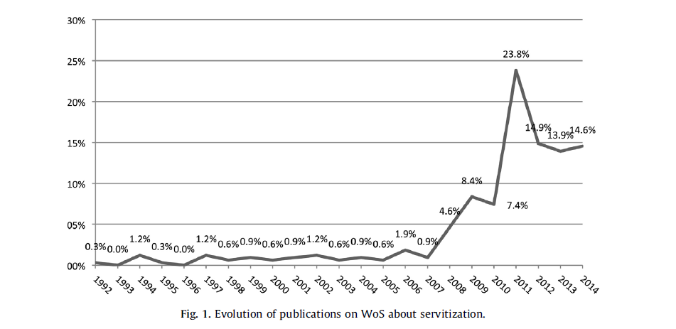
  - Comunidades / “tribos” / “igrejas”/ áreas de conhecimento / disciplinas identificadas
three main theme areas or schools that represent the intellectual structure of research on servitization, called: service strategy in industrial firms, service innovation and service dominant logic,
  - Características de cada tribo (os atributos e/ou explicações são definidos pelo próprio artigo)
- Service strategy in industrial firms: comprise the theoretical and conceptual foundations of what is known as servitization, which is the addition of services to manufacturing, with industrial firms producing different product and service combinations in which the product comes before the service. The provision of services satisfies specific client needs, so that more value is created for clients and represents a source of differentiation
- Service innovation: focus on service design in the context of product-service systems. The following research topics or fields can be identified in the documents in question: (I) technological innovation or technology and (II) sustainability and/or eco-efficiency
- ‘Service dominant logic: develop the conceptual framework of service dominant logic (SDL), basically from a marketing perspective.
Principais “achados” (findings)
- figura 1: a partir de 2007 o número de publicações passou a subir, atingindo seu maior número em 2011 e apesar de depois disso ter diminuído, ainda é maior que o número de publicações do período anterior.
- The 343 articles that form the cited sample were published in 118 different journals. 73% of the 343 documents that form the citing sample were published in one of these 36 journals (com maior impacto). Os journals são mostrados na tabela 2.
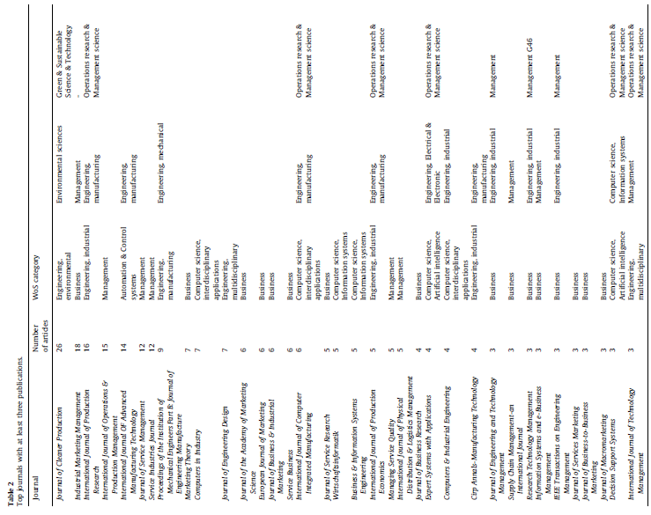
- Combined, the articles in the present review demonstrate clearly that the topic applies to many different research areas; however, these areas are mainly related to business, engineering (environmental, industrial and manufacturing), management and computer science, according to the WoS categories.
-The authors of these 343 articles come mainly from England (20% citing sample), USA (15% citing sample), Germany (8% citing sample) and Sweden (8% citing sample).
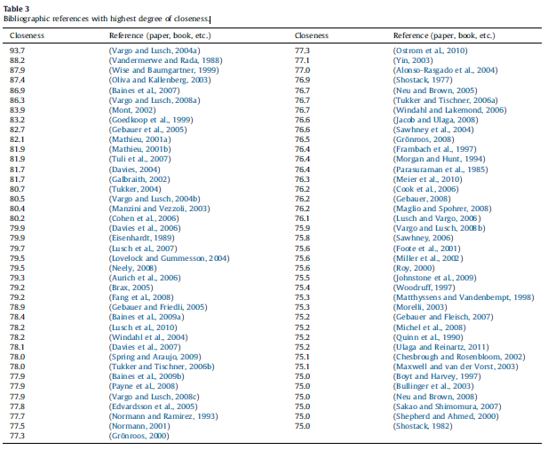
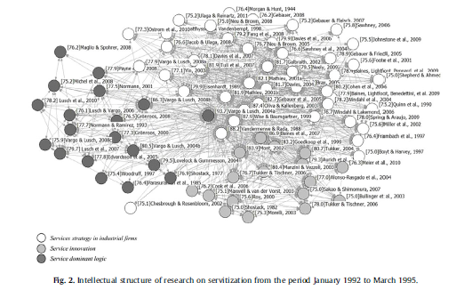
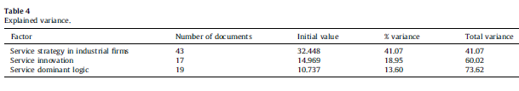
The results in Table 4 show that the line of research focusing on service strategy in industrial firms is related to the largest number of studies, followed by service dominant logic and, finally, service innovation.
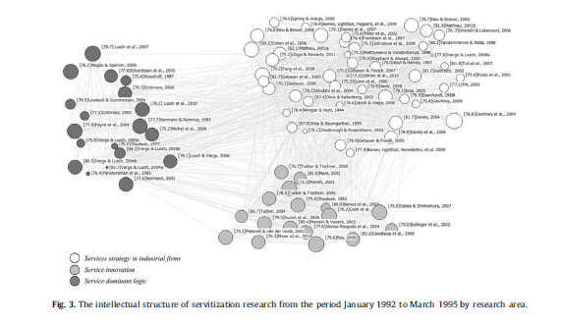
Pag:
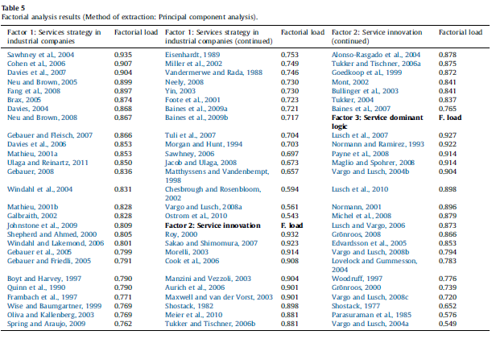
‘‘Service strategy in industrial firms’’
- documents that comprise the theoretical and conceptual foundations of what is known as servitization, which is the addition of services to manufacturing, with industrial firms producing different product and service combinations in which the product comes before the service.
- The provision of services satisfies specific client needs, so that more value is created for clients and represents a source of differentiation.
- The base of the literature is built around this term, first used by Vandermerwe and Rada (1988). The different studies are related to strategic management and represent research that tries to explain servitization as a business strategy (Neu and Brown, 2005; Gebauer, 2008).
- The output supply is seen as a continuum that goes from the production of goods to the production of services, resulting in an evolution in which firms provide the most appropriate combination of goods/services (Oliva and Kallenberg, 2003; Neu and Brown, 2005, 2008; Johnstone et al., 2009)
- It is considered that the addition of services to manufacturing processes responds to a change in strategy, ranging from vertical integration (Wise and Baumgartner, 1999; Davies et al., 2007) to the constitution of services in a new business model (Shepherd and Ahmed, 2000; Galbraith, 2002; Tuli et al., 2007).
- The analysis of the papers included in this first factor enables the identification of new approaches to the search for solutions:
1.System of solutions aimed at satisfying consumer demands by combinations of goods and services (Vandermerwe and Rada, 1988; Foote et al., 2001) developed as new business models in which portfolio complexity is the distinctive feature (Shepherd and Ahmed, 2000).
2. Solution orientation from a cultural, regulatory and organisational perspective (Wise and Baumgartner, 1999).
3. Integrated solutions in relation to: (a) the characteristics of the competition (Windahl et al., 2004), (b) the importance of business relations and value chain (Davies, 2004; Windahl and Lakemond, 2006), (c) comprehensive solutions for clients in which goods and services are integrated to provide custom products adapted to each client’s specification, based on the ‘‘dominant service’’ approach (Sawhney, 2006).
4. Effective solutions based on the study and analysis of provider and client variables (Frambach et al., 1997; Foote et al., 2001; Davies et al., 2007; Tuli et al., 2007; Bustinza et al., 2013).
5. ‘‘Hybrid supply’’ based on Resource and Capability Theory, focusing on the development of distinctive service-related capabilities (Davies et al., 2006; Ulaga and Reinartz, 2011).
- As this is a new topic that arose less than twenty years ago, most of the papers are not based on a specific theory, which is characteristics of new fields of research, where conceptual aspects are the priority, so there are different conceptual approaches.
- This factor has a clear strategic orientation, which includes the consideration of Resource and Capability Theory and the achievement of a competitive advantage (Davies et al., 2006; Fang et al., 2008; Brax, 2005; Ulaga and Reinartz, 2011)
- Other theories used include contingent theory, in Neu and Brown ([15TD$DIF]2005, 2008) and Gebauer (2008), which explains the adjustment process between internal and external factors for choosing the most appropriate servitization strategy. On the other hand, ‘‘resource-advantage theory of competition’’ enables the analysis of whether servitization strategy enables the firm to obtain comparative advantages in resources with which to provide greater value to clients (Neu and Brown, 2005).
- Organisation theory and organisational conduct and motivation are also used to explain managers’ reasons for initiating the servitization process and the internal factors that affect this strategy’s development (Gebauer et al., 2005; Gebauer and Friedli, 2005; Gebauer and Fleisch, 2007).
- And finally, in the papers that comprise the first factor, we have also found the operations strategy approach (Baines et al., 2009a; Spring and Araujo, 2009).
- A second line shows the importance of contextual factors in firms’ servitization processes and the manner in which they enable the appropriate integration of the servitization strategy in the strategic development of industrial firms. From this perspective, the aim is to: (1) identify the internal (organisational structure, strategy design and implantation, managerial behaviour, human resource policies) and external (characteristics such as complexity) factors that favour the development of a servitization strategy (Miller et al., 2002; Gebauer et al., 2005; Neu and Brown, 2005, 2008; Windahl and Lakemond, 2006; Tuli et al., 2007; Johnstone et al., 2009; Turunen and Toivonen, 2011); (2) identify the factors that determine the most appropriate combination of products and services and the type of servitization to be applied (Windahl et al., 2004; Gebauer, 2008).
- Another field of research focuses on the analysis of the effects and consequences of servitization for firms. It analyses the costs and benefits (Mathieu, 2001b), the risks (Sawhney et al., 2004) and the impact on financial performance (Neely, 2008). The conceptual bases include a literature review (Baines et al., 2009b) and the bases of the science of services (Ostrom et al., 2010).
- The studies that comprise this factor are largely theoretical, specifically 43% of the total; this is because research in this factor focuses on the conceptual foundations of the topic. On the other hand, 38% of the publications use the case study method, applying theoretical bases. As most of them highlight, the objective of this methodology is not to obtain generalisable results but find results that enable the development of a broader servitization strategy theory (Eisenhardt, 1989; Yin, 2003). The few empirical studies use primary sources to obtain information. In-depth interviews have been used, applying statistical techniques such as cluster, exploratory, descriptive or regression analysis.
‘‘Service innovation’’
- It is configured by papers that focus on service design in the context of product service systems.
- The following research topics or fields can be identified in the documents in question:
- technological innovation or technology and
- sustainability and/or eco-efficiency.
- The first of the identified topics is in all the analysed papers, so it can be said that the factor includes research on product service systems, focusing on: (a) the impact of innovation or technology on the servitization process, or (b) case studies of the development of technological services that supplement firms’ product (technological or not) supply.
- In this respect, Roy (2000) and Sakao and Shimomura (2007) aim to propose a new discipline in the engineering field, called ‘‘Service Engineering’’ (SE). Roy (2000) focuses on the analysis of the design of goods and services that reduces environmental impact while being economically feasible and acceptable for users. Sakao and Shimomura (2007) investigate eco-design and define service engineering as a discipline aimed at increasing the value of products and reducing environmental impact by focusing on services. They propose a service model in which the key variable clave is the change in the recipient’s satisfaction, suggesting a computer-assisted design tool called ‘‘SERVICE EXPLORER’’ that effectively satisfied consumer requirements
- Morelli (2003) maintains that the design of a PSS can be seen in a context in which:
(a) is a proposal for a new combination of technology based on functional parameters selected by the designer;
(b) the interaction between the service designed and the client is not mediated by the industrial product.
The first condition helps to focus on design, while the second defined the activity of designing a PSS as a multidimensional activity in which design aspects are related to organisational and social aspects. In product design, technological elements and social aspects represent two different moments in the product’s life cycle. This is shown in the sub-division of responsibilities between design, product engineering, system development, marketing and other disciplines.
- On the other hand, sustainability as the central topic of research regarding PSS is approached in a total of 6 papers, 5 of which refer both to eco-efficiency and sustainability, and the other paper to sustainability alone.
- Roy (2000) discusses the concept of sustainability of PSS and establishes that the key element of sustainable PSS is that they are designed and marketed to provide clients with a given outcome without them necessarily having to possess or physically purchase the products. ‘‘These sustainability ideas have developed from ‘cleaner and greener’ improvements to processes and products to socio-technical system changes and new product-service mixes’’ (Roy, 2000). Four types of PSS are thus established:
1. Result services, the objective of which is to reduce existing systems’ use of materials by selling a ‘‘result’’ instead of a product. One example is the sale of a clean clothing service instead of a washing machine.
2. Shared utilisation services aim to increase the use of parts of a system by the shared use of the product or products required. In the previous sample, it would involve sharing facilities in a communal clothes washing centre or commercial laundry instead of having washing machines in individual homes.
3. Product-life extension services; the primary function of these services is to increase the useful life of products or materials through maintenance, repair, reutilisation and recycling, thus reducing the energy and resources required to provide a given function. A simple example would be a personal computer firm that supplies or sells and also maintains and updates computers, as well as collecting them when no longer useful, for recycling.
4. Demand side management (occasionally referred to as minimum cost planning or integrated resource management) aims to reduce demand instead of increasing supply, o supplying at the lowest financial and environmental cost.
- Morelli (2003) focuses on the development of a PSS as support for a new working method based on the intensive use of information and technological communications. PSS is defined as an integrated set of products of services capable of satisfying a consumer’s needs.
- Manzini and Vezzoli (2003) also refer to the integral satisfaction of consumer needs, yet they see it as an innovation strategy, according to the case analysis contained in their paper.
- These definitions show the evolution of PSS from the traditional marketing perspective to the product management perspective. Ultimately, it refers to the extension of the service component around the product, for business activities that were traditionally product-oriented, or to the introduction of new service components in product businesses that were initially service-oriented. In this context, the term ‘‘strategic design for sustainability’’ represents the ability to create new configurations or types of stakeholder that develop an integrated product, service and communication system that is consistent with medium and long-term sustainability. This life cycle-oriented design concept in PSS is also adopted by Aurich et al. (2006), albeit only for technological products.
- The ratio between the product and service components in a PSS can vary according to technological development, economic optimisation and changing consumer needs, among other factors. The common characteristic in them all, however, is that they are conceived and supplied as products, which are designed taking a series of economic and technological criteria into account.
- Maxwell and van der Vorst (2003) develop a method for the development of sustainable products and service in order to provide a pragmatic orientation to business and industry, and to include this approach in existing corporate strategy and socalled clean production.
- Cook et al. (2006) delve deeper into the transfer of knowledge from academia to industry in relation to PSS, based on the premise that the adoption of technology and market push are factors that have been shown to be insufficient, as the existing technological paradigms do not provide a socially optimal solution in view of what is needed to improve sustainability. In this respect, the authors develop a methodology for the transfer of the concept from UK academic circles to industry, identifying the factors that define sustainable production and consumption methods.
‘‘Service dominant logic’’
- it comprises studies that develop the conceptual framework of service dominant logic (SDL), basically from a marketing perspective.
- The seminal study on this topic is Vargo and Lusch (2004a), the first authors to consider the re-definition of the basic characteristics of services (heterogeneity, intangibility and simultaneity) nor from the traditional production viewpoint but from the service dominant logic perspective.
- The second of the papers included in this third factor, Normann and Ramirez (1993), do not distinguish between product and service, yet they consider the idea of creating value creation systems for stakeholders by mobilising clients to help to create their own value through the firm’s supply. This paper is seen as the most influential in the development of the value co-creation concept.
- Other authors subsequently question the concept of the term service and its basic characteristics, defining it from the consumer’s perspective, based on the concept of value in use (Lovelock and Gummesson, 2004; Edvardsson et al., 2005).
- All the studies included in this factor support the thesis that the central proposal in service dominant logic is that the client becomes a co-creator of value. Yet prior to 2003 little was known of how clients are involved in the co-creation of value.
- Payne et al. (2008) develop a model for the understanding and management of the co-creation of value. This model is based on a summary of research on services, value for the client and relational marketing based on the centrality of processes in the co-creation of value. The model shows an interconnected set of processes and how they recur in co-creation.
- Lusch et al. (2007) sustain that service dominant logic challenges administration on all management levels to be at the service of all stakeholders; they understand that SDL is a logic or perspective that recognises the firm and its stakeholders in order to seek co-creation of value through mutual service provision. The study developed by these authors is based on the nine seminal proposals of SDL, eight of which were developed by Vargo and Lusch (2004a) and the ninth by Lusch et al. (2007).
- Although this paper is the most involved in the explanation of this factor, it can be concluded after analysis that this is the result of extending the seminal studied by the same authors to define service as an entity proper and the basis of competition in terms of competitive advantage.
- Once the first studies developed the concept of joint value in use, co-creation and service dominant logic instead of products, the following study goes one step further and develops the foundations of the science of services. So the discipline is developed chronologically, and based on the importance of the papers in the factor. In this respect, service dominant logic is the theoretical background on which the science of services is based. The authors established that their objective is to classify and explain the different existing service provision systems, and how service systems interact and evolve to co-create value.
- Although the aforementioned papers basically focus on the concept and rationale of the science of services, the rest are related to existing areas of knowledge, analysing some aspects from a client-oriented marketing perspective (Vargo and Lusch, 2004b; Lusch et al., 2010; Michel et al., 2008; Gro¨ nroos, 2008) or in relation to strategic management, using resource and capability theory (Michel et al., 2008; Lusch and Vargo, 2006)
  - Outros tópicos que não foram tratados aqui (sugestão para nova meta-informação ou resultados significativos)
NADA
  - Proposições de pesquisas futuras (geral)
NADA
  - Contribuições (para academia / prática / ambas?)
The methodology used enabled the identification of the lines of research that comprise the intellectual basis of the literature about servitization over the last thirty-five years, supplementing and improving the results of other studies that approached the topic from a qualitative perspective. Network analysis, by determination of closeness indicators, identified the most significant bibliographic references in the sense that they made the greatest contribution to configuring the intellectual structure of research on servitization.

The indicator of the degree of closeness (or centrality) of each node enabled the identification of the publications with the greatest impact, measured by closeness.
  - Conclusões
  - Trabalhos futuros (que o autor se propõe, diferente das proposições futuras)
This methodology can be applied to different periods of time to analyse its evolution, and to study the ‘‘state of the art’’ of each of the areas that comprise the intellectual structure of servitization
  - Limitações
The use of one database or another to obtain source documents (the citation sample) could condition the study’s results. However, the bibliometric analysis focuses on the analysis of references (co-citation analysis) so the differences found using other databases to obtain the citation sample would not be expected to bias the results. Moreover, most of the publications indexed in the WoS are also found in other databases, such as Scopus. Another aspect to be considered is that, in many cases, the citations are the result of different factors that influence the investigator when conducting his or her study. The frequency with which a document is cited does not infer quality, as excellent papers can be less cited, but the frequency with which a reference is cited or co-cited is certainly indicative of its importance or significance when configuring a field of knowledge.
Another limitation is related to the fact that the first published studies have been available to the scientific community for longer, and therefore have had more opportunities to be cited. This could bias the results, but only to a certain extent, as influence is a construct that depends on time. In other words, for a paper to be defined as influential it does not only have to be cited, but this has to occur over a long period of time.
- SUA ANÁLISE
  - Pontos fortes
Análise quantitativa das publicações
  - Pontos fracos
Não faz uma evolução dos fatores no tempo e se intitula a única revisão bibliométrica dos últimos trinta e cinco anos. Uma busca simples no scholar com as palavras servitization e bibliometrics mostra mais algumas revisões bibliométricas existentes.
  - Sugestões para melhoria do artigo
Faltou fazer uma evolução cronológica baseada nos fatores encontrados (service innovation, service dominat logic and service strategy in industrial firms)
- Figuras ou tabelas importantes (caso você queira copiar e citar nos tópicos anteriores)
No corpo do trabalho

