REFUGEES - TEMPLATE
TEMPLATE TO THE DISCIPLINE IN ENGLISH: refugees living in each studied country.
Please note that this ebook will be published, so all information coming from research of any kind must be properly referenced so that copyright is not infringed.
GROUP NAMES:
-
-

REFUGEES IN “STUDIED COUNTRY”
1) Presentation:
[itemized session, similar to what is found in Wikipedia, as a way to introduce the receiving country]
- Map of the country, localized in the mundi map
- Flag
- Official Name
- Capital
- Official language
- Gentilic
- Government (tipo e forma de governo: república ou monarquia; presidencialismo ou parlamentarismo)
- Independence or Establishment:
- Area
- Climate
- Population (quantity and density)
- GDP
- HDI
- GINI
- Currency

2) History
- short history of the country, mainly the one that can be related to the refugee problems
- population and society: composition of population
- political aspects (mainly related to treating refugees)
- economy

3) Refugees in the studied country (Must have):
- People from which country seek for refugee there (use figures)
- Why are they as a refugee specifically in this country
- How are they received in the country – is there any rule (quantity)? What is the legislation? Are there any refugee fields?
- What is the situation nowadays? (Is there a big flow? Are they still coming? Do they want to stay or go elsewhere?)
- What is the profile for these persons? Are they graduated? How old are they?

4) Conclusion
- How difficult is it to get the refugee status?
- How long does it take to get the condition?
- What are the rights of a refugee?

5) References

Here's an example of what is to be done:
EMIGRANTES SENEGALESES NO BRASIL
1) Presentation:
- Map of the country, localized in the mundi map
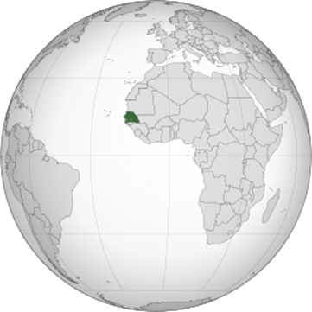
- Flag:
- Official Name: Republic of Senegal
- Capital: Dacar
- Official language: French
- Gentilic: senegalese
- Government (tipo e forma de governo: república ou monarquia; presidencialismo ou parlamentarismo): Unitarian semi-presidential republic
- Independence or Establishment: Independence of France, April 4, 1960
- Area: 196,712 km² (85º in the world)
- Climate: tropical
- Population (quantity and density): 74,56 hab./km²
- GDP: $ 59.987 billion (112th in the world, as estimated by 2018)
- HDI: 0.514 (166th worldwide, as estimated for 2018)
- GINI: 40,3 (2011)
- Currency: CFA Franc

2) Aspectos físicos/históricos:
-breve histórico do país
-população e sociedade
-aspectos políticos
-economia

3) Refugiados no Brasil (trabalhos da turma em português). Deve conter:
- motivo pelo qual fogem de seu próprio país (histórico)
- em quais estados se concentram mais e porque
- porque buscam refúgio especificamente no Brasil
- como está a atual situação (se ainda há um grande fluxo do país de origem para o país de refúgio)
- perfil dos refugiados (nível de escolaridade, encontram trabalho no Brasil, dificuldades)

4) Conclusão
Como é a concessão de asilo, demora para conseguir a condição de asilado

5)Referências

