Spectrum details
Project New project Spectrum name Spectrum 1

Electron Image
Image Width: 49.2 µm
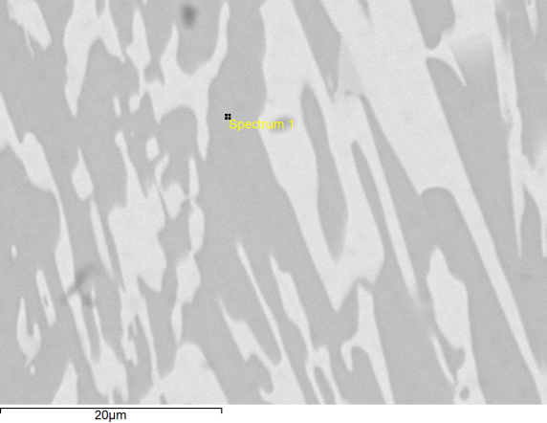

Acquisition conditions
Acquisition time (s) 30.0 Process time 5
Accelerating voltage (kV) 15.0
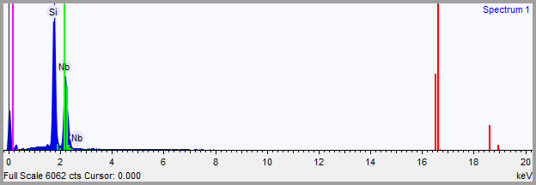

Quantification Settings
Quantification method All elements (normalised)
Coating element None

Summary results
Element | Weight % | Weight % σ | Atomic %
Silicon | 35.349 | 0.343 | 64.396
Niobium | 64.651 | 0.343 | 35.604

Spectrum details
Project New project Spectrum name Spectrum 2

Electron Image
Image Width: 49.2 µm
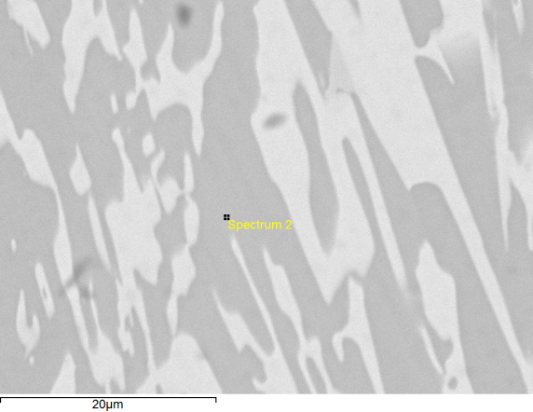

Acquisition conditions
Acquisition time (s) 30.0 Process time 5
Accelerating voltage (kV) 15.0
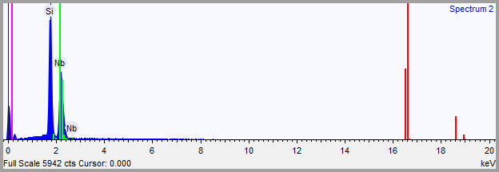

Quantification Settings
Quantification method All elements (normalised)
Coating element None

Summary results
Element | Weight % | Weight % σ | Atomic %
Silicon | 35.531 | 0.345 | 64.578
Niobium | 64.469 | 0.345 | 35.422

Spectrum details
Project New project Spectrum name Spectrum 3

Electron Image
Image Width: 49.2 µm
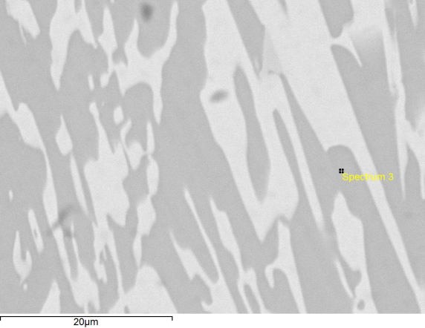

Acquisition conditions
Acquisition time (s) 30.0 Process time 5
Accelerating voltage (kV) 15.0
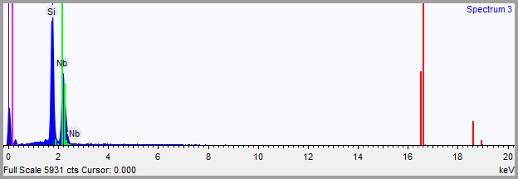

Quantification Settings
Quantification method All elements (normalised)
Coating element None

Summary results
Element | Weight % | Weight % σ | Atomic %
Silicon | 35.600 | 0.346 | 64.647
Niobium | 64.400 | 0.346 | 35.353

Spectrum details
Project New project Spectrum name Spectrum 4

Electron Image
Image Width: 49.2 µm
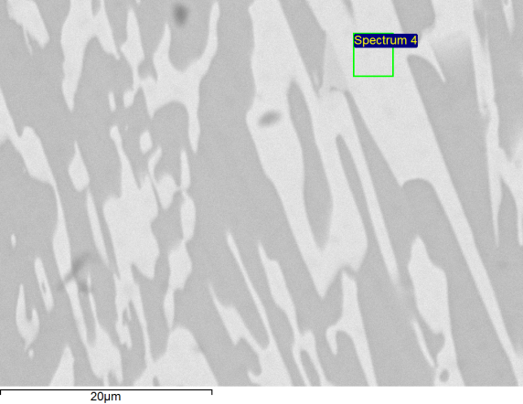

Acquisition conditions
Acquisition time (s) 30.0 Process time 5
Accelerating voltage (kV) 15.0
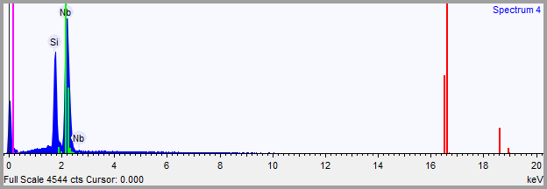

Quantification Settings
Quantification method All elements (normalised)
Coating element None

Summary results
Element | Weight % | Weight % σ | Atomic %
Silicon | 17.251 | 0.219 | 40.815
Niobium | 82.749 | 0.219 | 59.185

Spectrum details
Project New project Spectrum name Spectrum 5

Electron Image
Image Width: 49.2 µm
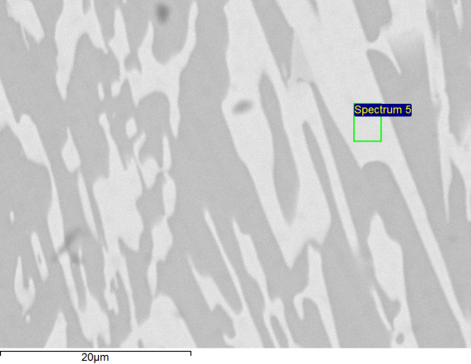

Acquisition conditions
Acquisition time (s) 30.0 Process time 5
Accelerating voltage (kV) 15.0
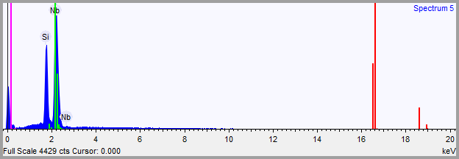

Quantification Settings
Quantification method All elements (normalised)
Coating element None

Summary results
Element | Weight % | Weight % σ | Atomic %
Silicon | 16.878 | 0.219 | 40.180
Niobium | 83.122 | 0.219 | 59.820

Spectrum details
Project New project Spectrum name Spectrum 6

Electron Image
Image Width: 49.2 µm
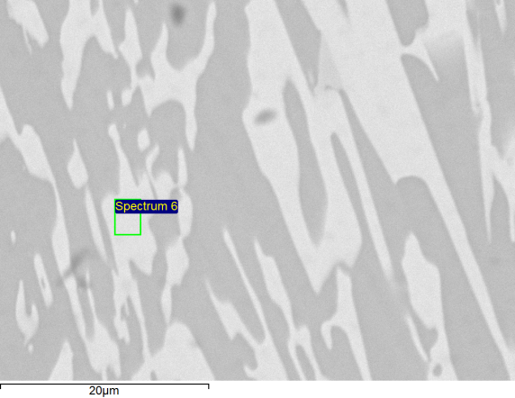

Acquisition conditions
Acquisition time (s) 30.0 Process time 5
Accelerating voltage (kV) 15.0
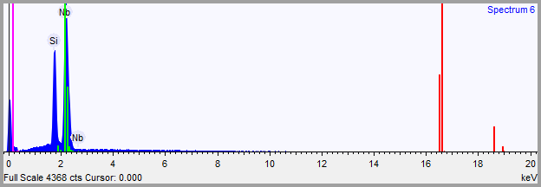

Quantification Settings
Quantification method All elements (normalised)
Coating element None

Summary results
Element | Weight % | Weight % σ | Atomic %
Silicon | 17.633 | 0.225 | 41.458
Niobium | 82.367 | 0.225 | 58.542

Spectrum details
Project New project Spectrum name Spectrum 1

Electron Image
Image Width: 196.8 µm
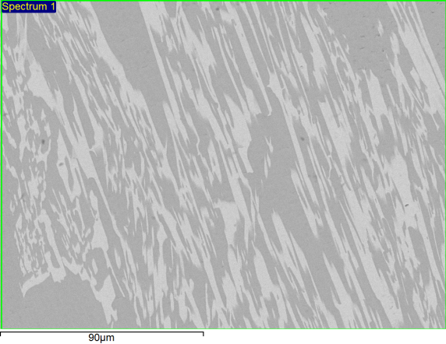

Acquisition conditions
Acquisition time (s) 29.8 Process time 5
Accelerating voltage (kV) 15.0
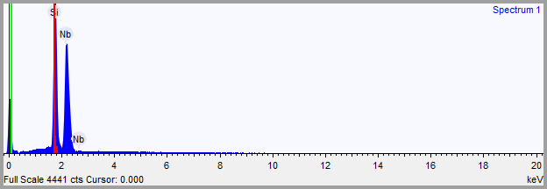

Quantification Settings
Quantification method All elements (normalised)
Coating element None

Summary results
Element | Weight % | Weight % σ | Atomic %
Silicon | 28.320 | 0.309 | 56.652
Niobium | 71.680 | 0.309 | 43.348

Spectrum details
Project New project Spectrum name Spectrum 1

Electron Image
Image Width: 393.5 µm
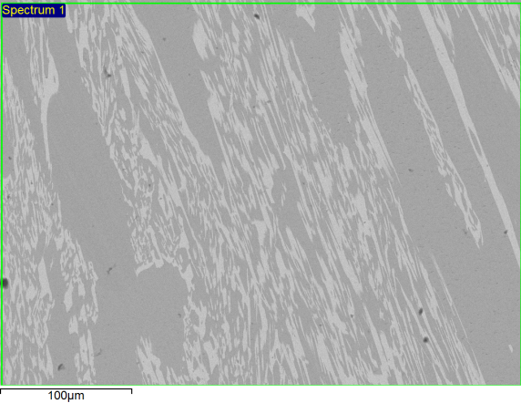

Acquisition conditions
Acquisition time (s) 29.6 Process time 5
Accelerating voltage (kV) 15.0
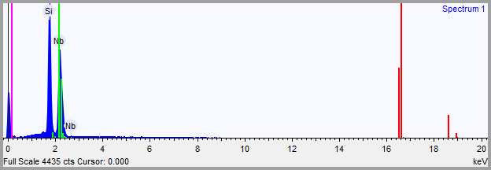

Quantification Settings
Quantification method All elements (normalised)
Coating element None

Summary results
Element | Weight % | Weight % σ | Atomic %
Silicon | 30.189 | 0.333 | 58.856
Niobium | 69.811 | 0.333 | 41.144

Spectrum details
Project New project Spectrum name Spectrum 2

Electron Image
Image Width: 393.5 µm
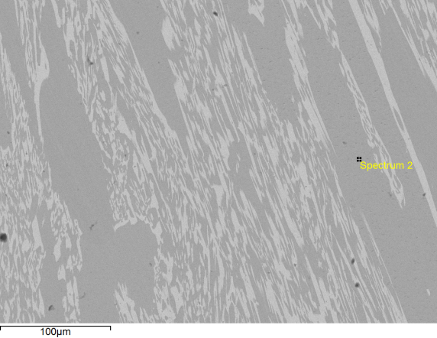

Acquisition conditions
Acquisition time (s) 30.0 Process time 5
Accelerating voltage (kV) 15.0
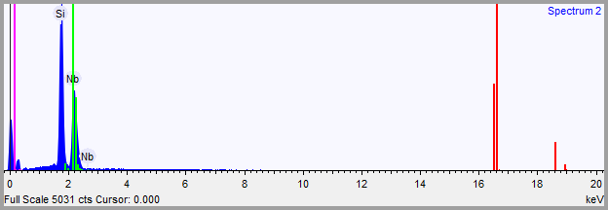

Quantification Settings
Quantification method All elements (normalised)
Coating element None

Summary results
Element | Weight % | Weight % σ | Atomic %
Silicon | 35.619 | 0.377 | 64.666
Niobium | 64.381 | 0.377 | 35.334

Spectrum details
Project New project Spectrum name Spectrum 3

Electron Image
Image Width: 393.5 µm
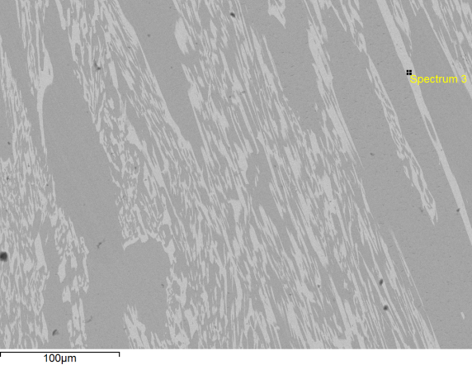

Acquisition conditions
Acquisition time (s) 30.0 Process time 5
Accelerating voltage (kV) 15.0
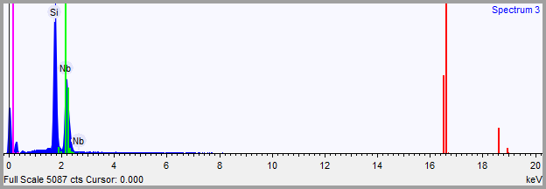

Quantification Settings
Quantification method All elements (normalised)
Coating element None

Summary results
Element | Weight % | Weight % σ | Atomic %
Silicon | 35.391 | 0.374 | 64.438
Niobium | 64.609 | 0.374 | 35.562

Spectrum details
Project New project Spectrum name Spectrum 4

Electron Image
Image Width: 393.5 µm
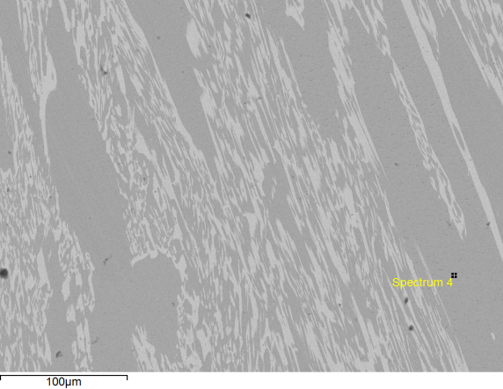

Acquisition conditions
Acquisition time (s) 30.0 Process time 5
Accelerating voltage (kV) 15.0
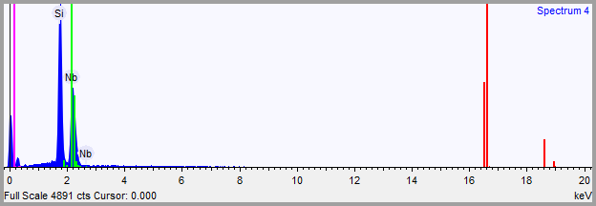

Quantification Settings
Quantification method All elements (normalised)
Coating element None

Summary results
Element | Weight % | Weight % σ | Atomic %
Silicon | 36.331 | 0.393 | 65.369
Niobium | 63.669 | 0.393 | 34.631

