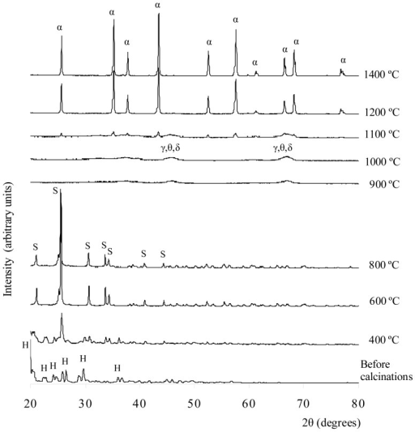
© Copyright Policy - open-access
Related In: Results - Collection
License 1 - License 2
Show All Figures

f3-ijms-13-16812: XRD result on Al2(SO4)3·18H2O sample before and after calcinations at 400–1400 °C for 3 h, where H = Al2(SO4)3·18H2O; S = aluminium sulfate; γ = γ-alumina; θ = θ-alumina; δ = δ-alumina; α = α-alumina.

