"The Digital Skills Gap and the Future of Jobs 2020 - The Fundamental Growth Mindset"
The Digital Skills Gap and the Future of Jobs 2020 - The Fundamental Growth Mindset

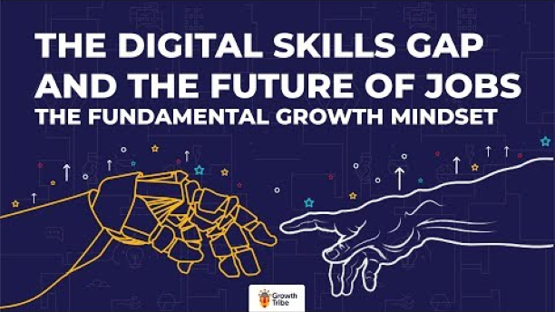

"The 5 Trends Shaping the Future of Work"
The 5 Trends Shaping the Future of Work

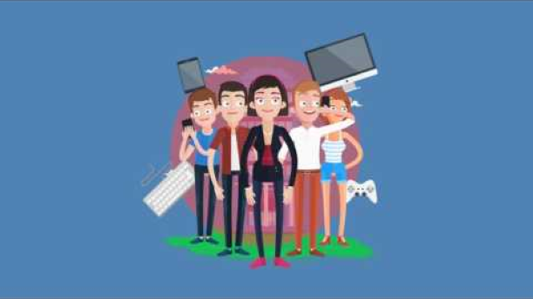

"AI FOR GOOD - The Future of Work"
AI FOR GOOD - The Future of Work

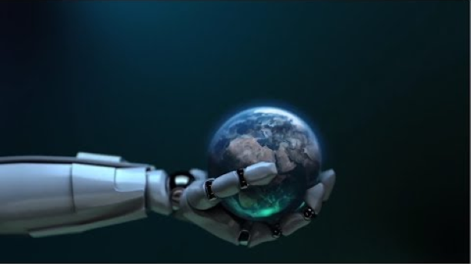

"The Future of Your Job in the Age of AI | Robots & Us | WIRED"
The Future of Your Job in the Age of AI | Robots & Us | WIRED

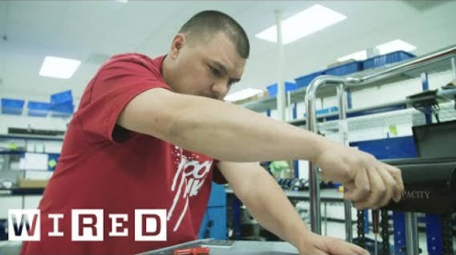

"The Future of Work: Will Our Children Be Prepared?"
The Future of Work: Will Our Children Be Prepared?

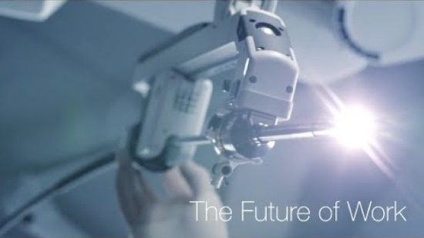

"Future Of Work GE"
Future Of Work GE

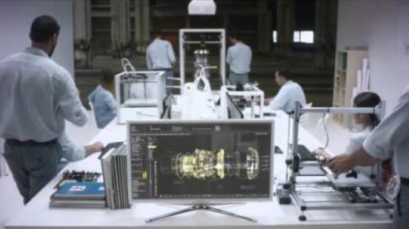

Assista a "The Future of Work Is No Work - Marc Coleman & Vivek Wadhwa"
Aprendizado contínuo

The Future of Work Is No Work - Marc Coleman & Vivek Wadhwa

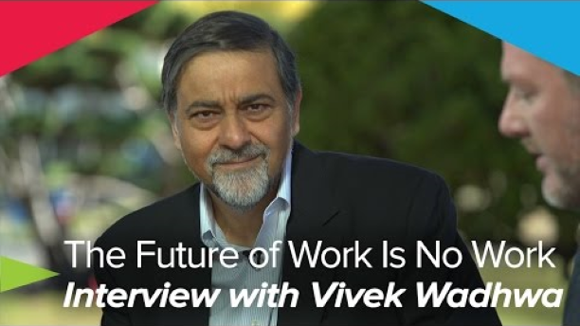

Como serão os empregos do futuro?
What will future jobs look like? | Andrew McAfee

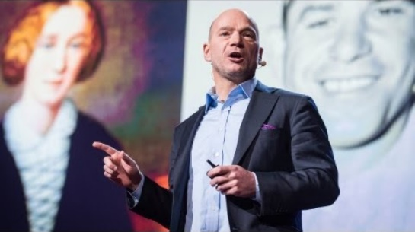

The jobs we'll lose to machines -- and the ones we won't | Anthony Goldbloom

