ACAP Boeing https://www.boeing.com/commercial/airports/plan_manuals.page

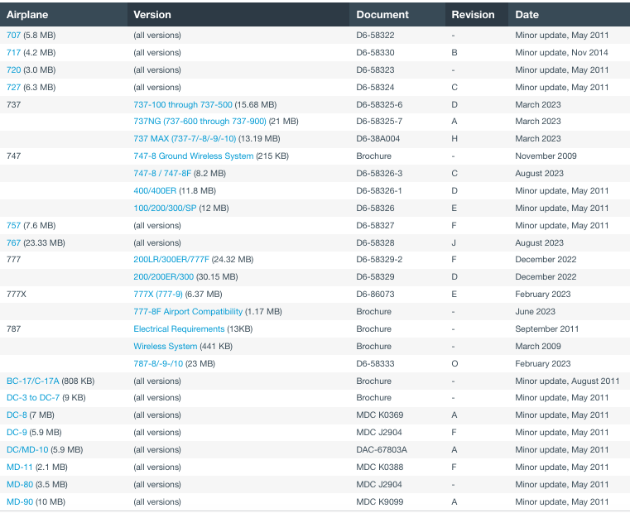

ACAP Airbus
https://aircraft.airbus.com/en/customer-care/fleet-wide-care/airport-operations-and-aircraft-characteristics/aircraft-characteristics

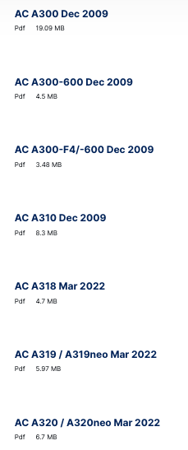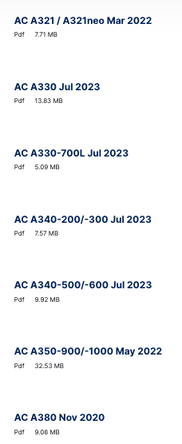

A 220
https://eservices.aero.bombardier.com/wps/portal/eServices/Public/airportpublicationairbus/!ut/p/z1/jc_BCoJAEAbgZ-ng1ZnSyrptFFlaYiXZXMLCVkNdWTd9_aK6BCXNbYbv_2GAIAQqojrlkUpFEWWP_UCDo2lP5zbzcO0NnQn6o4E3WW52Bq5N2D8B_hiGQP_kWwC11--BnsRb2KxrYs_BVcCQ-bMu61uugVvjDVo6lkA8E6fXu6w4GRYHkvEllrHUb_JxTpQqq7GGGjZNo3MheBbrZ5Fr-C2SiEpB-CmhzIMQr_2sdlnnDuT3P20!/dz/d5/L2dBISEvZ0FBIS9nQSEh/

