Espectroscopia Física 2021, Prova 2

- For the HBr molecule calculate the rotational constant B and predict quantitatively the vibrational-rotational spectra at 100 K and 1000 K
paying attention to the peak intensities

- Predict the vibrational-rotational absorption spectra and the rotational Raman spectra of a) H₂ and b) HD at 300 K.

- Consider two Ni²⁺ ion complexes in a square-planar and a tetrahedral (4-coordinated) environment. Based on the relevant Tanabe-Sugano diagrams, discuss the spectroscopic properties of these complexes, using group-theoretical arguments.

- Starting from the electron configuration in the extremely strong external field limit, and without considering Jahn-Teller effects, make an assessment of the relative stabilities of octahedral versus tetrahedral complexes for the first row transition metals series d¹-d⁹. Identify the d^{n} systems with the highest and the lowest preference of the octahedral environments.

- a) using group theory, develop the irreducible represenations of a Fe²⁺ ion in a cubic eight-coordinated environment in the weak external field limit. The electronic states of the free ion are ⁵D, ³H, ³P, ³F, ³G and ¹I.
- predict the spectroscopic transitions for the weak field case.

- Six-coordinated transition metal ions with electron configuration d^{n} (4 ≤ n ≤ 7) can occur both in the high-spin and in the low-spin states. Discuss the spectroscopic differences between the high-spin and the low-spin states as observed in:
- the infrared absorption spectrum of a d⁶ ion with coordination number six,
- the UV-VIS- absorption spectrum of a d⁸ ion with coordination number six.

- Predict the number of peaks observed for the following open-shell species
a)
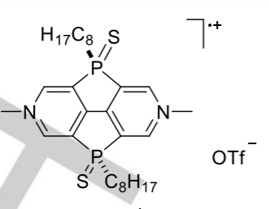
- A tetrahedral Na₄³⁺ ion in a diamagnetic matrix
- An MnF₆⁴⁻ ion in a single crystal
- An MnO₄²⁻ ion in a single crystal
- For which of the above species do you expect no g-anisotropy ?

