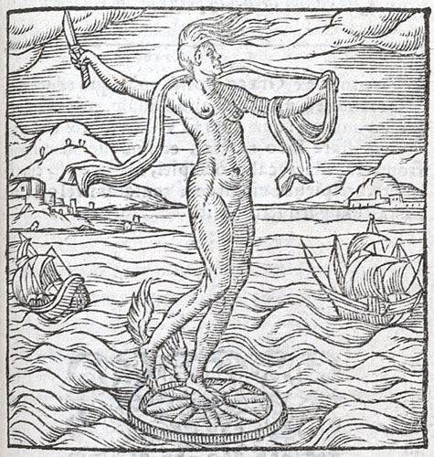

Lysippi[1] hoc opus est, Sicyon[2] cui patria. tu quis?[3]
Cuncta domans capti temporis articulus.
Cur pinnis[4] stas? usque rotor. talaria plantis
Cur retines? passim me levis aura rapit.
In dextra est tenuis dic unde novacula? acutum
Omni acie hoc signum me magis esse docet.
Cur in fronte coma? occurrens ut prendar. At heus tu
Dic, cur pars calva est posterior capitis?
Link to an image of this page Link to an image of this page [R1v f169v]
Me semel alipedem si quis permittat abire,
Ne possim apprenso postmodò crine capi.
Tali opifex nos arte, tui causa edidit hospes,
Utque omnes moneam pergula aperta tenet.

This image is the work of Lysippus, whose home was Sicyon. - Who are you? - I am the moment of seized opportunity that governs all. - Why do you stand on points? - I am always whirling about. - Why do you have winged sandals on your feet? - The fickle breeze bears me in all directions. - Tell us, what is the reason for the sharp razor in your right hand? - This sign indicates that I am keener than any cutting edge. - Why is there a lock of hair on your brow? - So that I may be seized as I run towards you. - But come, tell us now, why ever is the back of your head bald? - So that if any person once lets me depart on my winged feet, I may not thereafter be caught by having my hair seized. It was for your sake, stranger, that the craftsman produced me with such art, and, so that I should warn all, it is an open portico that holds me.

"Your wisdom cannot withstand her: she foresees, judges, and pursues her reign, as theirs the other gods. Her changes know no truce. Necessity compels her to be swift, so fast do men come to their turns. This is she who is much reviled even by those who ought to praise her, but do wrongfully blame her and defame her. But she is blest and does not hear it. Happy with the other primal creatures she turns her sphere and rejoices in her bliss" (Inferno, VII.85-96).

