Zeta potential is a parameter characterizing electrochemical equilibrium on interfaces. It depends on the properties of liquid as well as on properties of the surface. It plays an important role in theory of aggregative stability - DLVO theory [1,2]. Electrostatic repulsion between particles depends on the value of zeta potential. The higher the zeta potential, the stronger the repulsion, the more stable the system becomes. For instance, high zeta potential of the fat droplets in milk prevents them against coalescence. Reduction of it due to addition of acid would lead to cheese formation from coalescence droplets.
Zeta potential is a property of an electric structure that is usually built up at interfaces: Double Layer. According to Fundamentals of Colloid and Interface Science by J. Lyklema [3]: "...the reason for the formation of a "relaxed" ("equilibrium") double layer is the non-electric affinity of charge-determining ions for a surface...". This process leads to the build up of an "electric surface charge". This surface charge creates an electrostatic field that then affects the ions in the bulk of the liquid. This electrostatic field, in combination with the thermal motion of the ions, creates a countercharge, and thus screens the electric surface charge. The net electric charge in this screening diffuse layer is equal in magnitude to the net surface charge, but has the opposite polarity. As a result the complete structure is electrically neutral.
Distribution of the electric potential in the DL is shown on Figure below for positively charged surface.

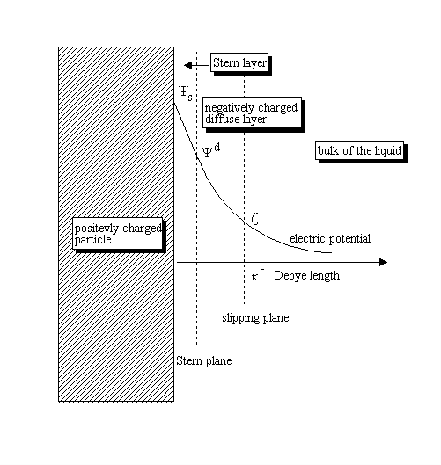
Electric potential decays almost exponentially, which allows introduction "Debye length" as estimate of the DL thickness. Electric potential drops by approximately 2.7 times at the distance from the surface that equals to the Debye length. Debye length depends mostly on an "ionic strength". It is approximately 1 nm at the ionic strength 0.1 M, and it increases as a reciprocal square root of the ionic strength (electrolyte concentration), becoming, for instance, 10 nm at the ionic strength 0.001 M.
There is another characteristic distance within DL - location of a "slipping plane" associated with tangential motion of the liquid relative to the surface. Liquid underneath of the slipping plane remains attached to the surface. Electric potential corresponding to the slipping plane is " Zeta potential ". It is measured in mV and cannot exceed 100 mV.
There is one more plane located even closer to the surface. Some of the counter-ions might specifically adsorb near the surface and build an inner sub-layer, or so-called "Stern layer". The outer part of the screening layer is usually called the "diffuse layer". What about the difference between the surface charge ions and the ions adsorbed in the Stern layer? Why should we distinguish them? There is a thermodynamic justification [3] but we think a more comprehensive reason is kinetic (ability to move). The surface charge ions are assumed to be fixed to the surface (immobile); they cannot move in response to any external disturbance. In contrast, the Stern ions, in principle, retain some degree of freedom, almost as high as ions of the diffuse layer [3,5].
In the general case of an electrolyte mixture there is no analytical solution that relates surface charge with Zeta potential or "Stern potential". However, some convenient approximations have been suggested [3-5]. In real life application Zeta potential is usually used as an estimate of Stern potential and the main characteristic of the electrostatic repulsion preventing particles aggregation.
Calculation of Zeta potential from the parameters measured by Zeta potential analyzer requires appropriate theory. There are two important asymptotic cases when analytical theories exist. The most know is the case of a "thin DL", which corresponds to particulates with DL that is much thinner than particle radius. The vast majority of aqueous dispersions satisfy this condition, except for very small particles and a low ionic strength media. Calculation of Zeta potential can be performed using "Smoluchowski theory", when surface conductivity is negligible.
The opposite case of a "thick DL" corresponds to systems where the DL is much larger than the particle radius. The vast majority of dispersions in hydrocarbon media, having inherently very low ionic strength, satisfy this condition.
These two asymptotic cases allow one to picture, at least approximately, the DL structure around spherical particles. A general analytical solution exists only for low potential, the so-called Debye-Hückel approximation.
There is one more important factor affecting DL structure - "overlap of DLs". Increasing volume fraction and/or reduction of the particle size brings particles surfaces close and eventually diffuse layers would overlap.
Overlap of Double Layers might become important for nano-particles, macromolecules, proteins. It is definitely important in non-polar liquids with very expanded double layers.
There are more details can be found in JUPAC report on Electrokinetic phenomena [7] and in Wikipedia [6].
Electric potential decays almost exponentially, which allows introduction "Debye length" as estimate of the DL thickness. Electric potential drops by approximately 2.7 times at the distance from the surface that equals to the Debye length. Debye length depends mostly on an "ionic strength". It is approximately 1 nm at the ionic strength 0.1 M, and it increases as a reciprocal square root of the ionic strength (electrolyte concentration), becoming, for instance, 10 nm at the ionic strength 0.001 M.
There is another characteristic distance within DL - location of a "slipping plane" associated with tangential motion of the liquid relative to the surface. Liquid underneath of the slipping plane remains attached to the surface. Electric potential corresponding to the slipping plane is " Zeta potential ". It is measured in mV and cannot exceed 100 mV.
There is one more plane located even closer to the surface. Some of the counter-ions might specifically adsorb near the surface and build an inner sub-layer, or so-called "Stern layer". The outer part of the screening layer is usually called the "diffuse layer". What about the difference between the surface charge ions and the ions adsorbed in the Stern layer? Why should we distinguish them? There is a thermodynamic justification [3] but we think a more comprehensive reason is kinetic (ability to move). The surface charge ions are assumed to be fixed to the surface (immobile); they cannot move in response to any external disturbance. In contrast, the Stern ions, in principle, retain some degree of freedom, almost as high as ions of the diffuse layer [3,5].
In the general case of an electrolyte mixture there is no analytical solution that relates surface charge with Zeta potential or "Stern potential". However, some convenient approximations have been suggested [3-5]. In real life application Zeta potential is usually used as an estimate of Stern potential and the main characteristic of the electrostatic repulsion preventing particles aggregation.
Calculation of Zeta potential from the parameters measured by Zeta potential analyzer requires appropriate theory. There are two important asymptotic cases when analytical theories exist. The most know is the case of a "thin DL", which corresponds to particulates with DL that is much thinner than particle radius. The vast majority of aqueous dispersions satisfy this condition, except for very small particles and a low ionic strength media. Calculation of Zeta potential can be performed using "Smoluchowski theory", when surface conductivity is negligible.
The opposite case of a "thick DL" corresponds to systems where the DL is much larger than the particle radius. The vast majority of dispersions in hydrocarbon media, having inherently very low ionic strength, satisfy this condition.
These two asymptotic cases allow one to picture, at least approximately, the DL structure around spherical particles. A general analytical solution exists only for low potential, the so-called Debye-Hückel approximation.
There is one more important factor affecting DL structure - "overlap of DLs". Increasing volume fraction and/or reduction of the particle size brings particles surfaces close and eventually diffuse layers would overlap.
Overlap of Double Layers might become important for nano-particles, macromolecules, proteins. It is definitely important in non-polar liquids with very expanded double layers.
There are more details can be found in JUPAC report on Electrokinetic phenomena [7] and in Wikipedia [6].

