Slave Emancipation in the United States

Disciplina de Pós-Graduação (2 Créditos)
Departamento de História
Universidade de São Paulo
20-22 Março de 2018

Professor Visitante

Dr. Brian Kelly, Queen`s University, Belfast b.kelly@qub.ac.uk

‘Col. Robert G. Shaw dying at the Battle of Fort Wagner` (Suzanne Schweig Langsdorf, 1940)

Content:
The defeat of the southern Confederacy in the American Civil War (1861-1865) brought an end to slavery in the United States and the demise of the most powerful slaveholding ruling class anywhere in the 19th century world. While among former slaves the overthrow of their masters brought hope for a new, more equal and democratic society, their adversaries aimed instead to hold on to the racial and class hierarchies that had prevailed under the old order. This antagonism drove one of the most explosive periods of social upheaval in all of US history, with an outcome that laid the foundations for the modern United States. Exploring the process of slave emancipation in the period of the American Civil War and Reconstruction, this seminar will seek to understand the persistence of race in the 21st century United States.

Schedule and location:
10am-1pm on Tuesday, Wednesday and Thursday

Readings:

All readings are in English and available in .pdf format at the discpline`s Moodle site.

“Then came this battle called Civil War. The slave went free; stood for a brief moment in the sun; then moved back again toward slavery.”

WEB Du Bois, Black Reconstruction in America, 1860-1880

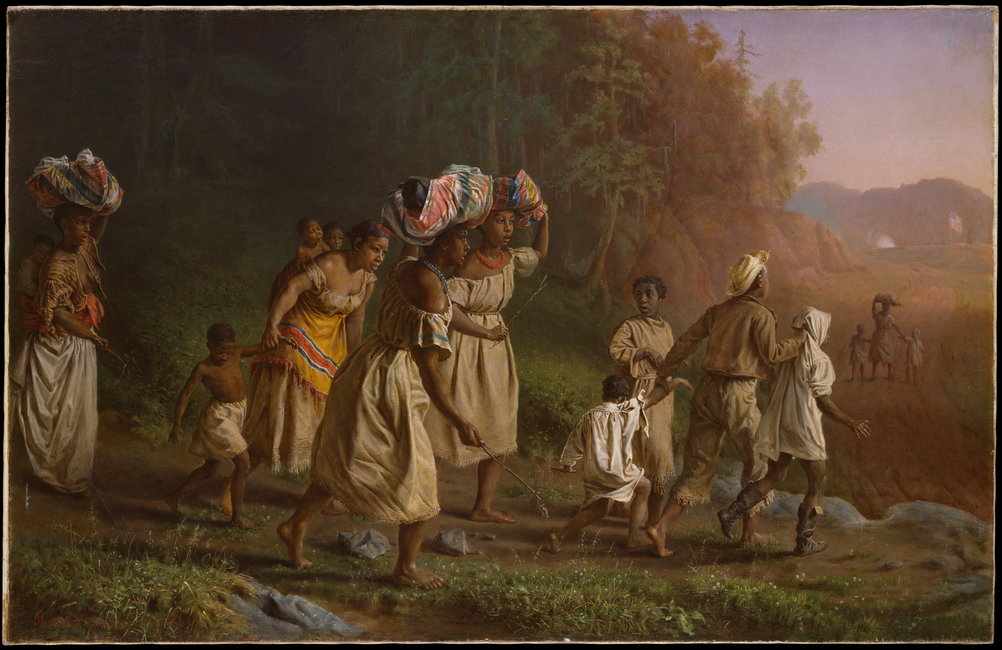
‘on to liberty’
(theorodr kaufmann, 1867)

Seminar 1: TerÇa- Feira, 20 de março, 10H-13H
who freed the slaves?

Readings:
James Oakes, “The Political Significance of Slave Resistance,” History Workshop Journal Vol. 22, No. 1 (Oct 1986), 89–107.

Ira Berlin, “Who Freed the Slaves? Emancipation and Its Meaning,” from Blight and Simpson, eds. Union and Emancipation: Essays on Politics and Race in the Civil War Era (1997), 105-122.

James McPherson, “Who Freed the Slaves,” Proceedings of the American Philosophical Society Vol. 139, No. 1 (Mar. 1995): 1-10.

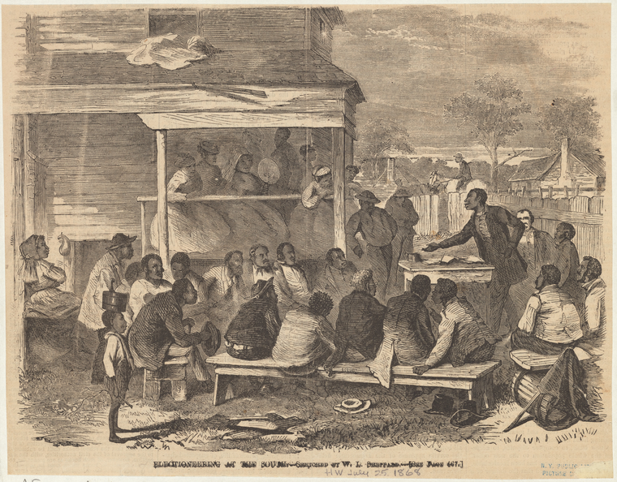
‘electioneering in the south’
(William L. Sheppard, 1868)

SeminAR 2: QUARTA-FEIRA 21 DE março, 10H-13H
‘Brief moment in the sun’: black mobilization after emancipation

Readings:
Michael Fitzgerald, “Land, Labor and the Loyal League” in The Union League Movement in the Deep South: Politics and Agricultural Change During Reconstruction (1989), 136-176.

Steven Hahn, “The Choked Voice of a Race at Last Unloosed,” in A Nation Under Our Feet: Black Political Struggles in the Rural South from Slavery to the Great Migration (2006), 62-115.

Susan E. O’Donovan, “Finding Freedom’s Edges,” in Becoming Free in the Cotton South (2007), 111-161.

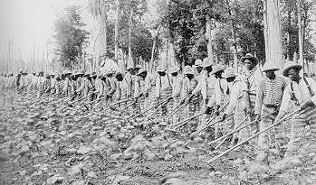
‘Prisoners working at the Mississippi State Penitentiary’, 1911

SeminAR 3: QUINTA-FEIRA, 22 DE março, 10H-13H
back toward slavery

Readings:
Eugene Genovese, “Re-examining Reconstruction, ” New York Times Book Review (4 May 1980)

Brian Kelly, “Jubilee and the Limits of African American Freedom after Emancipation,” Race and Class 57:3 (2016): 59-70.

Bess Beatty, “A Revolution Goes Backward: The Election of 1876 and the Hayes Administration,” in A Revolution Gone Backward: The Black Response to National Politics, 1876-1896 (1987), 1-30.

