INGLÊS INSTRUMENTAL/ CHAPTER 01/ Awareness raising

What is reading? 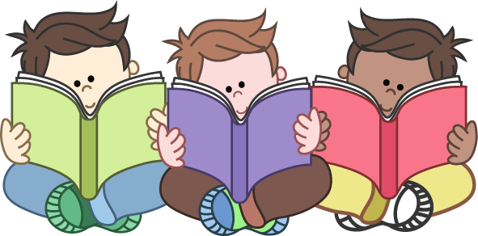
At the most basic level, reading is the recognition of words. From simple recognition of the individual letters and how these letters form a particular word to what each word means – not just on an individual level, but also as part of a text. In English, as in many other languages, different combinations of the same letters can be used to form different words with completely different meanings. So, the letters t c a can make both cat (an animal that goes miaow) and act (which has a number of meanings, from ‘do something’, to ‘behave in certain ways’, to ‘perform in a play or film’). Recognition of the actual word is not enough on its own to constitute reading.

Understanding what we are reading is key. It’s not much good if we simply stare at a text and say, ‘Well, I don’t understand it, but it looks nice!’ However, understanding a text is quite a complex issue and something that we will try and examine in the rest of this article.

Why do we read?
There are a number of reasons why we read, and this will often influence what we read and how we read it.
Sometimes we read quickly. We just want to get the general idea from a newspaper article, a report, or a book in a bookshop. Perhaps we want to know what it is about, or if it is interesting or important. We call this type of reading ‘skimming’.

We also read quickly to get a particular piece of information, such as a date, a telephone number, or the name of a restaurant. This is called ‘scanning’. We scan timetables, lists of names showing who has been accepted for a university, dictionaries, web pages.

We might read for pleasure. In this case, we will most likely be reading a book of some sort – maybe a novel, or perhaps a poem. We may also need to read a textbook, an article, or a report to understand everything. This is called ‘intensive reading’ or ‘study reading’. In this situation, we read slowly and check the meaning. We use our dictionaries a lot to help us. Perhaps we take notes and try to remember things. Sometimes we need to learn things by heart, like a mathematical equation.

We could also be reading the lyrics to a song, so our reasons for reading it may be slightly more complex than simply for pleasure. We could be reading it because we have heard the song but didn’t quite catch the words. Or perhaps our children are listening to it, but we are worried that some of the lyrics might not be suitable. Or perhaps we want to be able to sing along, so we’re trying to learn the words. Depending on our reason for reading the lyrics, we will need to use a different strategy. In other words, there are multiple reasons why someone might read a text. Why we are reading something will make a difference to how we read it and in what depth.

However, we must also bear in mind the purpose of the text from the writer’s point of view. Texts don’t exist in a vacuum; somebody wrote the text and they had a reason for doing so. It could be that the writer’s and the reader’s reasons are the same, or similar. But it is equally possible that the two have different purposes. The writer has a message they want to convey, and they encode this message in the words and style they choose. The reader then tries to decode the message by reading the same words.

