AULA 7 TIPOLOGIA FONOLÓGICA 2023 – NASAIS E LÍQUIDAS (MADDIESON 1984)

MOODLE

LÍNGUAS DO CURSO

Finlandês: 13C/8V = 1,625

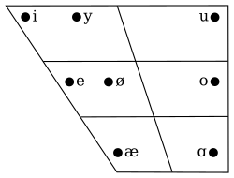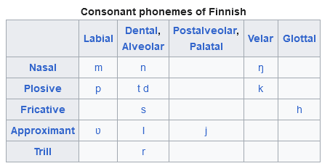

********************

Híndi: 38C/10V = 3,8 ou 38C/8V = 4,75
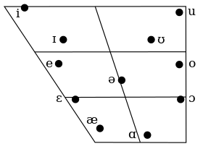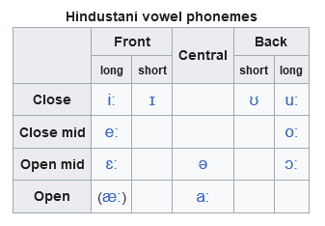
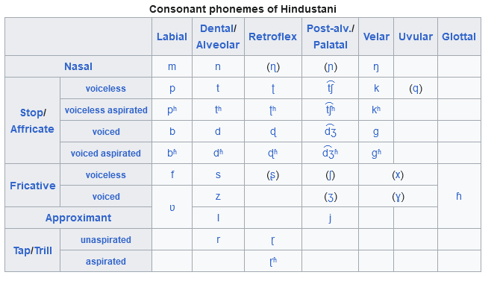

********************
Japonês: 17C/5V = 3,4
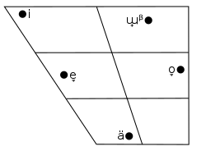
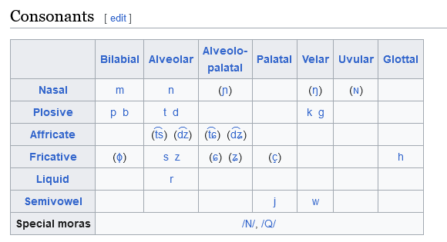

********************

Sueco: 18C/17V = 1,059 ou 18C/14V = 1,286
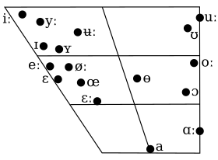
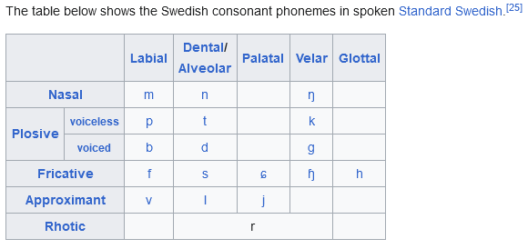

********************

Vietnamita: norte 21 C/9V = 2,33 e sul 23C/9V = 2,55
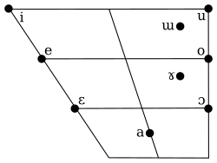
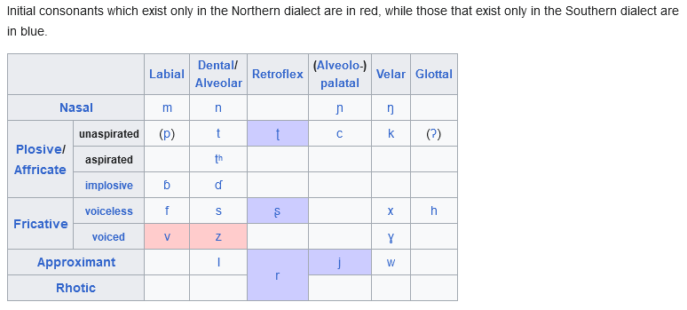

********************

Havaiano: 8C/5V = 1,6
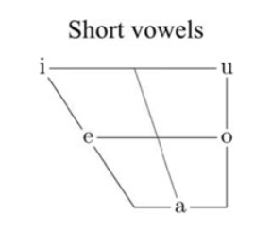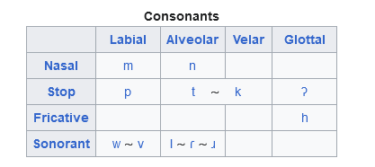

Capítulo 3 do WALS – 5 categorias:
- até 2,0: razão baixa
- acima de 2,0 e abaixo de 2,75: moderamente baixa
- de 2,75 até abaixo de 4,5: média
- acima de 4,5 e abaixo de 6,5: moderadamente alta
- de 6,5 ou mais: alta
Only 10 languages have ratios of 12 or higher.

********************

Nuxalk:
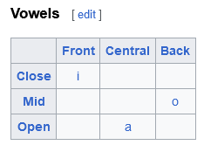
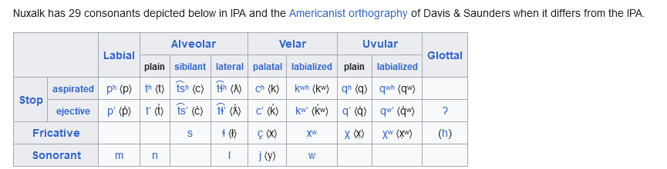

********************

ABKHAZ
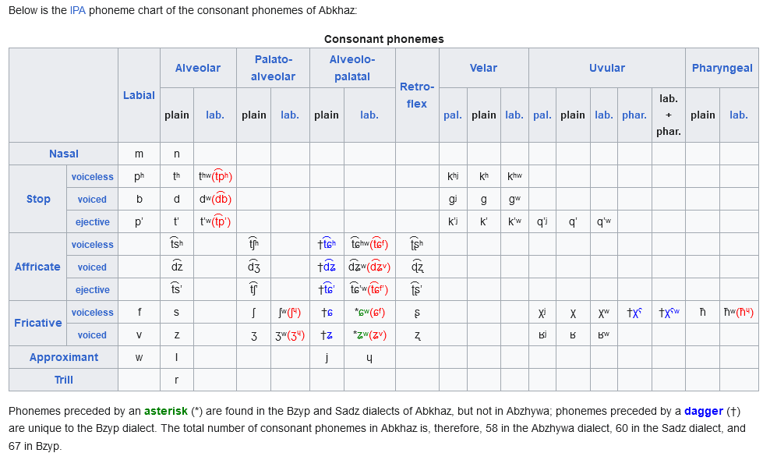

Chagas de Souza, Paulo; Silva, Bruno Pinto (2022). Tipologia e marcação das obstruintes latinas, com foco especial no vozeamento. Revista da ABRALIN XXI(1): 1-23.

MADDIESON CAP 6 (APROXIMANTES)

INTRODUÇÃO

- Approximants are consonantal sounds produced with a relatively unimpeded flow of air through the mouth. The constriction is not narrow enough to produce local turbulence, though cavity friction may be heard if the segment is voiceless (Catford 1977). Apart from those approximants which have a lateral escape or belong to the family of r-sounds, the only frequently-occurring approximants in the world's languages are those which have vocoid characteristics (Pike 1943). They are often known as "semi-vowels". This chapter examines the frequency of such sounds as phonemic units in the UPSID sample and discusses certain co-occurrence restrictions which relate to their role in phoneme inventories.
- In the UPSID file, vocoid approximants have been coded as consonants if they don't alternate with syllabic vocoid pronunciations and share distributional properties with other consonants. Over 90% of the surveyed languages have one or more such segments.

6.2 FREQUENCY OF VOCOID APPROXIMANTS

- The great majority of languages, 86.1%, have a voiced palatal approximant / j / or a closely similar segment, such as /ɪ̯/in Khasi (302).
- Substantially fewer languages, 75.7%, have a voiced labial-velar approximant /w/ or a closely similar segment. The frequency of these segments and their co-occurrence is shown in Table 6.1. The occurrence of /w/ is associated with the occurrence of /j/.
- From the independently calculated frequencies of /w/ and / j / , they would be expected to occur together in only 65.2% of the languages, not the 71.3% shown in Table 6.1. If these two segments were independently distributed, then there would be 31 or 32 languages in the survey with /w/ but no / j / , rather than the 14 actually found.
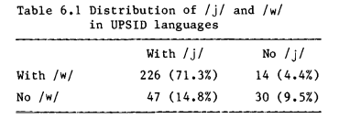

- In the UPSID data, therefore, the occurrence of /w/ usually implies the occurrence of /J/ in the same language.
- However, the association of /w/ and /j / is not as strong in UPSID as that found by Stephens and Justeson (1979) in the materials collected for the Stanford Phonology Archive. In these materials /w/ occurs without / j / in only 1% of the languages surveyed, as against over 4% in the UPSID languages.
- Stephens and Justeson also report substantially lower overall frequencies of both /w/ and /j /, with the percentage of languages having these segments about 15% lower in each case.
- It is not clear if these differences arise from the different selection of languages in the two surveys or from the application of different criteria for phonemic status of approximants.
- Nonetheless their claim that there is a statistically significant tendency for /w/ to occur only if /j/ also occurs is confirmed by our data (significance from χ² better than .001).
- Other vocoid approximants are comparatively rare. They may be divided into two groups - those which are modified variants of / j / and /w/ and those which have different places of articulation.
- Those in the second group include the labial-palatal approximant /ɥ/ (4 instances) and the velar approximant /ɣ̯/ (=/ɰ/) (5 instances).
의사 https://ko.forvo.com/search/%EC%9D%98%EC%82%AC/
μαγαζί https://en.bab.la/pronunciation/greek/%CE%BC%CE%B1%CE%B3%CE%B1%CE%B6%CE%AF

- These occur in less than 2% of the languages surveyed.
- They are not found in modified form in any of the UPSID languages. Palatal approximants occur voiceless, laryngealized and nasalized. Labial-velar approximants occur voiceless and laryngealized. The frequency of modified segments of these types is given in Table 6.2.
- Laryngealized approximants /j/ and /w/ occur with approximately equal frequency and are restricted to languages which have other glottalic or glottalized segments in their inventories and have plain voiced /j/ or /w/.
- Greenberg (1970) suggested that /j̰/ fills the place of an anticipated palatal implosive in languages with an implosive series and a palatal place of articulation.
- This issue is discussed in some detail in Chapter 7 where it is concluded that there does not seem to be support for it in the available data. A diachronic source of this kind for /j̰/ would predict that it would be more frequent than /w̰/, for which no parallel source is proposed. Only 5 of the 13 instances of /j̰/ in the survey occur in the kind of inventory that would appear to support Greenberg's suggestion. There is a much stronger association between the occurrence of /j̰/ and of /w̰/; in 12 cases /w̰/ and /j̰/ occur together. In other words, there is only one exception to the statement that the presence of /w̰/ implies the presence of /j̰/.
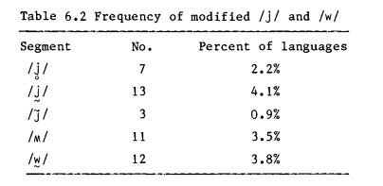

- The voiceless approximants /j̥/ and /ʍ/ differ fairly markedly in frequency, /ʍ/ being 1.7 times more frequent than /j̥/ .
- This is particularly surprising when considered in comparison to the relative frequency of their
voiced counterparts. The diachronic source of these voiceless segments is likely to be similar in both cases - documented instances seem to arise predominantly from a cluster of a voiceless obstruent and the voiced approximant, or from labialized or palatalized voiceless obstruents (which may be equivalent to a source in a cluster).
- Thus (one source of) /ʍ/ in Hupa (705) is from Proto-Athabaskan */ʃʷ/ (Huld 1980), Middle English /ʍ/ is derived from Old English /xʷ/, and */ʍ/ in early Northern Tai is derived from Proto-Tai */xʷ/ (Li 1977).
- They are likely to exit from inventories in a variety of ways, including vocalization (as in the widespread merger of */ʍ/ with /w/ in many varieties of Modern English), collapse into an undifferentiated voiceless vowel phoneme /h/ (as in the special development of */ʍ/ in English before /u/ and /o/ in words such as "who", "whoop", "whole"), or fricativization (as in the idiolectal /ç/ for the initial segments /hj/ = [j̥j] in English words such as "huge", "human" etc.; compare the change of earlier German /w/ into / v / ) .
- The relative frequency of /j̥/ and /ʍ/ suggests that there may be some factor which favors the development of /ʍ/ over /j̥/ or favors the loss of /j̥/ more than /ʍ/.
- It is probably the case that a true voiceless palatal approximant is poorly distinguishable from /h/, which occurs in most languages, and hence is likely to collapse together with it. If, on the other hand, /j̥/ is articulated more forcefully to preserve the distinction it would become a palatal fricative.
- A voiceless labial-velar approximant may survive better because its two strictures produce two cavities with resonances which are rather close to each other in frequency and hence reinforce each other (cf. Ohala and Lorentz 1977).

- Em frísio, ocorre uma alternância fonológica entre dois tipos de ditongos denominada breking, mais conhecido com a grafia inglesa breaking na literatura fonológica. Esse processo é sujeito a uma série de fatores que influenciam sua ocorrência ou não, entre os quais se incluem fatores morfológicos, fonológicos e extralinguísticos. Observe os dados abaixo e verifique qual a diferença entre as formas da primeira e as da segunda coluna. Que tipo de ditongo ocorre em cada coluna? Como pode ser analisado o processo em termos métricos? Qual a relação entre a morfologia e a fonologia?

doar [ˈdoə̯r] ‘porta’ doarren ‘portas’ [ˈdwarən]
doarke ‘portinha’ [ˈdwarkə]
foet [ˈfuə̯t] ‘pé’ fuotten ‘pé’ [ˈfwotən]
fuotsje ‘pezinho’ [ˈfwotsjə]
beam [ˈbɪə̯m] ‘árvore’ beammen ‘árvores’ [ˈbjɛmən]
beamke ‘arvorezinha’ [ˈbjɛmkə]
beammich ‘wooded [ˈbɪə̯m] [ˈbjɛməx]
jier ‘ano’ [ˈjiə̯r] jierdei ‘aniversário’ [ˈjɪdi]/ [ˈjɪdjə]
jierrich ‘idoso’ [ˈjɪrəx]
priem ‘agulha de tricô’[ˈpriə̯m] priemsk ‘sharp’ [ˈprjɪmsk]
foar ‘antes’ [ˈfoə̯r] foarlik ‘prematuro’ [ˈfwalək]
Ie [ˈiə̯] ‘nome de uma vila’ Iester ‘morador de Ie’ [ˈjɪstər]
hier [ˈhiə̯r] ‘cabelo’ hierren ‘cabelos’ [ˈ(h)jɪrən]
hierke ‘cabelinho’ [ˈ(h)jɪrkə]
heak ‘gancho’ [ˈhɪə̯k] heakje ‘to hook’ [ˈ(h)jɛkjə]

6.3 APPROXIMANTS AND RELATED VOWELS

- The approximants / j / and /w/ are closely related to the high vowels /i/ and /u/ respectively.
- The vast majority of languages have both these vowels, but there are more cases in which /u/ is missing than /i/ - in fact, /u/ is the most frequently missing of the major peripheral vowels (see chapters 8 and 9 ) .
- The greater frequency of /i/ is undoubtedly a predictor of the greater frequency of / j / . However, for both / j / and /w/ there are a few languages which have the approximant but lack the corresponding vowel. The numbers are given in Table 6.3.
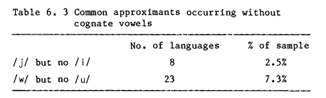

- There are about 3 times as many cases of /w/ occurring without /u/ as of / j / occurring without /i/.
- Disner in Chapter 9 suggests that the systems without /u/ may be regarded as falling into two principal classes: those with a "compensating" vowel which is high or back or rounded but not all three (such as /ɨ/ /ɯ/ /ʉ/ etc) and those which simply have a gap (and whose highest back vowel is usually / o / ).
- This is suggestive of a variety of possible sources for /w/ and may predict that the class of /w/ segments in languages may vary phonetically through a greater range than /j/ .
- The less frequently occurring approximants /ɥ/ and /ɣ̯/ (=/ɰ/) were also investigated in relation to the corresponding vowels, in this case /y/ and /w/ respectively.
- The numbers are given in Table 6.4. These suggest that /ɥ/ is most likely to occur if /y/ also occurs in the inventory, but that there is no such dependence of /ɣ̯/ on the occurrence of /ɯ/. However since these numbers are so small no great reliance should be placed on these indications.
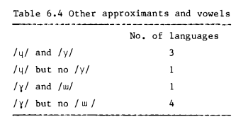

6.4 APPROXIMANTS AND RELATED CONSONANTS

/ j / and palatalized consonants
- True palatalized consonants, that is, ones with a palatal secondary articulation usually perceptible because of a /j/-like offglide, occur in about 10% of the languages in the survey. Since desyllabification of high vowels is a major process creating both /j/ and palatalized consonants, it might be expected that palatalized consonants would occur only in languages with /j/ (cf. Bhat 1978).
- There are, however, 3 languages in the survey which have palatalized consonants but no /j/-phoneme. This is exactly the number that would be predicted if there was no association between these 2 classes of sounds.
- Of these 3, Ocaina (805) seems straightforward, but Muinane (806) has a voiced palatal fricative /ʝ/ with [j] as an allophone, and Ket (906) also has /ʝ/, albeit largely restricted to intervocalic positions.
- Thus a generalization stating that palatalized consonants occur in inventories containing /j/ or /ʝ/ would have only one exception.

/w/, labial-velar stops and labialized velars

- As /w/ has two strictures of equal rank it falls into a class with other labial-velar consonants, especially /k͡p/ and /g͡b/ which are the most common labial-velar consonants after /w/. These labial-velar stops may vary a good deal in their initiation (Ladefoged 1968) but belong together by virtue of their shared place of articulation. The co-occurrences between /w/ and /k͡p, g͡b/ are shown in Table 6.5 below:
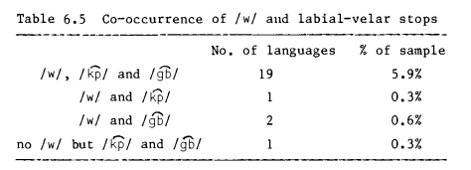

- An assumption that there is no relation betweeen the occurrence of /w/ and /k͡p/ or /g͡b/ predicts that we should expect 16 cases of /w/ with /k͡p/ (20 actual) and 16 or 17 cases of /w/ with /g͡b/ (21 actual). The observed numbers suggest that there is a tendency for /k͡p/, /g͡b/ to occur in systems with /w/ in preference to those lacking /w/. The one exception, Kpelle (103), is also unusual in another way that is described below.
- There is an obvious similarity between labialized consonants and /w/, and there is a historically similar source for both types of sounds in desyllabification of /u/ in many instances. We might therefore expect labialized consonants to occur preferentially in languages which have /w/.
- By far the most frequent labialized consonant types are labialized velar stops (cf. Ohala and Lorentz 1977). We will therefore use them as archetypes of labialized consonants. The co-occurrences of /w/ with /kʷ/ are shown in Table 6.6 (/gʷ/ only occurs if /kw/ occurs, so is not separately listed).
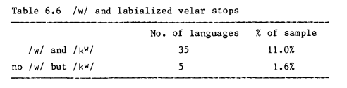
- Random co-occurrence of /w/ and /kʷ/ would predict that there would be 30 languages in the sample which contained both of these segments.
- The observed number (35) suggests that there is a weak tendency for /kʷ/ to be more likely to occur in languages which have /w/.
- The exceptions to the trend in UPSID are Mixtec (728), Guarani (828), Wantoat (615), Chipewyan (703), and Kpelle (103).
- In Chipewyan the labialized velars have a rather marginally contrastive status, since they are largely restricted to occurrence before back rounded vowels where plain velars do not occur. Kpelle is unusual in being the only language in the survey which has both labial-velar and labialized velar stops; and it also lacks /w/!

6.5 Other approximants

- In addition to the 4 most common approximants /j , w, ɥ, ɰ/ discussed above, it may be noted that 6 languages (1.9%) have a bilabial approximant /β̯/ (=/ʋ/) and 6 have a labio-dental approximant /W/. The remaining approximants in UPSID are classified as liquids and are discussed in Chapter 5.

6.6 Summary

- Most languages have /j/ and /w/, with /j/ being more frequent. There is a strong tendency for the presence of /w/ to imply the presence of /j/ in the same language.
- The greater frequency of /j/ is parallel to the greater frequency of / i/ than /u/, but these facts are not directly related since /j/ may occur without / i/ and /w/ without /u/.
- Modified varieties of /j/ and /w/ only occur in languages with the plain voiced counterparts. There is some association between the occurrence of palatalized consonants and /j/ and between labial-velar stops and labialized velars (and other labialized consonants) and /w/.

MADDIESON CAPS. 7 (CONSOANTES GLOTAIS E OUTROS SEGMENTOS GLOTALIZADOS)

GREENBERG (1970)

- "injectives [i.e. implosives] tend to have front articulation, ejectives to have back articulation". Greenberg acknowledges that these conclusions were partly anticipated by Haudricourt (1950) and independently discovered by Wang (1968).
- Our goal is to determine whether these place of articulation preference hierarchies for implosives and ejectives can be substantiated and to discover other distributional patterns relating to glottalic and glottalized segments in the UPSID data. The possible phonetic motivations for the patterns found will also be discussed.
- https://dlc.hypotheses.org/507 (ejetivas e altitude)

7.2 SONS GLOTÁLICOS E LARINGALIZADOS

- sounds which are the subject of this chapter. They are any segments produced with the glottalic airstream mechanism (i.e. ejectives and es) as well as "glottalized" segments where the glottal constriction does not serve as the airstream initiator (i.e. preglottalized and laryngealized consonants). Only those sounds articulated using the glottalic airstream mechanism will be referred to as glottalic. Pulmonic or velaric "glottalized" sounds will generally be referred to as laryngealized.
- Ejectives are those sounds produced by raising the larynx with the glottis closed; with a constriction in the oral cavity, air is compressed in the space enclosed between the oral constriction and the glottal closure. The oral occlusion or constriction is subsequently released with outward airflow. Implosives, on the other hand, are articulated by lowering of the larynx.
- In an idealized case, air enclosed between an oral occlusion and the laryngeal constriction is rarefied, and air flows in through the mouth when the oral closure is released. However, the glottis is usually not closed, but rather the vocal folds are allowed to vibrate through leakage of pulmonic air into the oral cavity (see Catford 1939). Thus ejectives tend to be unvoiced while implosives tend to be voiced.
- Moreover, as noted by Ladefoged (1968), Pinkerton (1980) and others, "implosives" do not always entail inward oral air flow upon release even when the larynx lowering gesture is present. The distinction between truly imploded consonants and those which are preglottalized or laryngealized with minimal or zero implosion has been difficult to maintain in UPSID.
- These sounds are frequently not distinguished in the literature, but where the airstream initiator of the most typical allophone is known to be or may be other than glottalic, the sound is classified in UPSID as laryngealized.
- As both Ladefoged (1968) and Greenberg (1970) conclude, the potential phonological contrast of these differing types is not realized in any of the languages known to them directly or through the literature (nor in any included in UPSID).
- ver fim 99 e começo 100
- as ejetivas são as mais difundidas do capítulo
- embora ocorram em várias das principais línguas do mundo, são mais abundantes nas Américas
- Two thirds (35 of 52) of the languages with ejectives in UPSID are in the Amerindian family - and most (30) of these are from North America. Almost 60% of the 51 Northern Amerindian languages in UPSID contain ejective systems. Only 4 of these languages also exhibit implosives or voiced laryngealized plosives.
- isso já havia sido comentado, mas um banco de dados como o UPSID deixa isso mais claro
- Nine of the remaining languages with ejectives are in the Afro-Asiatic family, 3 are Nilo-Saharan, 3 are Caucasian, and there is one in each of the Indo-European, Niger-Kordofanian and Khoisan families. Ejectives are not known to occur outside of these major language families, although it is quite likely that they may occur in the Austro-Asiatic and/or Austro-Tai families, since voiced "glottalized" stops (implosive, preglottalized or laryngealized) are found there (e.g. in Vietnamese, 303; Sedang, 304; and Sui, 403).
- OSSETA, ARMÊNIO
- As Greenberg (1970:2) notes, "the typical ejective obstruent is unvoiced". We find no exceptions to this in the languages surveyed, although phoneticians of the caliber of Catford and Pike have suggested that voiced ejectives are possible speech sounds. However, pre-voiced ejectives are reported in one language in the survey, !Xu (918). This language has the most complex consonantal system of.any of the languages in UPSID, including six series of stops apart from 48 click consonants. One of the stop series is described as consisting of voiced ejectives by Snyman
(1969), but his description sounds as if there is necessarily a phonetic sequence of voicing preceding ejection in these segments. He says: ...
- In "normal" ejectives, the available evidence shows that voicing begins very promptly on release of the glottal closure. Lindau (1982) shows this for ejective stops in Hausa and Navaho.
- haussá + navajo
- 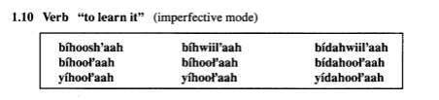
- Implosives and their close relatives, voiced laryngealized plosives, are found in fewer of the major language families and are more limited geographically than ejectives. Most such systems (29 of 41) are to be found on the African continent. The distribution of implosives thus also has a strong areal concentration, but it is one which cuts across 3 major language families, Niger-Kordofanian (10 languages), Nilo-Saharan (10 languages), and Afro-Asiatic (9 languages). The largest number among the remaining languages are Amerindian languages (6), but there are a few languages from Austro-Asiatic (3), Austro-Tai (3), and Sino-Tibetan (1).
- Laryngealized sonorants (nasals, liquids, and central approximants) are found in most language families mentioned above but not elsewhere. They too are most common in Amerindian languages.

7.3 EJETIVAS

- Of the 317 languages in UPSID, 52 contain ejectives, making ejectives the most common of the glottalic or laryngealized segments. Twelve of these languages also exhibit implosive stops and 15 also exhibit some laryngealized stops, fricatives, sonorants, and/or vowels.
- The most frequently occurring type of ejective is an ejective stop; there are twice as many ejective stops as ejective affricates in the data file - 188 to 94. Ejective fricatives are considerably rarer; only 20 are recorded in UPSID. Naturally, ejective stops have been the topic of more discussion than the other types of ejectives.
- Ejective stops Haudricourt (1950) suggested that ejective stops exhibit a strong preference for back articulations, Greenberg (1970) supported this claim mainly because he found that "a gap in the class of ejectives at the bilabial point of articulation is found in a number of world areas". Javkin (1977) made the implied hierarchy for ejective stops more explicit, formulating it as follows: "...[a language] will only have labial ejectives
if it has alveolar and velar; it will only have alveolar if it has velar."

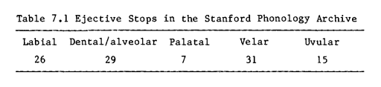

- There are relatively small differences in the numbers of ejectives reported at the 3 major places of articulation, but Javkin notes that the implicational hierarchy he has set up holds within the languages concerned. Javkin further notes that palatals and uvulars do not maintain the tendency
to prefer a further back articulation over a further front one "since these places of articulation tend to disfavor stops". Indeed, as Javkin suggests, the relative disfavoring of palatals and uvulars is not restricted to glottalic consonants (see chapter 2 in this volume for details concerning non-glottalic stop distributions and Gamkrelidze 1978).
- The frequency count of ejective stops in UPSID is given in Table 7.2.
- Plain velar ejective stops are no more frequent than plain dental or alveolar ones, there being 49 instances of each.
- However, because there are 3 languages (Nez Perce, 706, Porno, 742, Wappo, 760) with both a dental and an alveolar ejective stop and one language (Kwakw'ala, 731) with no plain velar but with a labialized velar, there are four more languages with an ejective stop at the velar place than languages with one at the dental and alveolar places considered together (50 vs. 46).
- One language, Hupa (705), has /*t’/ but no /k'/ (it does have /q'/ ). A tendency to prefer velar place for ejective stops can be seen in the fact that presence of /*t’/ implies the presence of /k'/; it is significant that the 5 languages which have only one place of articulation for their ejective stops all have velars.

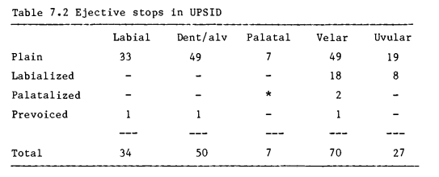
- What is far more salient is that both velar and dental/alveolar places are preferred to bilabial. There are significantly fewer occurrences of /p’/ than of either /k’/ or /*t’/.
- No language has /p'/ that does not have a velar, whereas 17 languages have /k'/ but no /p'/. Of the 11 languages with only two places of articulation for their ejective stops, 10 have /*t3, kV (the exceptional case is Berta, 218, with /p', k5/).
- Thus the UPSID sample shows principally that bilabial place is disfavored for ejective stops. This is reminiscent of the findings with respect to voiceless plosives, which are also disfavored at the bilabial place, although there is some evidence that the tendency to avoid /p1/ is stronger than the tendency to avoid /p/.
- This raises the question of whether both of these patterns should be explained in the same way. This question will be taken up again below.
- Uvular ejectives are relatively common. We may show this by comparing the ratio of uvular ejective stops to velar ejective stops, .39, with the ratio of plain voiceless uvular plosives to voiceless velar plosives, which is only .13.
- Their frequency is largely the result of the coincidence of two areal tendencies, use of the uvular place of articulation, and presence of ejectives, in North American languages. Of course, uvular ejectives are also consistent with a preference for back places for ejectives. The frequency of palatal ejective stops, on the other hand, is not disproportionate but is comparable to the proportion of plosives at the palatal place.
- Only one type of secondary articulation is at all frequent with ejective stops, and that is labialization with velar or uvular ejectives. More will be said about secondary articulation below.

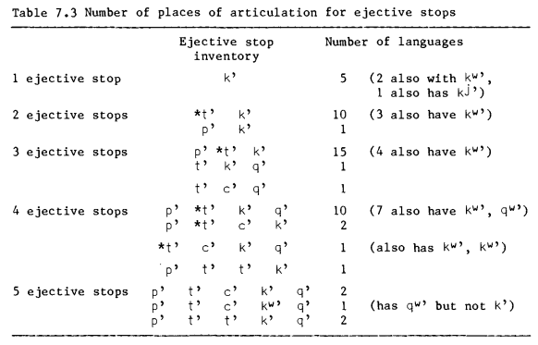
- Table 7.3 shows that the most commonly encountered set of ejective stops contains one at each of the most common places at which stops of any kind occur (bilabial, dental or alveolar, and velar).
- Frequently, these are the same places at which the language has other types of stops (glottal place is not considered in these cases). An example of this pattern is the stop system of Eastern Armenian (022):
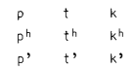
- Tzeltal (712), whose stop system is as follows (v. Lisker & Abramson 1964):
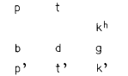

- The only other reasonably common ejective stop systems are those containing either 2 ejective stops - dental or alveolar and velar - or 4 ejective stops - labial, dental or alveolar, velar, and uvular.
- Typical of one type of ejective stop system with only 2 places of articulation is Itonama (800) whose stop inventory is as follows:
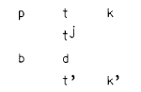
- If there are 4 or 5 ejective stops, there is usually one at the uvular place: this is so for 16 of the 19 languages concerned. Again, there are usually stops in other series at the same places of articulation. Quileute (732) is representative of stop systems with 4 ejective stops:

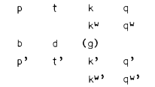
- All the languages with ejective stops at 5 places of articulation include those stops found in the common 4-place inventory. An example is Jaqaru (820):

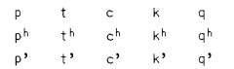

- Thus an inventory of ejective stops is usually built up this way: if there is one, it is velar; a second ejective is dental or alveolar; a third is bilabial; a fourth is uvular. A small minority of languages deviate from this pattern but the great majority conform (45 out of 52).

- A few of the languages which are exceptions to this pattern suggest that it may sometimes be appropriate to recognize a single series of "glottalic" stops whose members may be phonetically diverse.
- An example is K'ekchi (714), which has three ejective stops at alveolar, velar and uvular places. It lacks a bilabial ejective, but has a laryngealized voiced bilabial stop. There are no other members of a voiced laryngealized series. Hence there is one "glottalic" consonant corresponding in place to each of the plain voiceless plosives. The K'ekchi stop inventory is:
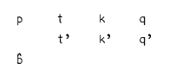

- The comparative background to this situation in K'ekchi has been investigated by Pinkerton (1980), who examined the phonetic nature of corresponding segments in K'ekchi and 4 other languages in the Quichean group of Mayan languages. Among these 5 languages, ejectives, voiced and voiceless implosives, and voiced laryngealized stops interchange (and, for the bilabials only, even plain voiced stops are involved). The correspondences are shown in Table 7.4.
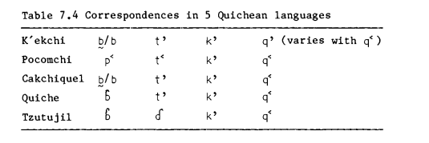
- Another exceptional language is Berta (218), a language with 2 ejective stops, one bilabial and the other velar:
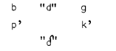
- The general pattern leads us to expect a dental/alveolar ejective. This dental/alveolar slot is filled by a glottalic consonant, but it is a voiced implosive, and this implosive stands alone in Berta. Thus the "deficient" ejective series and the isolated alveolar implosive between them create a full series of glottalic stops, with a counterpart to the plain voiced stops of the language at each place.
- Among other languages which could be analyzed as having a single series of "glottalic" stops even though they are phonetically heterogeneous are Ik (208) and Hausa (266). In the case of Hausa, Carnochan (1951) has pointed to phonotactic constraints that apply to all consonants with a "glottalic" component (including / ʔ/ ).
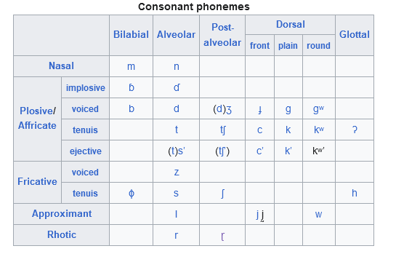

- A second class of exceptions is illustrated by Hupa (705), which seems at first glance particularly deviant in having 3 ejective stops but neither a velar nor a bilabial. Hupa is the only language with /c’/ and /q’/ that does not also have /p’/ and /*t'/ in its inventory.
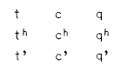

- In this language the ejective stop system shares the same unusual places of articulation as the voiceless plain and the voiceless aspirated stop series. If Hupa had the "normal" bilabial, alveolar and velar ejectives, it would be an exception to the general rule that languages have stops of different series at the same places of articulation (see Chapter 2). Specifically, this means that ejectives should be expected to occur only at places where non-glottalic stops occur.
- Thus, although there is a hierarchy of preferences for place of articulation for ejectives, it is outranked by the rule governing the relationship between places for plain stops and ejectives. In other words, as Fordyce (1980) stressed, phonological hierarchies may themselves be hierarchically arranged. Because Hupa conforms to the more important rule, it comes to violate the place hierarchy for ejectives considered by itself.
- The importance of the connection between these rules can also be appreciated from an examination of Haida (700). For a language with 4 ejective stops, Haida has an unusual set - dental, palatal, velar, and uvular. It does not have an ejective at the bilabial place, although it does have plain voiceless and aspirated stops which are bilabial. However, there is no sense in which the palatal ejective stop has supplanted the more usual bilabial one. The palatal is not unexpected because Haida is conforming to the rule that ejective stops occur where there are also plain stops. Palatal ejectives are not common largely because palatal stops in general are not common. As noted above, this language constitutes part of the evidence for the conclusion that bilabial ejective stops are disfavored over dental/alveolar or velar ones.
- Haida stop inventory:
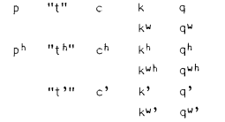

- The Wappo (760) system of 4 ejective stops, although it lacks a uvular one, is not an exception to the ejective place of articulation hierarchy. It contains an unusual contrast between dental and alveolar ejective stops, but the same place contrast is also found among the plain voiceless stops. Here again the occurrence of an unusual ejective series can be attributed to the precedence established by the plain stop series in the language.
- Two of the languages with 5 ejective stops, Nez Perce (706) and Pomo (742), also have both dental and alveolar stops, but there is no violation of the place of articulation preference hierarchy for ejective stops, which does not specify what a fifth member should be.
- The ejectives match the places of articulation found for the voiceless plosives in both of these languages, with the exception of Nez Perce /q’/ which appears despite the absence of /q/.
- The uvular place of articulation in Nez Perce is, however, represented by the affricate /qχ/, whereas there are no palatal or palato-alveolar obstruents of any kind. Given the rest of the Nez Perce system, an ejective at the uvular place of articulation is quite natural – certainly more so than a palatal one, for example.
- On the other hand, the 4-ejective stop systems of Kefa (264) and Maidu (708) contain palatal ejectives rather than the more common uvular ejectives. However, these languages lack any stops in the uvular position:
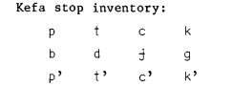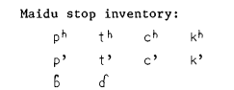

- The Maidu case is interesting since the plosives whose places of articulation are matched are aspirated ones rather than the voiceless unaspirated ones found in the other languages discussed here. Thus we may state more generally that an ejective usually occurs only if a plosive occurs at the same place. This rule is not limited to a particular type of plosives.

EJECTIVE AFFRICATES AND FRICATIVES

- Ejective affricates and fricatives have more limited occurrence than ejective stops. Forty languages in UPSID (12.6%) contain ejective affricates. In all but one of these languages, ejective stops occur as well. The exception is Iraqw (260) which does, however, have implosives. Thus ejective affricates occur only in those systems containing glottalic stops (almost exclusively ejectives). The most commonly occurring ejective affricates are the sibilants /*ts'/ and /tj'/ and the lateral affricate /*t4'/. The figures are given in Table 7.5.
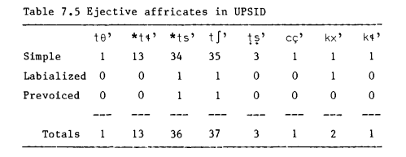

- Every language with any ejective affricates has at least one of the common sibilant types, /*ts'/ and /tʃ'/.
- Seven languages have only /tʃ'/, 5 have only /*ts5/, and 11 have both /*ts'/ and /tj'/ but no other ejective affricates.
- The remainder contain one or both of these sibilant ejective affricates plus one other, most frequently the lateral /*tɬ'/. Concerning /tʃ'/, Greenberg (1970: 17) commented that "for the palatal region in particular, it appears that the optimal ejective is the alveopalatal [affricate] rather than a stop".
- He goes on to observe that among non-glottalic obstruents, affricates are preferred over plosives in this articulatory region, and adds that the preference for affricates is even stronger in the case of ejective obstruents.
- In fact, Greenberg found "no example of an ejective palatal stop" in his sample. However, they not only do occur, but occur with a contrasting affricate. Of the 7 languages in UPSID with a palatal ejective stop, 5 also have a palato-alveolar or palatal ejective affricate.
- Nonetheless, Greenberg's observation may have some validity. While there are 5 times as many languages with /tʃ'/ than with /c'/, among the plain pulmonic obstruents there are only 3.4 times as many occurrences of /tʃ/ as /c/.
- With regard to ejective fricatives, Greenberg noted that they are "relatively infrequent and always imply the presence of some ejectives with abrupt onset".
- In the UPSID languages, ejective fricatives imply ejective stops without exception. Most commonly they imply ejective affricates as well, but exceptions do occur. Ten UPSID languages contain ejective fricatives (3.2%); only 3 of these do not contain ejective affricates. The ejective fricatives reported in the survey are given in Table 7.6.
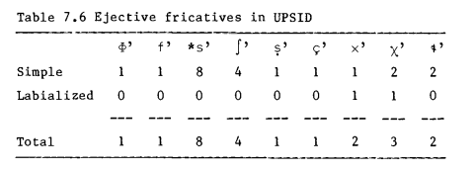

- Only /s’/ and /ʃ'/ occur in systems not containing ejective affricates. They are also the only ejective fricatives which occur without other ejective fricatives in the same language. Note that, among pulmonic fricatives, /f/ is almost as frequent as /ʃ/, but the ejective /f'/ is quite rare. Again, a labial place appears disfavored for an ejective.

SECONDARY ARTICULATIONS WITH EJECTIVES [110]

- Labialization is the only secondary articulation which is at all common with ejective segments. It occurs most often with ejective stops: 18 languages in the survey have labialized ejective stops.
- Among the stops it only occurs with velars and uvulars (see Tables 7.2 and 7.3).
- Labialized uvulars only occur if there is a labialized velar in the language, but both these types are unusually common. Well over a third of the languages with plain velar or uvular ejective stops also have their labialized counterparts.
- Compare this with the fact that only about 13% of the languages with the plosive /k/ have the labialized counterpart /kw/.
- The apparent increase in labialization for velars and uvulars is probably due to areal factors. Most labialized ejective stops are in North American languages, where distinctive labialization of velars and uvulars frequently applies to several manners of consonants in the same language.
- Except for Kwakw'ala (731), with /kw'/ but no /k'/, these labialized ejectives never occur unless the plain counterpart also appears. In addition to /kw'/, Hausa (266) has a palatalized velar ejective stop. Labialization also occurs occasionally with certain ejective affricates and fricatives. The only occurrences of labialized ejective affricates are in Lak (912), which has /tsw'/ and /tju'/. The only labialized ejective fricatives are those found in Tlingit (701), which has /xw'/ and /xw'/.

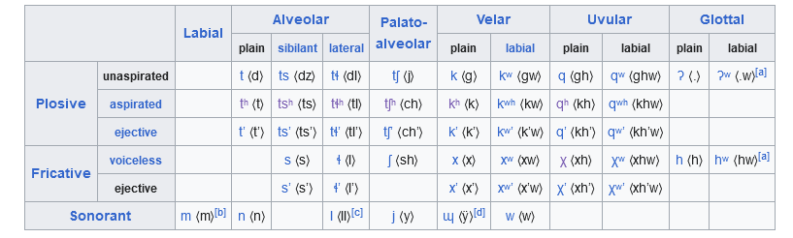

7.4 VOICELESS LARYNGEALIZED SEGMENTS

- Voiceless laryngealized segments are somewhat related to ejectives.
- They have a glottal stricture simultaneous with the oral stricture, but this is not used as initiator of an airstream.
- Three languages in the survey have a set of voiceless laryngealized segments, Korean (070), Ashuslay (814), and Siona (833). The first two have /p̰ t̰ k̰ t̰ʃ/ in common. Hausa (266) has the voiceless laryngealized fricative /s̰/, which also occurs in both Korean and Siona.
- This set of segments in Korean, usually called "fortis" or "tense" obstruents, has been quite extensively studied, and several studies agree that they are produced with a narrow glottal aperture (e.g. Kim 1970), although there is also evidence that there is accompanying tension in the supraglottal structures (Kim 1965; Dart 1984).
- Hausa speakers vary considerably in their production of /s̰/. This segment is sometimes pronounced as an ejective fricative and it may also occur as an ejective affricate [ts’], as well as occurring as a pulmonic fricative with a glottal constriction.
- No other voiceless laryngealized fricative is reported, although S. Nambiquara (816) has a rather obscure segment which is described as a laryngealized /h/.

7.5 Implosives and voiced laryngealized plosives

- As noted earlier, the only kind of glottalic ingressive segments reported are stops, that is, implosives.
- Thirty-two (10.1%) of the languages of the UPSID contain implosives.
- They are all voiced apart from the two segments /p</ and /t</ in Igbo (116).
- There are a further 10 languages which have voiced laryngealized plosives, making a total of 42 (13.2%). Since voiced implosives and voiced laryngealized plosives have often been discussed together, have not always been distinguished, and do not contrast we will discuss them together in this section.
- We will use the notation /ʔb/ to represent both /b/ and /ɓ/, etc., including when quoting from other authors.

VIETNAMITA (início e 0:30)
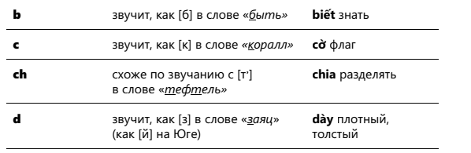

DO MEU CAP 5

De acordo com Ashby (2011: 73-74), as etapas na produção das implosivas são:
- no início, com a passagem para a cavidade nasal fechada, há uma corrente egressiva pulmonar. Forma-se, então, uma oclusão na cavidade oral.
- ao mesmo tempo, a laringe se abaixa, aumentando o volume da cavidade faringal.
- esse aumento de volume pode causar uma diminuição da pressão intraoral.
- ao final, a oclusão da cavidade oral é desfeita e a pressão intraoral e pressão ambiente se igualam.

Essa descrição não corresponde exatamente à definição dada logo antes do início da seção ‎2.6.1.1. Como apontam Clements e Osu (2002: 307), o abaixamento da laringe e outras estratégias usadas para manter o vozeamento não são exclusividade das implosivas. As oclusivas sonoras também apresentam essas características. Na página 308, Clements afirma que nem o fechamento da glote, nem o fluxo ingressivo de ar, nem a pressão do ar negativa (rarefação), nem o abaixamento da laringe são critérios que distinguem claramente as implosivas das oclusivas sonoras. Embora tradicionalmente se pensasse que nas implosivas há fluxo ingressivo de ar e pressão do ar negativa (rarefação), nenhuma das duas necessariamente ocorre. Como há vibração das pregas vocais, também não há fechamento da glote. Clements defende, então, que o que distingue as implosivas das oclusivas é que nas primeiras não há aumento da pressão do ar na cavidade oral. Pode haver diminuição ou não, mas não há aumento.

- Greenberg (1970) used the term "injective" to cover both these segment types. Following Haudricourt (1950) and Wang (1968), he noted that "injectives tend to have front articulation". He goes on to suggest that
ɓɗʄɠʛ
if a language has one injective, it is /ɓ/; if two, they are /ʔb/ and /ʔd/ (the most common pattern); if three, they are /ʔb/, /ʔd/, and /ʔɟ/ (the latter a palatal stop, often replaced, however, by [the laryngealized approximant] /]/) ; and, if four, they are /ʔb/,
/ʔd/, /ʔɟ/ and /ʔg/.

- The general preference for front articulations was borne out in a count of the Stanford Phonology Archive by Javkin (1977).
- Table 7.7 gives the count of voiced implosives and voiced laryngealized plosives in the languages of UPSID, which shows a similar pattern for these stops at the different places of articulation.
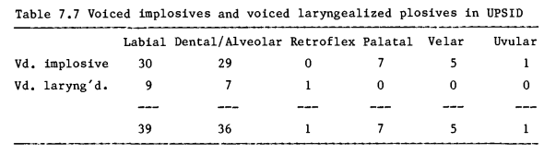
- These counts suggest that a correction might need to be made to the implicational hierarchy posited by Greenberg. In fact he notes himself that "there are a few languages whose sole injective is /ʔd/". The fact that /ʔb/ and /ʔd/ are essentially equally frequent, and that either may occur as the sole implosive in an inventory suggests that the hierarchy is blind to the distinction between labial and alveolar implosives.

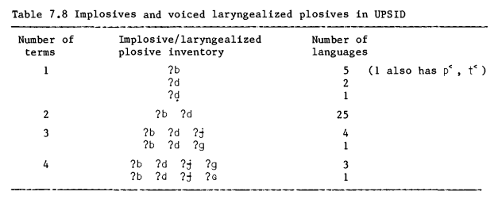
- Of the languages with only one of this class of segments, 5 have /ʔb/ (Kpelle, 103, Igbo, 116, and Zulu, 126, have /ɓ/; Lakkia, 401, and K'ekchi, 714, have /b̰/ ). Berta (218) and Kullo (262) have /J7 alone. Somali (258) has /ɖ̰/.
- The number of cases is small, so any interpretation of the results should be cautious. However, the systems with a single term here are varied, unlike ejective stops where a single term is always /k'/.
- The suggested revision of the hierarchical relationships of place in this case would go as follows: the presence of /ʔb/ implies the presence of /ʔd/ or of no other implosives, /ʔd/ implies the presence of /ʔb/ or of no other implosives, while /ʔɟ/ implies the presence of both /ʔb/ and /ʔd/, and /ʔg/ implies the presence of /ʔb/, /ʔd/, and /ʔɟ/.
- As Greenberg observed, the system with two terms, one bilabial and one dental or alveolar, is the most common. In fact it is the only common system. All 25 languages with this inventory have velar stops in other stop series. This is quite strong evidence that the velar place is disfavored for voiced implosives and for voiced laryngealized plosives. An example of such a system is that of Doayo (128):
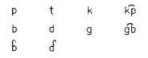

- A 3-term system also generally avoids use of the velar place of articulation, having members at the bilabial, dental or alveolar, and palatal places. An example of such a system is Yulu (216):
- As in Yulu, so also in the other 3 languages concerned (Kadugli, 102, Angas, 267, Ngizim, 269) there is at least one plosive with a palatal place of articulation in the inventory. One language, Hamer (265), stands apart from the others with 3 implosive terms. It has them at bilabial, alveolar and velar places. Despite the presence of palatal plosives it does not have a palatal implosive. This language is discussed further below.
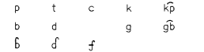

- Three of the four 4-term systems contain /ɓ ɗ ʄ ɠ/. An example is Nyangi (207).
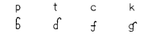

- The other two languages concerned, Swahili (124) and Maasai (204), do not have palatal plosives in their inventories, although they do have palato-alveolar affricates. The unusual 4-term language is Ik (208), which has /ɓɗʄʛ< /, that is, it has a uvular rather than a velar fourth term. This is despite the fact that the language has no other reported uvular segments and does have velar plosives.
- All 9 of the languages in UPSID with more than two implosives or voiced laryngealized plosives are from Africa. They are drawn from 3 different major language families, Niger-Kordofanian, Nilo-Saharan, and Afro-Asiatic. It follows also that the only languages using the palatal and velar places for segments of this type are African languages. Despite the small number of cases, this seems to be an important areal trend.
- We do not find evidence to support Greenberg's suggestion that languages often have /j̰/ , a laryngealized palatal approximant, in place of /ʔɟ/. The most obvious candidate language in our sample to test this claim is Hamer (265), since it has both palatal plosives and an implosive series which lacks a palatal member. The Hamer stop inventory is:
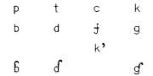

- However Hamer does not have / j / despite the obvious "gap" at the palatal place of articulation in the implosive series to which it could correspond.
- The segment / j / does occur in 5 of the 25 languages with the two-term system /ʔb, ʔd/ but in all but one of these it occurs as part of a set of laryngealized continuants including at least /w/.
- Only in Hausa (266) could a case be made for considering / j / as complementing a gap in the stop system. Moreover, in Hausa / j / is historically derived from "palatalized" occurrences of /d/. But Hausa is a special case.
- It does not outweigh the fact that most (28 of 33) languages with a series of implosives or voiced laryngealized stops but with no palatal member of the series lack / j / , or that most (8 of 13) languages with / j / lack any implosives or voiced laryngealized plosives. It is true that no language in the survey has both /?;}/ and / j / which might be evidence for the suppletion of /?;}/ by / j / . However, given the low frequency of these segment types only one co-occurrence of /?;}/ and / j / could be expected in a sample 3 times the size of the UPSID sample even if the occurrences of the two types were unrestricted. We therefore conclude that the suggestion that / j / takes the place of /?j/ is unfounded. For discussion of / j / in relation to other approximants see Chapter 6.

RETRACTION OF DENTAL/ALVEOLAR IMPLOSIVES

- Both Greenberg (1970) and Haudricourt (1950) noted that an implosive corresponding to a non-implosive dental/alveolar is often retroflexed or, at least, articulated further back than the non-implosive.
- In UPSID a retroflex implosive or laryngealized voiced plosive occurs in only one language, Somali (258), in which the plain plosives are dental.
- Two other languages, Tama (210) and Yulu (216) have dental plosive /t̪ d̪/ but alveolar implosive /ɗ/.
- Apart from these instances, there is insufficient phonetic detail in most of the UPSID sources to determine if implosives are typically articulated with a further back contact than other stops made with the tongue tip and blade.
- A study of voiced alveolar plosives and implosives in Shona using dynamic palatography (Hardcastle and Brasington 1978) did find a more retracted contact (with a smaller area) for the implosive relative to the plosive for the speaker studied.

VOICELESS IMPLOSIVES

- Overwhelmingly, implosives are voiced.
- However voiceless implosives do occur. Only one language in UPSID, Igbo (116), has any voiceless implosives.
- Ladefoged et al. (1976) demonstrate that both voiced and voiceless bilabial implosives occur in the Owerri dialect of Igbo, so that /p</ is in contrast with /ɓ/. Igbo also has the voiceless alveolar implosive /t</.
- Pinkerton (1980) shows that the uvular ejective stop in K'ekchi (714) can vary allophonically with a voiceless uvular implosive, and in certain related Quichean languages the voiceless uvular implosive occurs as the normal case (see Table 7.4 above).
- Other examples of voiceless implosives are mentioned by Campbell (1973).

7.6 Languages with both ejective stops and implosives

- Thirteen languages in UPSID contain both some ejectives and some implosives or voiced laryngealized plosives. Given the numbers of languages which have segments of these two classes, we would expect only 6 or 7 such languages in the sample if their occurrence was unassociated. The larger number suggests that these two classes of segments have a tendency to occur together in a language. One might also expect, given the differing place of articulation preferences for ejectives and implosives, that they would rarely occur at the same place of articulation. In several cases, however, they do. Zulu (126), Koma (220), Maidu (708) and Otomi (716) have both / p 7 and /?b/. Koma, Kullo (262), Maidu, Otomi, Mazahua (717), and Southern Nambiquara (816) have both /*t7 and /*?d/. Hamer (265) has / k 7 and /^/.

7.7 LARYNGEALIZED SONORANTS
- The glottalic airstream mechanism is not used in the production of sonorant types of segments, but sonorants do occur laryngealized.
- As Greenberg (1970) noted, "the phonological opposition in individual languages between ejectives and injectives applies effectively only to obstruents, and is neutralized for sonants and semi-vowels".
- In other words, he regards laryngealized sonorants as counterparts in some way to the glottalic obstruents, although with a neutralization of the airstream contrast.
- There is evidence that glottalic obstruents and laryngealized sonorants are members of the same phonological class in at least some languages.
- For example, in Hausa any segment which is either glottalic or laryngealized may not co-occur with a different glottalic or laryngealized consonant in a word (Carnochan 1951).
- What is relevant here is that this rule disallows co-occurrence of the laryngealized sonorant /j̰/ with glottalic obstruents /k'/, /s’/ etc.
- Greenberg also noted that "there is quite surely no phonological contrast of voicing" for the laryngealized nasals and liquids, nor, we might add, for the laryngealized approximants and vowels. All segments of these classes in UPSID are reported as voiced. Moreover, in all cases a plain voiced counterpart also occurs in the inventory of a language if there is a laryngealized sonorant.
- In general, laryngealized sonorants are found only in languages with glottalic stops. Nineteen of the 20 languages in UPSID which have laryngealized sonorants have ejective stops, implosives or voiced laryngealized plosives in their inventories.
- The exception is Tiddim Chin (513) with /l̰/ and /w̰/ but no other segments with a "glottalic" component.
- Within this group of sounds, laryngealized nasals and vocoid approximants are a little more frequent than laryngealized liquids, as Table 7.9 shows.
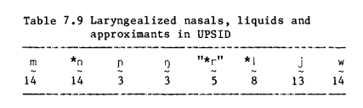

- The distribution of laryngealized nasals can be seen to be parallel to that of voiced "glottalized" stops in that both bilabial and dental/alveolar places are more common than back articulations, but yet are not between themselves in hierarchical relation.
- In most cases (13 of 17 languages concerned) /m̰/ and /*n̰/ occur together just as /ʔb/ and /*ʔd/ occur together.
- However, note that among plain voiced nasals bilabial and dental/alveolar places are also the most common and the velar place is less common (see Chapter 4).
- Hence it is not certain if the prevalence of /m̰/ and /*n̰/ among laryngealized nasals should be attributed to their laryngealized nature or to their simply being nasals.
- The laryngealized approximants /j̰/ and /w̰/ usually occur together (12 of 16 languages concerned).
- There are 5 languages with a laryngealized trill, tap or flap (collected in the table under the symbol / "*r̰”). One language, Wapishana (822), has a laryngealized voiced retroflex fricative, /ʐ̰/.

7.8 DIACHRONIC IMPLICATIONS

- Greenberg (1970: 23) suggests that "it is possible to derive the general diachronic hypothesis that at least one source of injectives might be a sound shift from voiced plain to voiced implosive stops".
- This is based on his observation that languages with implosives tend to lack corresponding non-implosive voiced stops.
- Greenberg also suggests that loss or addition of implosives should follow the place of articulation preference hierarchy for implosives discussed above. One reasonable prediction to read into his diachronic suggestions is that implosives at the same place of articulation as voiced plosives should be rather rare. This, however, is not the finding of our survey.
- As noted above, languages with implosives most commonly also have voiced plosives corresponding to each implosive.
- In a very few cases, such as Swahili (124), where there is no voiced plosive series, it does appear that the source of the implosives may be from an earlier voiced plosive series (Guthrie 1967-70).
- But even this case is unclear because it is conceivable that Swahili has merged a voiced plosive series with an implosive series; Stewart (1972) has found reasons to posit Proto-Bantu implosives in addition to voiced plosives.
- The failure to confirm Greenberg's prediction does not completely refute the diachronic hypothesis, since in the languages that do not conform to the prediction there may also have been a shift in another stop series to replace the former plain voiced series, or the original voiced plosive series may have split into plosive and implosive sets. However, it does weaken the evidence for positing voiced plosives as the straightforward source of implosives.

7.9 PHONETIC EXPLANATIONS FOR THE STRUCTURE OF GLOTTALIC SYSTEMS

- A phonetic explanation for Greenberg's (1970) place of articulation hierarchies of ejectives and implosives has been offered by several linguists, including Greenberg himself. Recall that some weakening of the preference hierarchies posited by Greenberg has been suggested. For ejectives, although a velar place of articulation is common, it is only marginally more common than a dental/alveolar one; however, both these places are preferred to a bilabial one. For implosives, etc., bilabial and dental/alveolar places of articulation are equally common, and both are preferred to velar.
- Javkin (1977) clarified the role played by Boyle's Law in explaining implosive and ejective distributions, correcting a misinterpretation by Greenberg.
- Lei de Boyle-Mariotte (geralmente citada somente como Lei de Boyle) enuncia que a pressão absoluta e o volume de uma certa quantidade de gás confinado são inversamente proporcionais se a temperatura permanece constante em um sistema fechado. Em outras palavras, ela afirma que o produto da pressão e do volume é uma constante para uma devida massa de gás confinado enquanto a temperatura for constante. A lei recebe o nome de Robert Boyle, que a publicou em 1662,[3] e de Edme Mariotte, que posteriormente realizou o mesmo experimento e o publicou na França, em 1676, sem ter tido conhecimento dos trabalhos de Boyle.
- Javkin (1977) noted that the claim that back articulations confer an advantage in compressing air in the supraglottal chamber (for ejectives) and front articulations confer an advantage in rarefying air (for implosives) cannot be entirely correct. This is because it takes the same effort to produce either compression or rarefaction in a chamber of a given size.
- What matters is the proportional change in the size of the chamber. Javkin's model suggests that the ability to change the volume of the chamber is proportionally greater for a velar closure than for a bilabial, dental or alveolar closure. That is, the same amount of raising or lowering of the larynx will have a greater effect on the volume of air between a velar closure and a glottal closure than if the oral closure is further forward. If articulatory efficiency were the explanation for the difference in the place preferences for ejectives and implosives, and there were nothing else to consider, then both types of sounds would show a preference for back articulation. It is possible to maintain this kind of explanation for the preference for velar ejectives, providing some overriding factor can be found to explain why implosives do not share the preference for back articulations. Javkin suggests that this factor is voicing.
- As noted above, implosive segments are almost invariably voiced. If we grant, for the time being, that voicing is an essential part of their nature, then anything that facilitates voicing will be favored. In a voiced segment some volume of pulmonic air must flow into the oral cavity. The absolute volume by which the oral cavity is expanded must be greater than this volume of pulmonic air or there will be no rarefaction, hence no implosion. A chamber created by a back oral closure may not permit expansion by the required absolute volume, whereas one further forward may allow greater absolute expansion through adjustments of tongue position and oral cavity walls. Such oral cavity expansion has been shown to be normal in voiced plosives in several studies of English (e.g. Kent & Moll 1969; Smith 1971; Bell-Berti 1975; Westbury 1983), and Lindau (1982) specifically argues that the achievement of an even or rising amplitude of voicing
throughout the closure may be a major part of the "target" in production of an implosive. Lindau compares the bilabial implosive and plosive in the Niger-Kordofanian language Degema and finds that whereas the amplitude of voicing actually increases during the closure for the implosive, during the plosive the amplitude of voicing tends to decay and the periods become irregular. Of course, some air can flow through the glottis without any cavity expansion being required. Again, the further forward the oral closure is formed, the less the intraoral air pressure increases for a given volume of transglottal air flow.
- No measurements have been done to confirm the occurrence of oral cavity expansion by tongue movement, jaw lowering or use of the cheeks in production of implosives, although Hardcastle and Brasington (1978) show a pattern in the occlusion for an alveolar implosive in Shona which is consistent with some cavity expansion by tongue lowering. Nonetheless, the theory that such expansion occurs is plausible and appealing. In addition to accounting for a preference for bilabial implosives, it also suggests why the patterns for voiced laryngealized plosives are similar to those for true implosives. For, as Greenberg (1970) and Ladefoged (1968) have noted, "implosives" do not always entail inward air flow upon release. In some languages (e.g. Hausa, 266) some speakers use implosives while others use laryngealized stops. If implosion, especially the contribution of the lowering of the larynx to oral cavity expansion facilitating transglottal air flow, is predominantly a mechanism employed in the more general aim of achieving salient voicing in the production of a stop, then actual achievement of inward oral air flow is a minor part of the target. This means that the cavity expansion need only equal, not exceed, the volume of transglottal air flow.
- Note that we are not suggesting that plain voiced plosives are likely to become implosives (pace Greenberg) as speakers endeavor to sustain voicing through the duration of the oral closure. Instead it see"ms more likely that, given a contrast between voiced stops of two different types in a language, a tactic for enhancing the contrast between them by implosion and emphasized voicing is exploited. In this view, implosives and voiced laryngealized plosives would be expected to co-occur with plain voiced plosives, as they do. Because the cavity expansion possibilities are greatest when there is a front articulation, not only is a front articulation preferred when the target is to achieve enhanced voicing, but also when the target is for an "ordinary" degree of voicing, since if the oral cavity is not expanded, voicing will cease when the oral air pressure reaches equilibrium with the subglottal air pressure. Hence place preferences for voiced implosives and for voiced plosives are similar (see chapter 2). The disfavored velar implosives, if they arose, would tend to fall together with voiced velar plosives, since it would be difficult to maintain a distinction between them on the basis of differences in their voicing characteristics.
- On the other hand, since production of voiceless plosives has nothing to do with rarefaction of air in a closed chamber, we would expect place preferences for ejective stops and voiceless plosives to differ, as they do. A small chamber confers no advantage in producing voiceless plosives, hence no preference for a velar place is found. Instead, dental or alveolar plosives are most common, perhaps because the tongue tip/blade is the most mobile of all the articulators. Note that this view predicts that voiceless implosives should show the same preferences for back articulations as ejectives, rather than those found for voiced implosives, since the preference for front articulation in voiced implosives is attributed to the intention to achieve voicing. The data in UPSID is insufficient to deal with this question. The one language with voiceless implosives, Igbo (116), looks like a counterexample since it has them at bilabial and alveolar places, and not at the velar place, but note that several of the Mayan languages cited in Table 7.4 have uvular implosives which are voiceless.

7.10 SUMMARY OF GENERALIZATIONS
(i) An ejective segment is voiceless. 309/312 99.0%.
(ii) An ejective segment is likely to be a stop. 188/312 60.3%.
(iii) If a language has /p’/ it also has /*t'/. 33/34 97.1%.
(iv) If a language has /* t 7 it also has /k'/. 45/46 97.8%.
(v) If a language has only one ejective stop, it is /kV. 5/5 100%.
(vi) If a language has /c'/ or /q'/ it also has / p 7 , /*t'/ and /k'/. 15/19. 78.9%.
(vii) If a language has / q w 7 it also has /q'/ and /kw'/. 8/8 100%.
(viii) If a language has /kw'/ it also has /k'/. 17/18 94.4%.
(ix) If a language has ejective affricates it also has ejective stops. 39/40 97.5%.
(x) An ejective affricate segment is usually sibilant. 70/88 79.5%.
(xi) If a language has any ejective fricatives, at least one of them is sibilant. 10/10 100%.
(xii) An implosive segment is voiced. 72/74 97.3%.
(xiii) A language with any implosives or laryngealized voiced stops has /?b/ and /?d/. 36/42 85.7%.
(xiv) If a language has /?g/ it has /?j/. 3/4 75.0%.
(xv) Laryngealized sonorants are voiced. 74/74 100%.
(xvi) If a laryngealized sonorant segment occurs, the plain voiced counterpart occurs in the same language. 74/74 100%.
(xvii) If a language has any laryngealized sonorants it also has glottalic or laryngealized stops.
19/20 95.0%.

CAP 7 WALS GLOTTALIZED CONSONANTS [15/15]
CAP 5 WALS Voicing and Gaps in Plosive Systems

*********

CAP 18 WALS ABSENCE OF COMMON CONSOANTS [20/35]
CAP 19 WALS PRESENCE OF UNCOMMON CONSOANTS [20/55]

JOHN H. ESLING; SCOTT R. MOISIK; ALLISON BENNER; LISE CREVIER-BUCHMAN (2019) VOICE QUALITY: THE LARYNGEAL ARTICULATOR MODEL
Fallon, Paul Dennis - The synchronic and diachronic phonology of ejectives (1998)

