Escola: ____________________________________________________________________ Ano: ______________ Idade:_____ anos.

1-Desenhe o que acontece com o alimento ingerido.

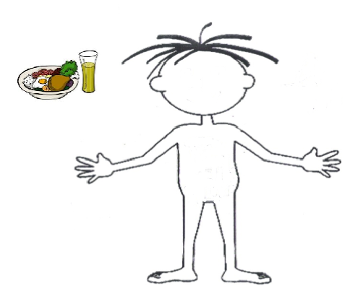

2-Explique o que acontece durante a digestão.
____________________________________________________________________________________________________________________________________________________________________________________________________________________________________________________________________________________________________________________________________________________________________________________________________________________________________________________________________________________________________________________

3-Como nosso corpo utiliza o que ingerimos?
____________________________________________________________________________________________________________________________________________________________________________________________________________________________________________________________________________________________________________________________________________________________________________________________________________________________________________________________________________________________________________________

