Sampling Instructions

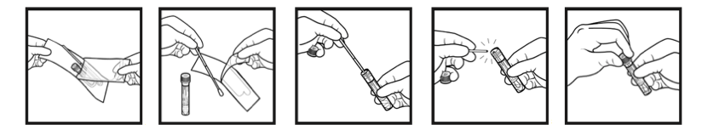
Copan ESwab TM Product Insert

- SWAB
- Before swabbing, please use gloves to ensure that you do not accidentally deposit your skin or bacterial cells into the tubes.
- Wet the swab in the transport medium.
- Swab a selected surface for a minimum of 3 minutes, while rotating the swab. If there are more than one surfaces of the same type, swab all of them. For instance, when swabbing a turnstile, try to swab from more than one turnstile, as this gives optimal results.
- Handle the swab only above the red mark. If the swab breaks, it’s okay. Just continue swabbing. If it falls on the floor or touches an un-intended surface, get a new swab.
- Swab an area that is approximately 1 square meter large.
- Note: People may ask what you’re doing swabbing. Simply explain to them that you are part of an international research project sampling the microbiome of public surfaces. If they’re interested, show them a copy of the “Data Collector Letter.”
- What to swab? There should be 2-3 replicates within each station (kiosk, bench, railing, or other) also one swab on the train/bus at that station. (n=3-4 samples per site).

- STORE
- Insert swab into the provided transport tube, and break the swab shaft at the breakpoint indicated by the red mark. (OPTIONAL: If possible, place samples on ice. But, the Copan transport media ensures minimal or no growth as long as swabs within the day of collection).
- Discard the broken handle part of swab shaft.

- SEAL
- Replace cap on the transport tube and secure tightly.
- Place the corresponding sample ID label on the tube and place in collection bag. If you are manually writing the sample ID, please use neat, legible writing (no gel pens- they smudge!!).
- Follow instructions below to record location and metadata with the GIS Cloud app.

- SEND
- Once the samples have been collected, store them in a -80 or -20 degree Celsius freezer. The samples can be frozen for 3-6 months but they should ideally be extracted as soon as possible to ensure maximum yield.
- If you have DNA extraction capabilities, you can extract the samples locally. If not, please ship the samples to the

We strongly recommend using gloves however, if there are any social concerns of using gloves (public concerns, city officials, etc.)

