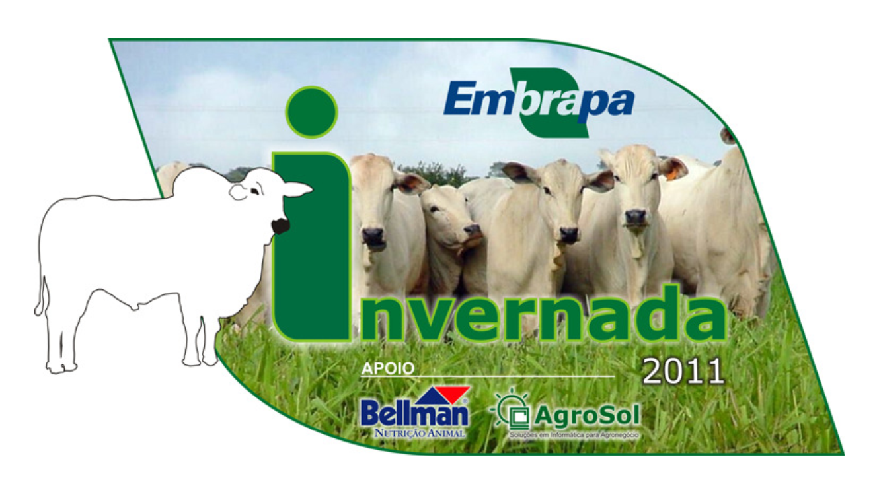
https://www.invernada.cnptia.embrapa.br/

http://www.brcorte.com.br/br/

https://sites.google.com/site/ppfrparaexcel2007ousuperior/

http://nutritionmodels.com/beef.html

