[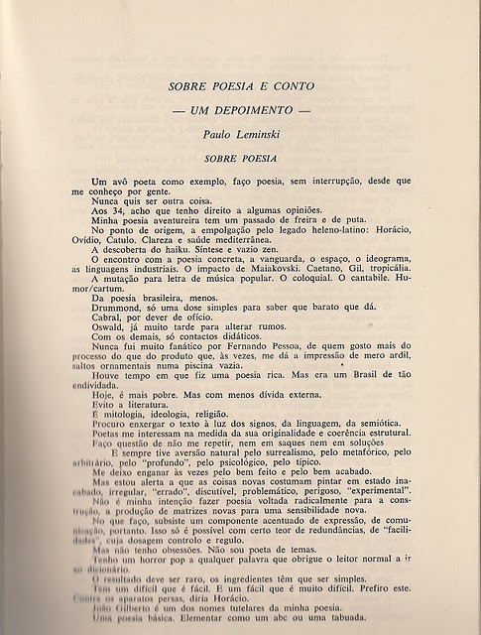](http://2.bp.blogspot.com/_PLQ-Fqs-P_g/TShrBkhH1DI/AAAAAAAAACk/yrDbE_NXMEE/s1600/digitalizar0002.jpg)

[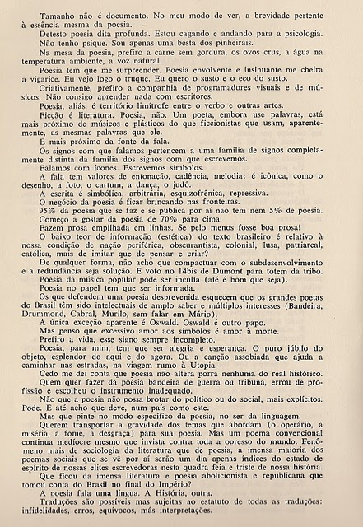](http://3.bp.blogspot.com/_PLQ-Fqs-P_g/TShrIi8W0CI/AAAAAAAAACo/N6MrmKfE5YI/s1600/digitalizar0003.jpg)

[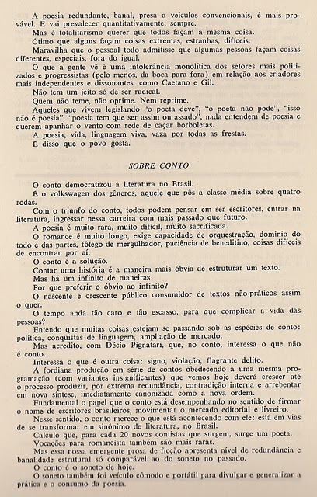](http://4.bp.blogspot.com/_PLQ-Fqs-P_g/TShrOEVJhII/AAAAAAAAACs/X79qF8Aq1Vo/s1600/digitalizar0004.jpg)