Aula: Análise térmica dos materiais - **Parte 3: DMA (análise dinâmico-mecânica)**

*>>>DMA measures stiffness and damping (modulus and tan delta). Because we are applying a sinusoidal force, we can express the modulus as an in-phase component, the storage modulus, and an out of phase component, the loss modulus. The storage modulus, either E’ or G’, is the measure of the sample’s elastic behavior. The ratio of the loss to the storage is the tan delta and is often called damping. It is a measure of the energy dissipation of a material.*

*While Young’s modulus, which is calculated from the slope of the initial part of a stress-strain curve, is similar conceptually to the storage modulus, they are not the same. Just as shear, bulk and compressive moduli for a material will differ, Young’s modulus will not have the same value as the storage modulus.*

*Damping is the dissipation of energy in a material under cyclic load. It is a measure of how well a material can get rid of energy and is reported as the tangent of the phase angle. It tells us how good a material will be at absorbing energy. It varies with the state of the material, its temperature, and with the frequency.<<<*

*http://www.metrotec.es/metrotec/WWW_DOC/GDE_IntroductionToDMA-1-CAT-E-R1.pdf (Perkin Elmer)*

>>>The material may be:

- A thermoplastic, a thermoset, or an elastomeric polymer.

- A polymer blend or "alloy";

- A liquid, a melt, or a solid;

- A soft solid such as cheese or toothpaste;

- A foam, wet or dry, soft or rigid;

- A dispersion, emulsion, or solution;

- "Neat" or with extenders, fillers, pigments, plasticizers, or fibers.

Usually, testing is nondestructive and only small samples are needed, an advantage for testing experimental materials.<<<<

(www.sealseastern.com/PDF/DynamicMechThermalAnal.pdf)

DMA fornece informações sobre o comportamento termo-mecânico de um material quando em presença de forças dinâmicas.

Estudos sobre: propriedades visco-elásticas, endurecimento e amolecimento de cadeias, transições vítreas, transições de segunda ordem e caracterização de ligações cruzadas em cadeias.

Alguns modos de operação da técnica:

a) Flexão de três pontos

Amostra é colocada sobre duas extremidades e uma força de cima para baixo é aplicada em um terceiro ponto central desta amostra. O espaçamento entre os dois pontos extremos deve estar em acordo com as normas técnicas (ASTM).

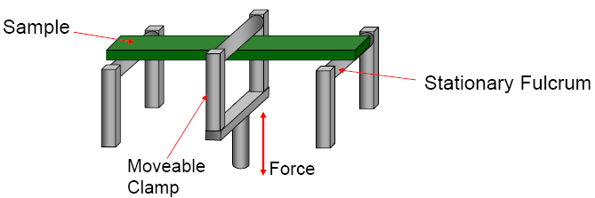 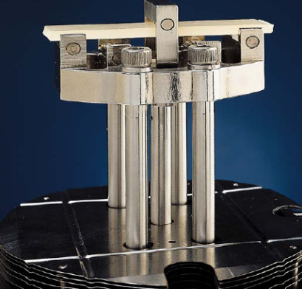

Amostras: termoplásticos, elastômeros. Estudo sobre cura polimérica.

b) Compressão

A amostra é disposta em porta-amostras na forma de disco e certa força é aplicada de cima para baixo com uma haste. Útil para materiais com baixo ou médio módulo (géis, elastômeros)

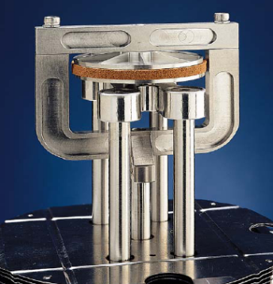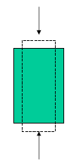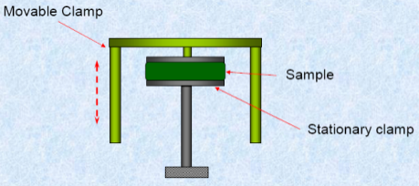

c) Tração

Muito usado em filmes finos, fibras e amostras finas de borracha. A parte inferior da amostra é presa a um porta-amostras e a parte superior é fixada à haste para o ensaio de tração uniaxial.

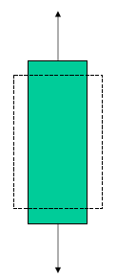 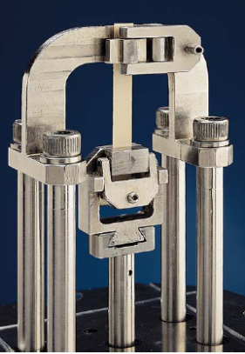 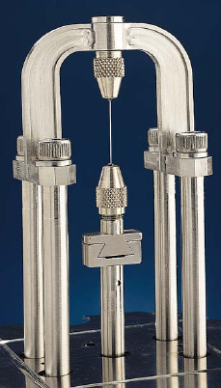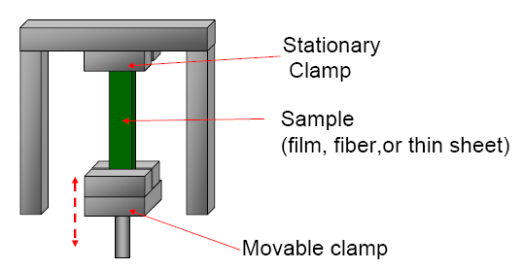

d) Cisalhamento

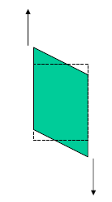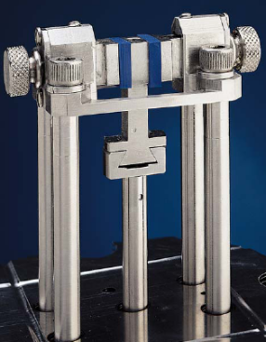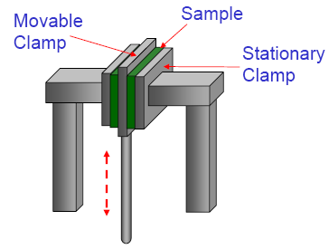

Permite a obtenção de G*, G’, G” e G(t); usada para análises de géis, adesivos e elastômeros com alta Tg, fundidos e resinas de alta viscosidade.

Teoria

1. Definições – artigo de Luckenbach

**>>>Rheology**. science that studies the deformation and flow of materials in liquid, melt, or solid form in terms of the material's elasticity and viscosity. This is accomplished by applying a precisely measured strain to the sample to deform it, and accurately measuring the resulting stress developed in the sample. The developed stresses are related to material properties through Hooke’s and Newton’s laws.

**Elasticity**. ability of a material to store deformational energy, and can be viewed simply as the capacity of a material to regain its original shape after being deformed.

**Viscosity**. a measure of a material’s resistance to flow.

**Viscoelasticity**. Materials respond to an applied displacement or force by exhibiting either elastic or viscous behavior, or a combination of these, called viscoelastic behavior. Most polymers are viscoelastic, their mechanical properties showing a marked time- and temperature- dependence.

**Stress**. a distribution of forces over an infinitesimal area.

**Strain**. a measure of a body’s change in shape. The change in strain with time is the shear rate. The change in strain with time is the shear rate.

**Hooke’s law**. defines the mechanical behavior of an ideal solid, relating the applied strain (ε or γ) to the resultant stress (σ or τ) through a factor called the modulus (E or G). Thus, σ = Eε (tension, bending) or τ = Gγ (shear). The modulus is a measure of the material's stiffness (i.e., its ability to resist deformation). The linear region in which the modulus does not change when the strain is changed is called the Hookean region.

**Newton’s Law**. Newton developed a relationship similar to Hooke's law for ideal viscous fluids, relating the stress (τ) linearly to the shear rate (dγ/dt). Thus, τ = ηdγ/dt, where η is the coefficient of viscosity. A fluid is Newtonian if, when sheared, its viscosity does not depend on shear rate.

**Ideal Solids.** follow Hooke’s law; the stress is proportional to the strain amplitude, and the stress and strain signals are in phase.

**Ideal Fluids.** The stress is proportional to the strain rate (Newton’s Law). Here, the stress signal is out of phase with the strain signal, leading the strain signal by 90o.

**Viscoelastic Materials.** The stress signal generated by a viscoelastic material can be separated into two components: an elastic stress in phase with the strain, and a viscous stress in phase with the strain rate (90° out of phase with the strain). The elastic stress measures the degree to which the material behaves as an ideal solid; the viscous stress, the degree to which the material behaves as an ideal fluid. This separation of the stress components vectorially allows the material's dependence on strain amplitude and strain rate to be measured simultaneously.

**Modulus.** The elastic and viscous stresses ere related to material properties through the ratio of stress to strain, the modulus. The ratio of the elastic stress to strain is the elastic (or storage ) modulus G’; the ratio of the viscous stress to strain is the viscous (or loss) Modulus G”. When testing is done in tension or flexure rather then in shear, E’ and E” designate the elastic and viscous moduli.

**Complex Modulus.** The complex modulus G* = G’ + G” reflects the contribution of both elastic and viscous components to the material’s stiffness.

**Complex Viscosity.** The complex viscosity η* is a measure of the material’s overall resistance to flow as a function of shear rate.

**Damping Factor.** The ratio of the viscous modulus to the elastic modulus is the tangent of the phase angle shift δ between the stress and strain vectors. Thus, G”/G’= tan δ. This measures the damping ability of the material.

**Glass Transition.** During measurement of the moduli (G’, G”) and damping behavior (tan δ) of a polymer at a chosen oscillatory frequency over a sufficiently wide range of temperature, the effect of the polymer’s Tg can be clearly observed. The Tg (sometimes called the α transition) is a reversible change of the polymer between rubbery and glassy states, and the temperature at which this occurs, called the glass transition temperature Tg, can be measured accurately by DMRT, which is considered the most sensitive method for measuring a material’s glass transition temperature.

The Tg is detected as a sudden and considerable (several decades) change in the elastic modulus and an attendant peak in the tan δ curve. This underscores the importance of the glass transition as a material property, for it shows clearly the substantial change in rigidity that the material experiences in a short span of temperatures. Accordingly, the glass transition temperature is a key factor in deciding the usefulness of a polymer. But merely knowing the temperature at which the Tg occurs (all that DSC and TGA provide) is not enough. Besides being a more accurate measure of Tg, DMRT tells much more about the material before and after the Tg. DMRT also measures the rubbery plateau modulus which is much more sensitive than is Tg for detecting, for example, small differences in a thermoset polymer cure level<<<

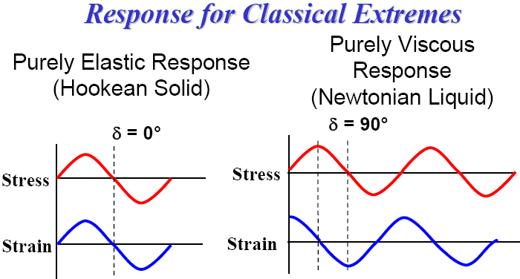 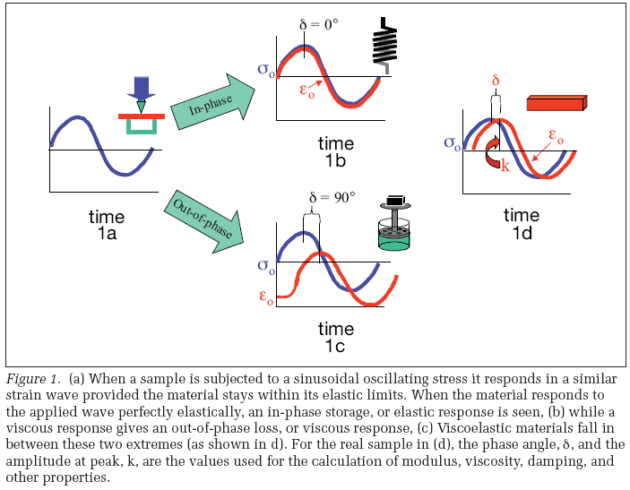

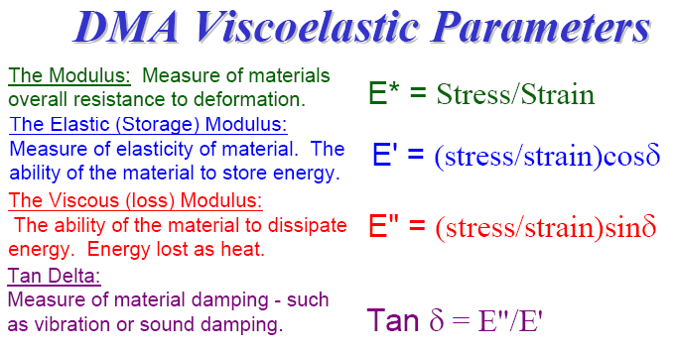 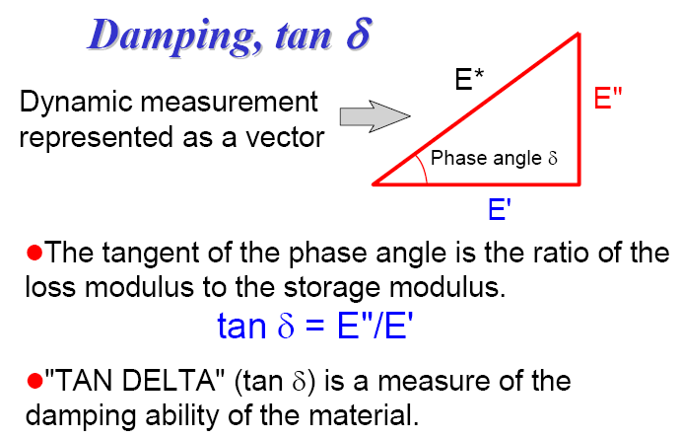

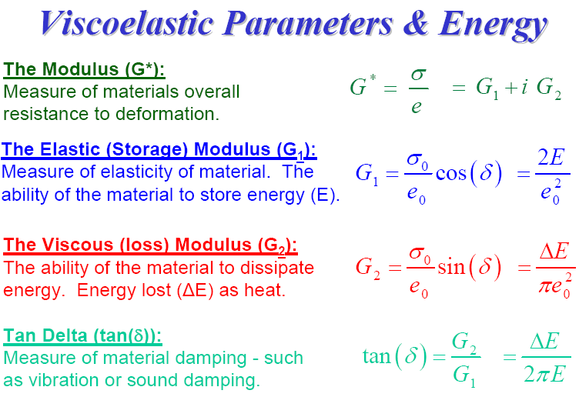

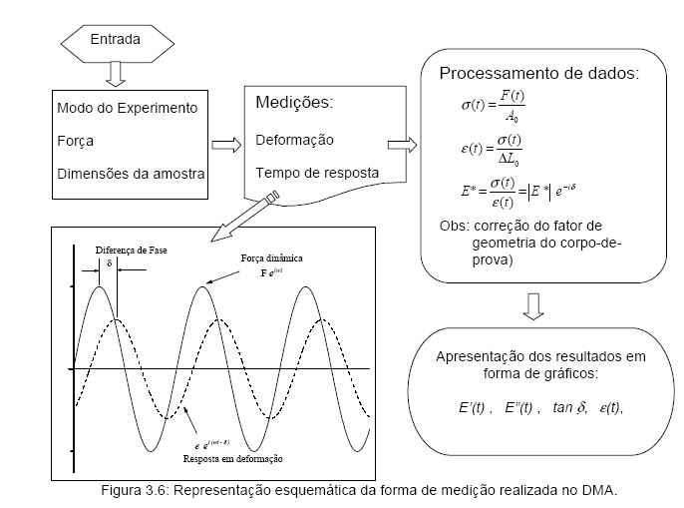

Exemplos

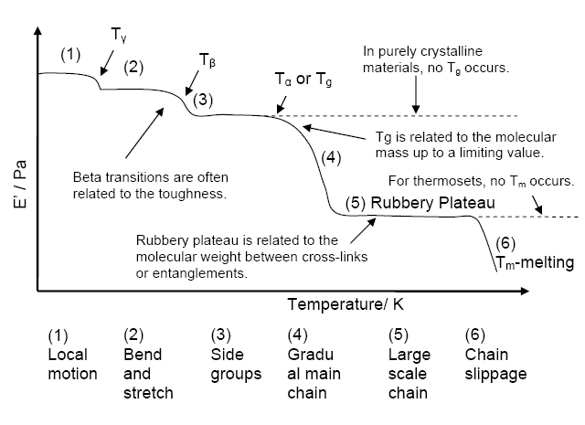Menard, p. 96.

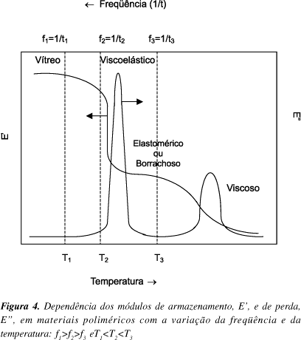

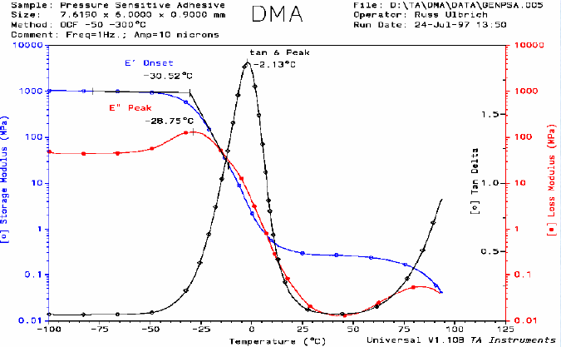

(site TA Instruments)

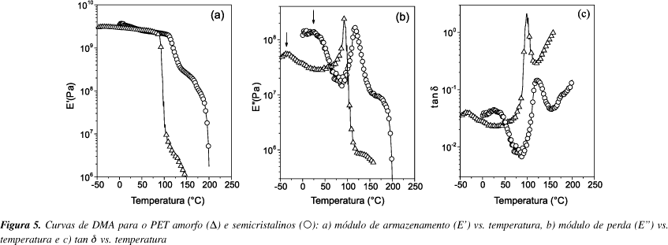

(artigo Felisberti)

Observação: Este é um texto de aula, que serve apenas como apoio, para se ter uma sequência de tópicos; é uma compilação dos textos consultados, livros, sites na internet e artigos. Não é uma versão final e pode conter trechos de outros autores com modificações; algumas figuras não contêm ainda a fonte e/ou contêm a fonte incompleta (somente uma indicação).

**Fontes (sugestões de estudo)**

1. T. Hatakeyama, F.X. Quinn, Thermal Analysis, Fundamentals and Applications to Polymer Science, 2ª Ed., Wiley, 1999.

2. J.C. Anderson, K.D. Leaver, R.D. Rawlings, J.M. Alexander, Materials Science, 3a ed., Van Nostrand Reinhold, 1985.

3. R. Tilley, Understanding Solids, The Science of Materials, Wiley, 2004.

4. J.F. Shackelford, Ciência dos Materiais, 6ª ed., Pearson, 2008.

5. W.D. Callister Jr., Materials Science and Engineering, Wiley, 3ª ed., 1994.

6. D.A. Skoog, J.L. Leary, Principles of Instrumental Analysis, Saunders, 4a. ed., 1992.

7. K.P. Menard, Dynamic Mechanical Analysis, A Practical Introduction, CRC, 1999.

8. Aulas abertas, *online*, de Khaled Mezgahani (ocw.kfupm.edu.sa).

9. Perkin Elmer online, An Introduction to Dynamic Mechanical Analysis (DMA); Dynamic Mechanical Analysis. Basics: Part 1. How DMA Works.

# 10. Apostila Análises Térmicas (*online*), Departamento de Engenharia Mecânica, UFSC, G.V. Rodrigues, O. Marchetto, P.A.P. Wendhausen.

11. IUPAC, http://www.iupac.org/publications/analytical_compendium/Cha05sec2.pdf.

12. Aula *online*, Análises Térmicas, http://www.chem.mun.ca/courseinfo/c4110.

13. S.N. Cassu, M.I. Felisberti, Quimica Nova, 28, 255, 2005. (DMA).

14. Site TA Instruments.

15. *DMTA: Dynamic Mechanical Thermal Analysis* (disponível online). www.sealseastern.com/PDF/DynamicMechThermalAnal.pdf

16. O. Mendieta-Taboada, R.A. de Carvalho, P.J. do A. Sobral, Química Nova, 31, 384, 2008. (DMA).

17. C. Bernal, A.B. Couto, S.T. Brevigli, E.T.G. Cavalheiro, Química Nova, 25, 849, 2002. (DSC).