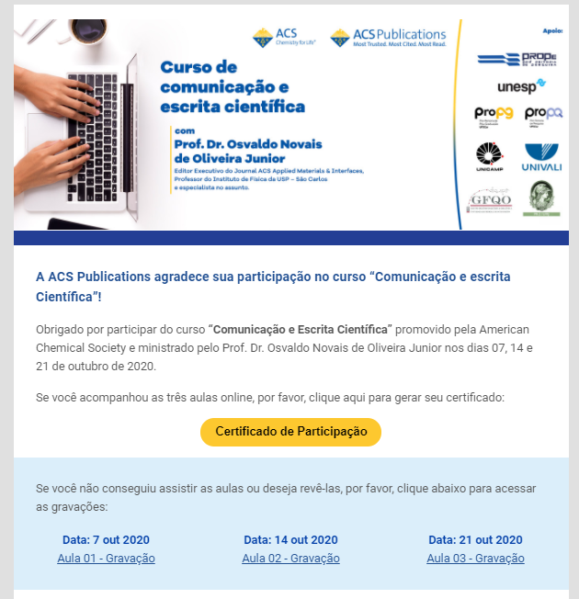
Aula 1
Link: https://american-chemical-society.zoom.us/rec/play/uxmI_EsLCHxwVGk8i2veLVSe_WpaqZ3ZfKj8uPhhslD3XaCQLlvom3Ra3Xpak9VM7_24D_qfy4_ekBiv.PpVui4fyFvB59je5?continueMode=true&_x_zm_rtaid=imREDLbdS_qTRqevmY7uFg.1603963019081.63e9e53fe21028055c719f779a95de0f&_x_zm_rhtaid=965

Aula 2
Link: https://american-chemical-society.zoom.us/rec/play/zRtI5Ik5HBCZ4-Q5gjl3sFmQG_jYgFACFGgZtsmbqB24Eeq1r_T3TmNRAGa5SmoHnxDX1jtXOD7pYT1f.SgSbgwKZ_-wNoYBw?continueMode=true&_x_zm_rtaid=imREDLbdS_qTRqevmY7uFg.1603963019081.63e9e53fe21028055c719f779a95de0f&_x_zm_rhtaid=965

Aula 3
Link: https://american-chemical-society.zoom.us/rec/play/YDasj85ybJRhg9rEqpTr3cJrF9PWS6FD8Vtozv_2czTpJSNLkpkEg3dNNt_Ygp45Dn6mmCzMM88VDjJU.ItsgDOEBul1TPT36?continueMode=true&_x_zm_rtaid=imREDLbdS_qTRqevmY7uFg.1603963019081.63e9e53fe21028055c719f779a95de0f&_x_zm_rhtaid=965

