Lista de Web Semântica (parte 1)
Some of the questions bellow were taken from the internet, including from Farhan Ansari - University of Leicester Semantic Web course.

- Brieﬂy explain the statement “Semantic Web is not a replacement of the current Web”.
- Enumerate and brieﬂy explain the purpose of each of the languages standardized by the W3C for the Semantic Web. Use a figure to illustrate the order of the languages as per their expressiveness.
- Explain the importance of developing ontologies.
- Explain the following statement “A URI can be used to name anything” using examples.
- Within the context of Linked data, discuss the statement “Don’t just link the documents, link the things”.
- O que são Literals em RDF? Para que são usados?
- Como fazemos para indicar que um Literal é o sujeito de uma tripla RDF?
- Explain the 303 URI strategy for content negotiation. Identify its limitations
- Explain the purpose of Microdata. Illustrate with examples any two Microdata attributes.
- Explain the purpose of RDFa from a Web of Documents and a Web of Data point of view.
- Para o RDF abaixo, faça o desenho do diagrama correspondente.
< http://scc230.ia/pessoas#abcd"> rdf:type owl:Class ;
foaf:name ABCD ;
foaf:surname EFGH.

- Dado o código RDF abaixo:
@prefix rdf: <http://www.w3.org/1999/02/22-rdf-syntax-ns#> .
@prefix rdfs: <http://www.w3.org/2000/01/rdf-schema#> .
@prefix : <http://www.scc2310.ia#> .
:InstrumentoMusical rdf:type rdfs:Class .
:Cordas rdf:type rdfs:Class ;
rdfs:subClassOf :InstrumentoMusical .
:Sopro rdf:type rdfs:Class ;
rdfs:subClassOf :InstrumentoMusical .
:Violino rdf:type :Cordas ;
:musico "A".
:Violao rdf:type :Cordas ;
:musico "B".
:Trombone rdf:type :Sopro ;
:musico "C".
:Violoncelo rdf:type :Cordas ;
:musico "D".

Apresente o código SPARQL para as consultas a seguir:
- Liste as classes e subclasses
- Liste os instrumentos musicais de corda (e apresente o nome do músico e a subclasse do instrumento)
- O termo "tripla" usado em RDF refere-se a que?
- O que seria um “blank node” em RDF? Para que eles são usados?
- Qual a diferença entre RDFS e OWL? Exemplifique algo que uma das linguagens pode fazer e a outa não.
- Qual é a diferença entre URI e IRI?
- If it is possible to write ontologies in RDFS, why do we need the OWL language?
- Model the following travel ontology in RDFS using Turtle.
Aircraft, Train and Bus are transport modes. High Speed train is a type of train. Trains are driven by drivers. Drivers have names. Trains have carriages. Each carriage is of a specific class (e.g. standard class or first class). City buses and coaches are types of buses.
Assume all properties take values of type string.
- Brieﬂy explain the linked data paradigm. Enumerate some of the advantages of publishing datasets as linked data.
- Consider the following RDF ontology and instance data:
@prefix: <http://www.example.org/sample.rdf#>.
@prefix rdf:<http://www.w3.org/1999/02/22−rdf−syntax−ns#>.
@prefix rdfs:<http://www.w3.org/2000/01/rdf−schema#>.
:Human rdfs:subClassOf :Mammal.
:Dog rdfs:subClassOf :Mammal.
:hasGuardian rdfs:range :Human ;
rdfs:domain :Human.
:hasPetDog rdfs:range :Dog;
rdfs:domain :Human.
:hasParent rdfs:subPropertyOf :hasGuardian.
:Max a :Human;
:hasPetDog :Adam.
:Abel a :Human;
:hasParent :Max.
:Adam a :Dog.

What would the result of executing the following SPARQL query be?
prefix : <http://www.example.org/sample.rdf#> .
prefix rdf: <http://www.w3.org/1999/02/22-rdf-syntax-ns#> .
prefix rdfs: <http://www.w3.org/2000/01/rdf-schema#>.

SELECT ?x ?p ?z
FROM <http://www.example.org/sample.rdf>
WHERE {
?x rdfs:subClassOf :Mammal.
?p a ?x.
?p :hasParent ?z.
?z :hasPetDog ?y.
}

- Given the following XML document
<?xml version=" 1.0 " encoding="ISO− 8859− 1"?>
<CO2source>
<sourceID>source123</sourceID>
<LocationData>
<NUTSregion>UKM61</NUTSregion>
<city>Birmingham</city>
<lat>26.99</lat>
<lng>−5.67</lng>
</LocationData>
<Requirement>
<source>OilPlant</source>
<quantity>250</quantity>
<unit>TonsPerAnnum</unit>
</Requirement>
</CO2source>

- Write an RDF instance document that corresponds to the above XML document using the Turtle notation.
- Write a SPARQL query that selects city, lat, lng, quantity and unit for all CO2 sources from the RDF instance document where the quantity is above 200 TonsPerAnnum. The selection should be such that results are ordered by quantity.
- Model the following travel ontology in RDFS using Turtle.
Aircraft, Train and Bus are transport modes. High Speed train is a type of train. Trains are driven by drivers. Drivers have names. Trains have carriages. Each carriage is of a specific class (e.g. standard class or first class). City buses and coaches are types of buses.
Assume all properties take values of type string.
- Model the following education ontology in RDFS using Turtle.
School, College and University are places of education. International university is a type of university. A School has a school bus. Buses have numbers. University has buildings. Each building has a code number. Cafeteria and library are types of building.
Assume XSD properties take values of type integer.
- Model the following scenario description of an operation room as an ontology in RDFS using the Turtle notation. Your model should include 6 RDF classes, 4 RDF properties and 2 RDF individuals. Refer to the last page for important namespaces. All Definitions must include either label or RDFS comments.
An operation room or an operation theatre is a room in a hospital equipped for the performance of surgical operations in a sterile environment. Operating rooms are fitted with overhead surgical lights, viewing screens and monitors. Rooms are supplied with wall suction, oxygen, and anesthetic gases. Key equipment consists of the operating table and the anesthesia cart. “Heart Surgery Operation Theatre” is an Operation room. “Heart lung machine” is an equipment used in “Heart surgery” which is a surgical procedure. All operation rooms have a numerical reference number and a name. Assume XSD properties take values of type String or int.

- Considere o código RDF abaixo:
@prefix rdf: <http://www.w3.org/1999/02/22-rdf-syntax-ns#> .
@prefix rdfs: <http://www.w3.org/2000/01/rdf-schema#> .
@prefix : <http://www.scc2310.ia#> .

:Computador rdf:type rdfs:Class .
:ComputadorVelho rdf:type rdfs:Class ;
rdfs:subClassOf :Computador .
:Servidor rdf:type rdfs:Class ;
rdfs:subClassOf :Computador .
:ComputadorVerde rdf:type :ComputadorVelho ;
:anoFabricacao "1980".
:ComputadorAmarelo rdf:type :ComputadorVelho ;
:anoFabricacao "1990".
:ComputadorPreto rdf:type :Servidor ;
:anoFabricacao "2010".
:ComputadorBranco rdf:type :Servidor ;
:anoFabricacao "2020".
Apresente o código SPARQL para as seguintes consultas:
- Listar nome e ano dos computadores velhos:
NomeComputador | Ano
ComputadorVerde | 1980
ComputadorAmarelo | 1990

- Listar os nomes e classes de todos os computadores:
NomeComputador | Classe
ComputadorBranco | Servidor
ComputadorPreto | Servidor
ComputadorVerde | Computador Velho
ComputadorAmarelo | Computador Velho

- Para o grafo abaixo:
- Liste todas as propriedades que se referem a Literals.
- Escreva uma query SPARQL que retorne o nome do livro, o autor e o nome do tradutor (se existir) de todos os livros publicados em Londres antes de 1960.
- Seria possível também retornar o ISBN dos livros?

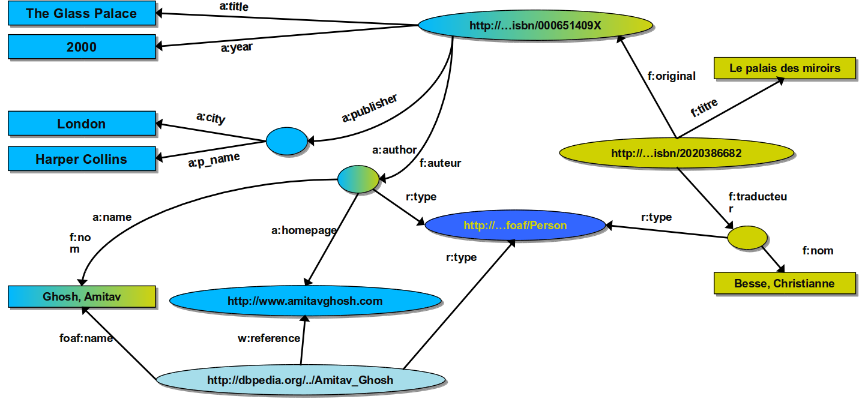

- Given the following XML document
<?xml version=" 1.0 " encoding="ISO−8859−1"?>
<Catalog>
<Plant>
<Common>Bloodroot< /Common>
<Zone>4</ Zone>
<Light >Mostly Shady</ Light >
<Price>2.44</ Price>
</Plant>
<Tool>
<Name>Grass trimmer</Name>
<type>Electric</type>
<Code>041560</code>
</Tool>
</Catalog>
- Write an RDF document that corresponds to the above XML document. You can use either the Turtle notation or the RDF/XML syntax. The headers for the document can be ignored.
- Write a SPARQL query that selects use, price, code and type for all tools from the RDF document

- For the following graph (consider that the prefix have proper URIs defined for them):
:Homer
a foaf:Person;
foaf:age "36"^^xsd:int;
foaf:name "Homer Simpson";
fam:hasSpouse :Marge.
:Marge
a foaf:Person ;
foaf:age "34"^^xsd:int ;
foaf:name "Marge Simpson";
fam:hasSpouse :Homer.
fam:hasSpouse [a foaf:Person;
fam:hasFather :Abraham].
:Lisa
a foaf:Person ;
foaf:age "8"^^xsd:int ;
foaf:name "Lisa Simpson";
fam:hasFather :Homer;
fam:hasMother :Marge;
fam:hasParent [a foaf:Person;
fam:hasSister :Patty, :Selma];
fam:hasParent [a foaf:Person ;
fam:hasBrother :Herb].
:Bart
a foaf:Person ;
foaf:age "10"^^xsd:int ;
foaf:name "Bart Simpson";
fam:hasFather :Homer;
fam:hasMother :Marge.
:Maggie
a foaf:Person ;
foaf:age "1"^^xsd:int ;
foaf:name "Maggie Simpson";
fam:hasFather :Homer;
fam:hasMother :Marge;
fam:hasParent [a foaf:Person;
fam:hasFather :Abraham];
fam:hasParent [a foaf:Person;
fam:hasMother sim:Mona].
:Simpsons
a fam:Family ;
fam:hasFamilyMember :Maggie, :Homer, :Lisa, :Bart, :Marge.
:Abraham a foaf:Person .
:Mona a foaf:Person.
:Herb a foaf:Person.
:Patty
a foaf:Person;
fam:hasSister :Selma.
:Selma
a foaf:Person;
fam:hasSister :Patty.

- Find all Persons and order them by identifier, list also optionally their name. Use the result variable names ?person, ?name.
Tip: This is a simple query, where you will need to use SELECT, WHERE, OPTIONAL and ORDER BY. It is also important to set namespaces correctly in order for the query to work. If you do not get any results, try the query
SELECT ?s ?p ?o
WHERE {?s ?p ?o}
and see if your get the expected results and namespaces. This query lists all triples in the graph.
- Find everyone who has a mother or a father and list both the person and the mother or father. Order by mother/father. Use the result variables name ?person, ?parent.
- Find everyone with a name with ‘M’ as first letter. Result variable name: ?person.
- Find all of Maggie’s grandmothers. Result variable name: ?grandmother.
- Find everyone older than 10. Order by age, oldest first. Output name and age. Result variable names: ?person, ?age.
- Is Herb the brother of Homer? Tip: use ASK.
- Write a CONSTRUCT SPARQL query that produces a FOAF file for Homer, adding his name, a foaf:knows relationship to his spouse, and the name of his spouse.

- A graph contains information about actors, movies and directors following the graphs bellow (where only information about James Dean is shown):
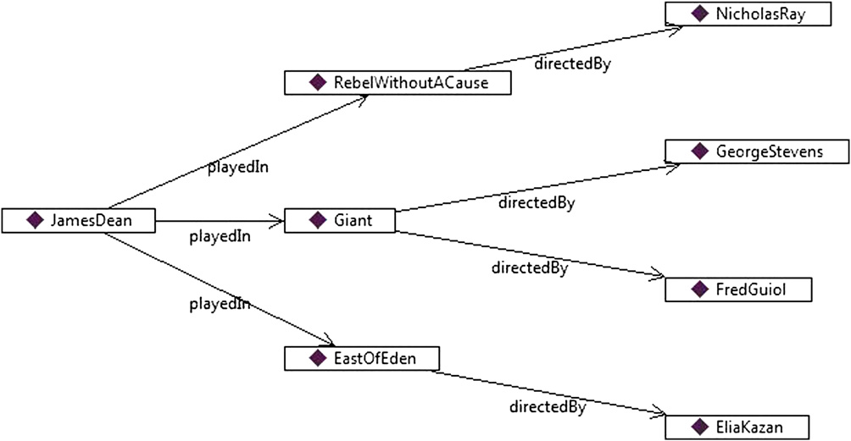
For each actor or director the following information is available:
Property | Value
bornOn | 1931-02-08
diedOn | 1955-09-30
playedIn | Giant
playedIn | EastOfEden
rdf:type | Man
rdfs:label | James Dean
Write SPARQL queries to:
- Find all movies that James Dean played with their directors.
- Find all actresses that played in the same movies as Rock Hudson that are still alive. Print them in alphabetic order.
- Return a RDF graph relating Rock Hudson with all actors that played with him in the same movies. Use the property :playedWith. Also include the name and type of each actor.
- Using the same graph of the last question and RDFS constructs, we want to represent actor names using the property :actorName and director names using the property :directorName, but still want any query using rdfs:label to work. How to do it?

