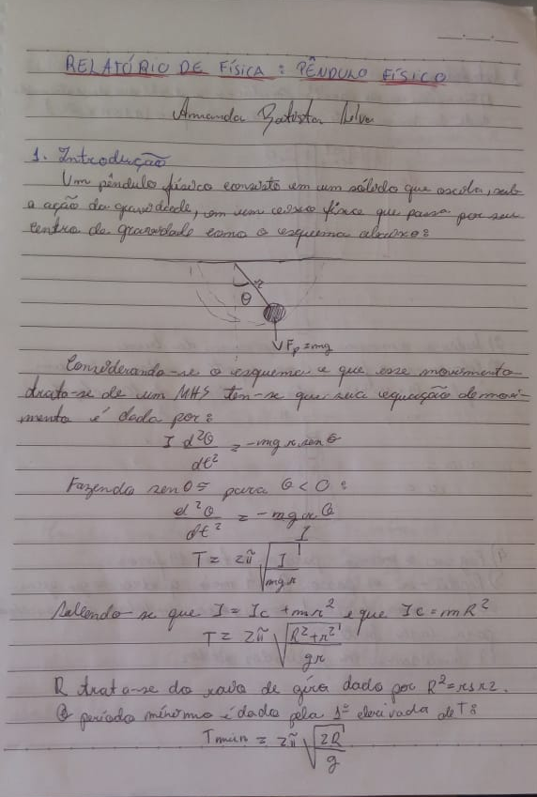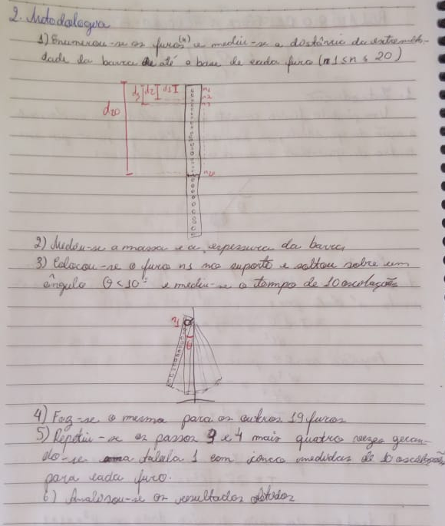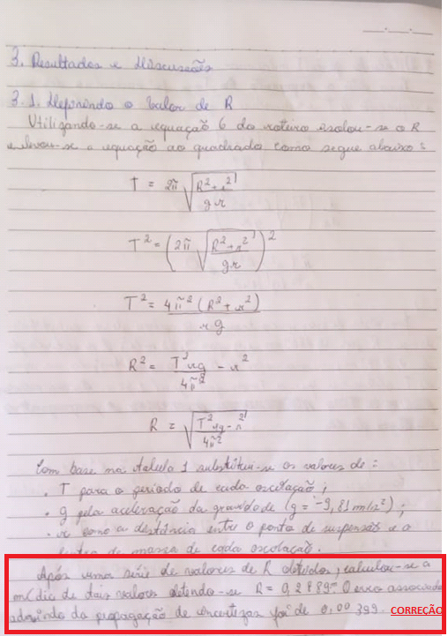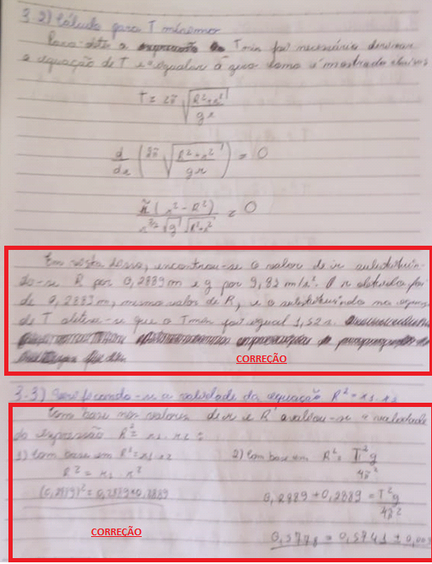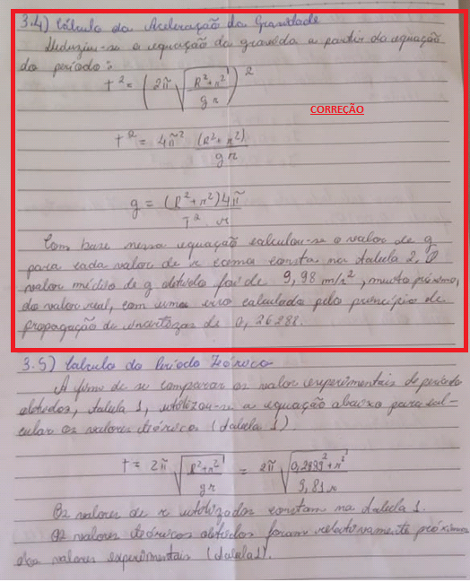
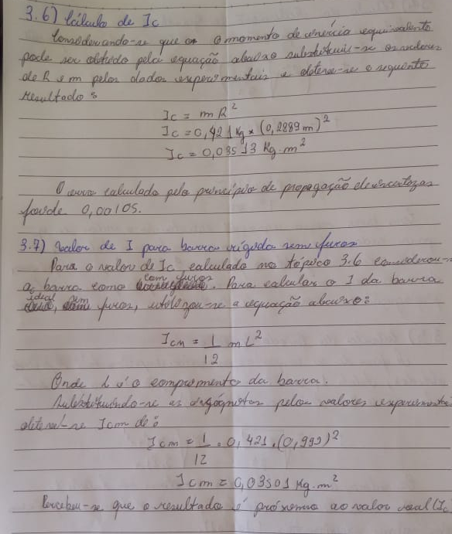

Tabela 1 - Período experimental e período teórico do pêndulo físico.
Furo | d (m) | r(m) | T exp. | T teo
1 | 0,026 | 0,477 | 1,68 | 1,62
2 | 0,053 | 0,450 | 1,63 | 1,60
3 | 0,0725 | 0,431 | 1,58 | 1,59
4 | 0,103 | 0,400 | 1,55 | 1,57
5 | 0,127 | 0,376 | 1,54 | 1,55
6 | 0,153 | 0,350 | 1,54 | 1,54
7 | 0,178 | 0,325 | 1,53 | 1,53
8 | 0,203 | 0,300 | 1,52 | 1,53
9 | 0,227 | 0,276 | 1,52 | 1,53
10 | 0,253 | 0,250 | 1,52 | 1,53
11 | 0,278 | 0,225 | 1,53 | 1,55
12 | 0,302 | 0,201 | 1,57 | 1,57
13 | 0,328 | 0,175 | 1,71 | 1,62
14 | 0,353 | 0,150 | 1,66 | 1,69
15 | 0,378 | 0,125 | 1,76 | 1,79
16 | 0,404 | 0,099 | 1,91 | 1,95
17 | 0,429 | 0,074 | 2,14 | 2,20
18 | 0,454 | 0,049 | 2,58 | 2,66
19 | 0,479 | 0,024 | 3,51 | 3,75
NÃO FOI POSSÍVEL MEDIR O Nº 20- o VALOR DE T TENDE AO INFINITO
Tabela 2 - Aceleração da gravidade obtida através do valor de T experimental.
Furo | r(m) | T exp. (s) | $$g(m/s^{2})$$
1 | 0,477 | 1,68 | 9,12
2 | 0,45 | 1,63 | 9,47
3 | 0,4305 | 1,58 | 9,84
4 | 0,4 | 1,55 | 9,94
5 | 0,376 | 1,54 | 9,93
6 | 0,35 | 1,54 | 9,81
7 | 0,325 | 1,53 | 9,79
8 | 0,3 | 1,52 | 9,92
9 | 0,276 | 1,52 | 9,84
10 | 0,25 | 1,52 | 9,98
11 | 0,225 | 1,53 | 10,01
12 | 0,201 | 1,57 | 9,82
13 | 0,175 | 1,71 | 8,83
14 | 0,15 | 1,66 | 10,13
15 | 0,125 | 1,76 | 10,06
16 | 0,099 | 1,91 | 10,21
17 | 0,074 | 2,14 | 10,31
18 | 0,049 | 2,58 | 10,38
19 | 0,024 | 3,51 | 11,23

CORREÇÕES
